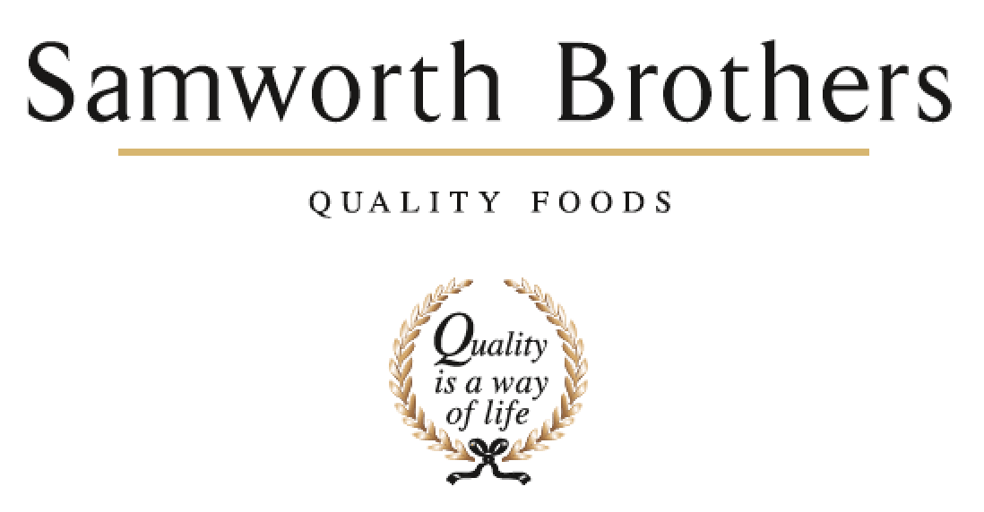

|  |  |  |  |
| --- | --- | --- | --- |
| ROLE PROFILE | | | |
| Job title | Hygiene Systems Coordinator | Date | June 2025 |
| Business | The Cornwall Bakery | | |
| Department | Technical | | |
| Location | Callington, Cornwall | | |
| ROLE SUMMARY | | | |
| Reporting to the Tamar Bakery Hygiene Manager, this role is responsible for the coordination of the site wide Hygiene Management System including Gateway AC, Hygiene reporting and trending and facilitating the planning of resource to achieve both Lynher and Tamar Bakery Hygiene Key Performance Indicator targets. | | | |
| REPORTING STRUCTURE | | | |
| Reports to | Tamar Bakery Hygiene Manager | | |
| Deputy | Tamar Bakery Hygiene Manager | | |
| Direct & indirect reports |  | | |
| Key internal stakeholders | Hygiene, Production, Packing, Preparation, Despatch functions, Planning | | |
| Key external stakeholders | Hygiene suppliers, Hygiene contractors | | |
| KEY ACCOUNTABILITIES AND RESPONSIBILITIES | | | |
| Monday – Friday, 0830 – 1700   * Coordinate and administrate the maintenance, development and archiving of the site wide Hygiene Management System including:   + Gateway AC   + Records   + CIC’s   + SOP’s   + Safe Systems of Work * Develop weekly Hygiene task and manning plans, including forward planning for periodical tasks, supported by the bakery Hygiene Managers and Area Managers and in collaboration with Planning and Operational colleagues to maximise KPI performance and minimise operational impact. * Support the bakery Hygiene Managers to co-ordinate permanent and temporary labour forecasts to support shift performance and control bakery labour budget. * Support bakery Hygiene Managers to coordinate reviews of departmental risk assessments and document Safe Systems of Work for Hygiene tasks across the site. * Generate timely Hygiene KPI reporting and trending for the bakery Hygiene Managers to drive visibility and continuous improvement across the site and category. * Support the bakery Hygiene Manager in the administration of the site Listeria Management Programme. * Ensure communication channels within area of responsibility are robust and delivers the right messages in a timely manner to all staff as required. * Drive a culture of change by engaging, coaching, and implementing the Samworth Values. | | | |
| QUALIFICATIONS, EXPERIENCE, TECHNICAL SKILLS / KNOWLEDGE | | | |
| * Competent computer skills including Microsoft Word, Excel, Powerpoint, Microsoft Teams * Demonstrable experience within food manufacturing hygiene leadership | | | |
| CORE COMPETENCIES, ATTRIBUTES & BEHAVIOURS FOR SUCCESS | | | |
| **Competency** | **Descriptors** | | |
| Values People | *Demonstrates the belief that people are our most important asset and central to the success of the organisation. Everybody should be treated with dignity and respect at all times.* | | |
| Customer Focus | *Demonstrates the understanding that the satisfaction of our internal and external customers is the foundation of our success* | | |
| Collaborative Team Working | *The willingness to act as part of a team and work towards achieving shared objectives through adopting best practice in line with PQP and Federalism.* | | |
| Flexibility & Adaptability | *The ability to change and adapt own behaviour or work procedures when there is a change in the work environment, for example as a result of changing customer needs.* | | |
| Initiative & taking ownership | *Steps up to take on personal responsibility and accountability for tasks and actions in line with PQP and Federalism.* | | |
| Drive for Excellence | *Knows the most effective and efficient processes for getting things done, with a focus on continuous improvement.* | | |
| Resource Management | *Effectively manages resources and cost drivers to achieve sustainable productivity and profitability.* | | |
| Technical Expertise | *Has the skills, knowledge and experience required to excel in own area of specialism and the willingness to further grow and develop.* | | |
| Self-Management | *Uses a combination of feedback and reflection to gain insight into personal strengths and weaknesses, so that own time, priorities and resources can be managed to achieve goals.* | | |