 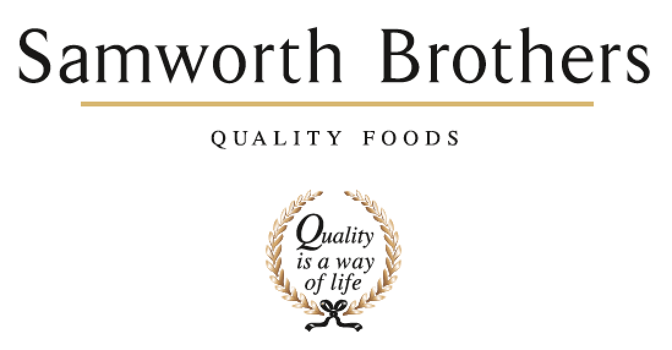

|  |  |  |  |
| --- | --- | --- | --- |
| **ROLE PROFILE** | | | |
| Job title | Multi Skilled Technician | Date | 31st March 2021 |
| Department | Engineering | | |
| Location | Soreen | | |
| **ROLE SUMMARY**  Summarise in one or two sentences the highlights of the job in terms of its purpose and overall responsibility. | | | |
| * To maximise production efficiencies by the effective inspection of production equipment and rapid resolution of problems to prevent unplanned production stoppages. * To provide engineering resource in carrying out planned maintenance, breakdown repairs, refurbishment, installation, improvements and modifications or upgrade to plant and services in order to minimise downtime and maintain the equipment in the best possible condition. * To improve machine availability, life cycle costs and efficiency. * To carry out all engineering work to high Engineering, Quality, Safety and Hygiene standards. | | | |
| **REPORTING STRUCTURE** | | | |
| Reports to | Engineering Manager | | |
| Key internal stakeholders | All Soreen functions | | |
| Key external stakeholders | All Group functions and contractors | | |
| KEY ACCOUNTABILITIES AND RESPONSIBILITIES | | | |
| **Principle Accountabilities**  Deliver a comprehensive maintenance program based on Shire Pirana CMMS targeted at reducing unplanned work and maximizing machine availability.  Modify and update PPM system and hard copy information on a daily basis to ensure engineering information is up to date and accurate.  Pass relevant information daily to colleagues.  Deliver a first-class pro-active service and support for production requirements and factory services.  Train and assist production to deliver efficient machine setup and rapid startups.  Work pro-actively with contractors, agencies and other Soreen staff to ensure efficient and compliant running of the factory.  Champion specific machinery and projects.  Manage own self to meet company objectives to agreed timescales.  **Job Scope – Dimensions**   * Should operate in a safe and correct manner at all times within the safety responsibilities of a Shift Engineer and ensure others do the same. You should also ensure the site is a safe place to work within at all times for yourself and others. * Demonstrate a full knowledge of operations for entering unsafe machinery * Asses plant machinery and buildings for potential Health & Safety problems. * Should adopt good housekeeping practices at all times.   **Limits of Authority**   * Issue of permits as authorised by the management team. * Purchasing of spares and services within authorisation limit.   **KPIs**   * Safety * Reliability of services to factory * Factory OEE (breakdowns) * Delivery of maintenance plans * Delivery of overhauls and improvements * Effective shift handover and communication * Proactive / reactive ratio * Environmental compliance | | | |
| QUALIFICATIONS, EXPERIENCE, TECHNICAL SKILLS / KNOWLEDGE List the skills gained through education and experience required to effectively function in the position | | | |
| Essential Skills/Abilities  A positive and proactive approach  Ability to analyze and solve problems methodically  Able to build relationships across all factory functions as part of a team  Drive to improve, learn and succeed  Open to change  Previous experience as a multi skilled technician  Practical experience gained within engineering function within FMCG environment  Desirable Skills/Abilities  Engineering City and Guilds qualification or equivalent | | | |
| **ATTRIBUTES & BEHAVIOURS FOR SUCCESS** | | | |
| **Behaviour** | **Descriptors** | | |
| **Focused on developing people** | * Consistently demonstrates that people are the top business priority. * Devotes a significant % of time to supporting and coaching their people. * People related activities are consistently placed high on the “to do” list. * Always make themselves available to support team members, regardless of how busy they are. | | |
| **Builds strong relationships** | * Demonstrates they are a good listener who can take on board other points of view. * Demonstrates trust in other teams and other colleagues. * Displays a high level of emotional intelligence to understand how to improve a relationship. * Willing to be the “better person” for the sake of building or maintaining a relationship. * Consciously aware of key relationships which require more work to improve. | | |
| **Courage to make tough decisions** | * Demonstrates they can make a positive decision when none of the alternatives are attractive. * Is able to make quick decisions when needed even if the data is not complete. * Is able to take the “hard / right” decision (which will upset some people) rather than always opting for the “easy / but wrong” decisions. * Consistently demonstrates high standards and does not drop standards just because the implications are challenging. | | |
| **Calmness during challenging times** | * The more challenging the situation the calmer we want our people to be. * Does not get over-emotional when things go wrong. * Recognises that challenging times call for the best kind of leadership. * Focuses on the issue…….not the person who made a mistake or who discovered a problem. | | |
| **Leads by example** | * We should “walk the walk” as well as “talk the talk”. * Displays a consistent approach in how they deal with everyone in the business regardless of their level. * Demonstrates an unshakeable positive attitude regardless of how challenging the circumstances. * Appreciates the views of everyone in the business and welcomes new ideas and challenges. | | |