` 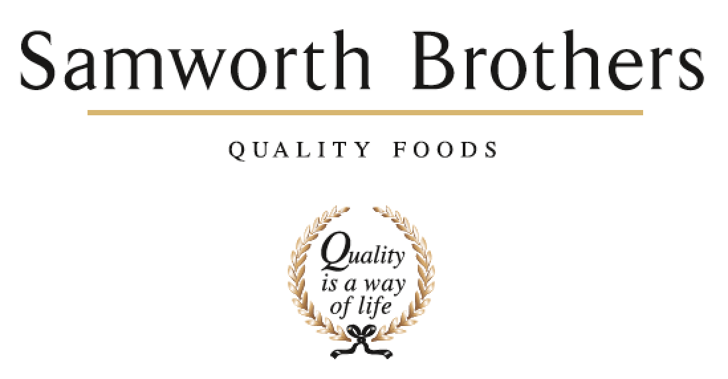

ROLE PROFILE
Job title | Commercial Manager | Date | 2024
Business | Samworth Brothers Food to Go
Department | Commercial
Location | Leicester/Melton Mowbray
ROLE SUMMARY
This Commercial Manager role will be responsible for the relationship and effective account management of our Food to Go (FTG) customers.

Our FTG commercial vision is to create “one trusted empowered team, building collaborative partnerships that deliver sustainable growth by meeting the changing needs of the FTG consumer”. We aspire to grow the FTG business, enhance our profitability, and to become the recognised supplier of choice in FTG.

The primary function of this role is to build close and trusted relationships with the customer partners and internal teams, ensuring we are active leaders within the categories we operate. You will ensure we deliver against our budget commitments and growth agenda outlined in the FTG Category & Commercial Strategy.

We have been rated #1 by our retail customers in the Advantage Group Survey for 3 consecutive years. By putting the customer at the forefront of everything we do, our ambition is to retain this and further improve the key measures across our customer base in the coming years.

REPORTING STRUCTURE
Reports to | Head of Commercial
Direct & indirect reports | N/A
Key internal stakeholders | FTG Commercial Leadership team  FTG site teams  Category and Insight teams  NPD & Development team  Commercial Finance team
Key external stakeholders | Retail customers (TBC)

KEY ACCOUNTABILITIES AND RESPONSIBILITIES
- Day-to-day management of multiple accounts, with the support of a Commercial Executive
- Lead the relevant NWTs to ensure the team exceeds customer expectations
- Grow and develop sales with current customers/categories in line with/exceeding business targets (gross margin & GSV)
- Support customer negotiations, aligning with Group category colleagues when required
- Align customer and business strategies
- Work in partnership with the Category and NPD colleagues to ensure viable products are developed that deliver for the consumer and the customer whilst meeting/exceeding Samworth FTG financial requirements
- Develop strong relationships with customer and internal stakeholders
- Understand and build a knowledge of major competitors
- Develop a sound financial understanding for costing products and devising promotional programmes
- Develop robust sales forecasts, alongside the Planning team and in collaboration with the customer, to deliver industry-leading service levels
- Review the success of each launch/promotion – ensure lessons are learnt/robust post-launch reviews are carried out
- Identify and deliver on E2E opportunities to reduce complexity and add value to Samworth FTG and its customers

QUALIFICATIONS, EXPERIENCE, TECHNICAL SKILLS / KNOWLEDGE
KNOWLEDGE & SKILLS
- Financial and commercial acumen
- Attention to detail
- Ability to work at all levels – day-to-day problem solving through to long-term strategy development
- A strong working knowledge of Microsoft Word, Excel and PowerPoint
- Negotiation skills
- Good analytical ability
  - Preparing external reports and persuasive arguments to the customer
  - Understanding of internal systems – forecasting and financial models
- Strong communication and presentation skills
- Passion for food
- Chilled food experience

QUALIFICATIONS
- Degree education or equivalent business experience
KEY PERFORMANCE INDICATORS
- Sales revenue/gross margin targets to be achieved
BEHAVIOURS/DEVELOPMENT CRITERIA
- Passionate team player
- Good leadership skills
- Excellent interpersonal skills, engaging with internal and external stakeholders
- Relationship building
- Desire to deliver best in class service to customers

CORE COMPETENCIES, ATTRIBUTES & BEHAVIOURS FOR SUCCESS
Competency | Descriptors
Values People | Demonstrates the belief that people are our most important asset and central to the success of the organisation. Everybody should be treated with dignity and respect at all times.
Customer Focus | Demonstrates the understanding that the satisfaction of our internal and external customers is the foundation of our success
Collaborative Team Working | The willingness to act as part of a team and work towards achieving shared objectives through adopting best practice in line with PQP and Federalism.
Flexibility & Adaptability | The ability to change and adapt own behaviour or work procedures when there is a change in the work environment, for example as a result of changing customer needs.
Initiative & taking ownership | Steps up to take on personal responsibility and accountability for tasks and actions in line with PQP and Federalism.
People Management | The ability to understand people and their motivations, build good relationships with them and help them unlock their potential.
Decision making and judgement | In line with our guiding principles of PQP & Federalism, makes timely and informed decisions that take into account the facts, goals, constraints and risks that keep the organisation moving forward.
Commercial awareness | Demonstrates an understanding of the impact decisions and actions have on the organisation in line with PQP and Federalism.
Developing partnerships | The ability to establish formal and informal relationships inside and outside the organisation, and to anticipate and balance the needs of those whose cooperation is needed for the long-term success of the business.
Engaging others through change | The ability to communicate a compelling vision throughout the organisation, generating genuine motivation and commitment and to act as a sponsor of change.
Focussing on the future | Demonstrates enthusiasm about our future by identifying strategic issues, opportunities to drive sustainable, profitable growth, and managing risk.

