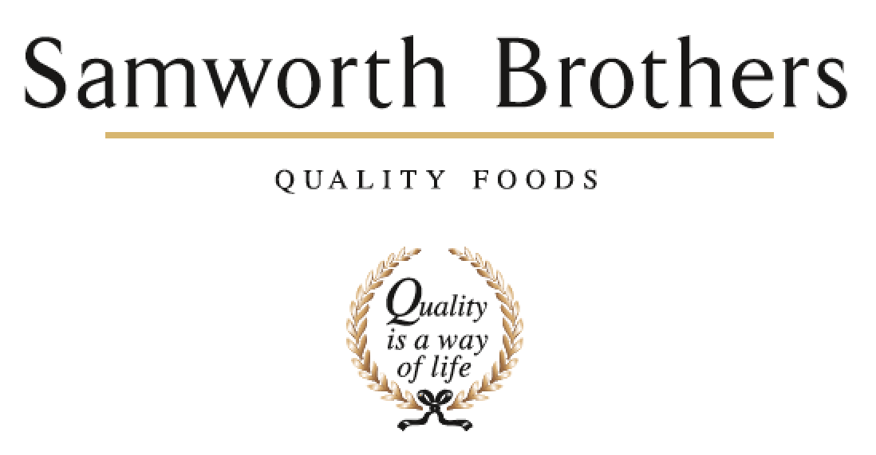

|  |  |  |  |
| --- | --- | --- | --- |
| ROLE PROFILE | | | |
| Job title | New Product Development Manager | Date | July 2020 |
| Business | Samworth Brothers Meals | | |
| Department | Commercial | | |
| Location | Kettleby | | |
| ROLE SUMMARY | | | |
| Manage projects from initial concept idea to handover, with a supporting role until launched in stores, via process.  The purpose of this role is to Lead the NPD function to create, develop and deliver commercially viable products in line with our growth strategy.  Along with supporting the development of new concepts you will get involved with refreshing and optimising existing products following a development gate process.  You will work cross functionally in partnership with the Commercial, Category, Sourcing and Procurement functions, Production and Technical/Process teams in the development of new products from concept through to launch. | | | |
| REPORTING STRUCTURE | | | |
| Reports to | Head of Innovation | | |
| Direct & indirect reports | Senior Technologist, Development Technologists, Development Chef | | |
| Key internal stakeholders | NPD Managers, Senior Technologists, Development Technologists, Senior Chef, Development Chef, Junior Chef, Commercial & Category Teams, Costing Teams, Technical and Process, NPD Sourcing Specialists & Procurement | | |
| Key external stakeholders | Retailer Product Managers, Chefs & Technologists. Suppliers. | | |
| KEY ACCOUNTABILITIES AND RESPONSIBILITIES | | | |
| * Lead and drive the Product Development process from the Kitchen as defined by the business strategy, in line with all customer briefs that have passed Gate 0. This role covers products made across all 3 bakeries – Customer dependant. * This role encompasses being the main business NPD contact and commercial support for all retail and some B2B & brand. * Ensure that the company follows an NPD Launch process and critical path to ensure launches are kept within company objectives and products are launched to a high standard in a timely manner. * Own the customer Critical Path from brief to product handover to process, ensuring engagement at all stages with relevant Samworth colleagues to ensure adherence to timeframes and that all challenges are met with a proactive resolving approach. * Own the ingredient part of costings and ensure with the NWT/Pod that delivery against margin is achieved. * Co-ordinating all activities of the NPD team, the Chef Team and support functions to ensure that all internal and external meetings are implemented. Communication and visibility to all is key, ensuring all projects are delivered within key dates and timelines. * As a customer-facing role the job holder is expected to support the Commercial Account Managers and Lead the food presentation with the support of the Senior Technologists with presentations and customer visits. * This role also encompasses identifying and evaluating food trends in conjunction with the category team and commercial and development chefs to support the business vision and customer strategy within a rolling 2-year horizon. * Liaise with Ingredient Sourcing Specialist and Packaging Executive to ensure all raw materials and packaging are available for product development and submissions. * Positive Release of customer/event samples. * Ensure the team adheres to safe ways of working and site procedures. * Support the Senior Technologist and Technologists in achieving daily tasks and ensure the correct level of training is supported by a well-managed PDP with reviews. * Working cross functionally with Technical, Process and operations to ensure alignment through the stage & gate process. | | | |
| QUALIFICATIONS, EXPERIENCE, TECHNICAL SKILLS / KNOWLEDGE | | | |
| * Min 4 years' experience in food manufacturing environment. * BSc or equivalent in a Food related discipline. * Previous Project Management experience. * Competent with all major software packages. * Strong leader with good interpersonal and communications kills with the ability to communicate across departments/suppliers and external customers. * Strong organisational, and project management skills to assist with critical path deadlines and project priorities. * Working knowledge of the factory and raw materials currently used on site. * Is able to effectively time manage - to structure the team's day efficiently with regards to differing priorities / workloads as well as working to tight deadlines. * Hardworking and passionate with an eye for detail. * Ability to problem solve | | | |
| CORE COMPETENCIES, ATTRIBUTES & BEHAVIOURS FOR SUCCESS | | | |
| **Competency** | **Descriptors** | | |
| Values People | *Demonstrates the belief that people are our most important asset and central to the success of the organisation. Everybody should be treated with dignity and respect at all times.* | | |
| Customer Focus | *Demonstrates the understanding that the satisfaction of our internal and external customers is the foundation of our success* | | |
| Collaborative Team Working | *The willingness to act as part of a team and work towards achieving shared objectives through adopting best practice in line with PQP and Federalism.* | | |
| Flexibility & Adaptability | *The ability to change and adapt own behaviour or work procedures when there is a change in the work environment, for example as a result of changing customer needs.* | | |
| Initiative & taking ownership | *Steps up to take on personal responsibility and accountability for tasks and actions in line with PQP and Federalism.* | | |
| Drive for Excellence | *Knows the most effective and efficient processes for getting things done, with a focus on continuous improvement.* | | |
| Resource Management | *Effectively manages resources and cost drivers to achieve sustainable productivity and profitability.* | | |
| Technical Expertise | *Has the skills, knowledge and experience required to excel in own area of specialism and the willingness to further grow and develop.* | | |
| Self-Management | *Uses a combination of feedback and reflection to gain insight into personal strengths and weaknesses, so that own time, priorities and resources can be managed to achieve goals.* | | |