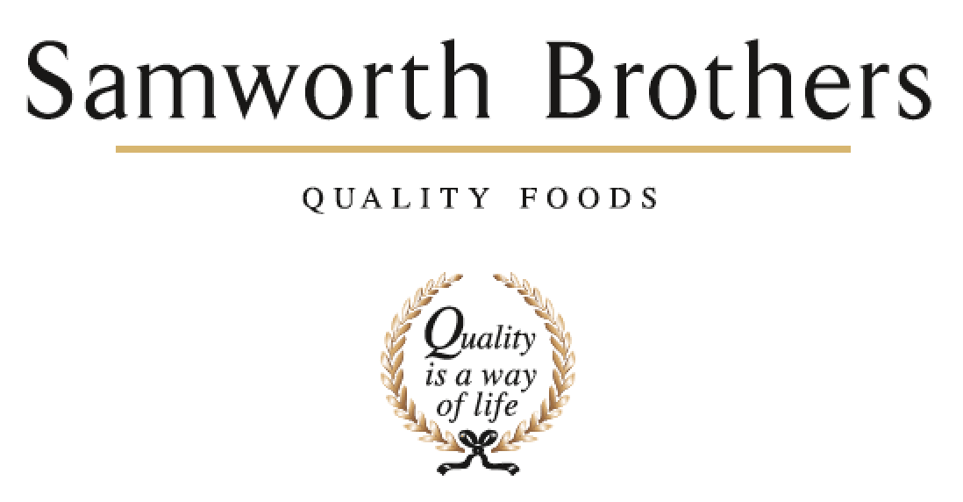

|  |  |  |  |
| --- | --- | --- | --- |
| ROLE PROFILE | | | |
| Job title | Development Chef | Date | 22/01/2021 |
| Business | Samworth Brothers Food to go | | |
| Department | NPD | | |
| Location | Bradgate Bakery | | |
| ROLE SUMMARY | | | |
| To support the NPD team in a very fast paced environment through idea generation and development of new products. To help generate new business in existing and emerging categories through creative and innovative thinking. The role requires face to face contact with the customer as well as internal colleagues. Passion for food is absolutely essential with a drive to challenge and improve processes and product quality. | | | |
| REPORTING STRUCTURE | | | |
| Reports to | Senior Development Chef | | |
| Direct & indirect reports |  | | |
| Key internal stakeholders | NPD Managers, OPP, Process | | |
| Key external stakeholders | TBC | | |
| KEY ACCOUNTABILITIES AND RESPONSIBILITIES | | | |
| * Create exciting products for our categories – delivering new and interesting ideas. * Assist in generating and delivering the innovation and blue-sky pipeline. * Responsible for developing new ranges whilst tweaking products to reflect changes in the market, ingredients or costs. * Be abreast of current food trends and influences and be able to apply these to relevant areas of our business. * Organisation and preparation of food samples, to include ordering of materials, costing, practical application and despatch of product. * Assist in product presentations both internally and externally. * Understand the customer brand values to enable effective translation into product   proposition.   * Understand the business and its USPs to develop outstanding products that translate effectively once scaled up. * Support the operations and technical department with product launches. * To assist in building a positive food culture – challenging the operations and process functions to improve product quality and enhance the business reputation as development experts. * Responsible for day to day housekeeping of the development kitchen. * Communicate effectively and work collaboratively with the rest of the development team.   **Please note this job list is not exhaustive and may include other duties deemed to be within the share of responsibilities.** | | | |
| QUALIFICATIONS, EXPERIENCE, TECHNICAL SKILLS / KNOWLEDGE | | | |
| |  |  |  | | --- | --- | --- | | **Person Specification** | | | | **Qualifications** | Food Hygiene  NVQ/City & Guilds | Essential | | **Work Experience** | Commercial NPD experience.  Chilled product development experience would be ideal.  Culinary expertise is essential. Candidates must have a good understanding of kitchen housekeeping and health & Safety | Essential  Desirable  Essential | | **Knowledge** | Candidates should display a real passion for food with a reasonably broad knowledge of food ingredients and flavour pairings.  Understanding of the retail sector | Essential  Essential | | **Job Skills** | Passion for good food Excellent food production skills Time management skills Creative and innovative thinking Presentation and communication skills Able to perform under pressure and at short notice Experience in setting up recipes. | All  Essential | | **Computer Skills** | Candidates must be computer literate. Regular use of excel, word and outlook will be required. | Essential | | **Literacy and Numeracy** | Ability to speak articulate, clear and fluent English.  Ability to read and understand written English.  Good written English Language Skills.  Good numeracy skills. | Essential | | **Circumstances** | Full driving Licence required.  Ability to work flexibly. | Essential  Essential  Essential | | | | |
| CORE COMPETENCIES, ATTRIBUTES & BEHAVIOURS FOR SUCCESS | | | |
| **Competency** | **Descriptors** | | |
| Values People | *Demonstrates the belief that people are our most important asset and central to the success of the organisation. Everybody should be treated with dignity and respect at all times.* | | |
| Customer Focus | *Demonstrates the understanding that the satisfaction of our internal and external customers is the foundation of our success* | | |
| Collaborative Team Working | *The willingness to act as part of a team and work towards achieving shared objectives through adopting best practice in line with PQP and Federalism.* | | |
| Flexibility & Adaptability | *The ability to change and adapt own behaviour or work procedures when there is a change in the work environment, for example as a result of changing customer needs.* | | |
| Initiative & taking ownership | *Steps up to take on personal responsibility and accountability for tasks and actions in line with PQP and Federalism.* | | |
| Drive for Excellence | *Knows the most effective and efficient processes for getting things done, with a focus on continuous improvement.* | | |
| Resource Management | *Effectively manages resources and cost drivers to achieve sustainable productivity and profitability.* | | |
| Technical Expertise | *Has the skills, knowledge and experience required to excel in own area of specialism and the willingness to further grow and develop.* | | |
| Self-Management | *Uses a combination of feedback and reflection to gain insight into personal strengths and weaknesses, so that own time, priorities and resources can be managed to achieve goals.* | | |