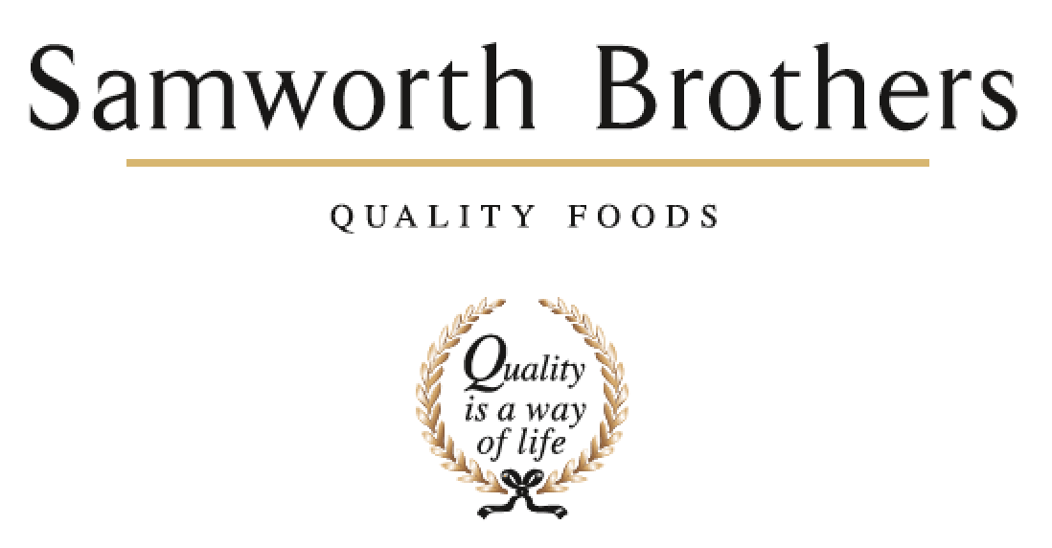

|  |  |  |  |
| --- | --- | --- | --- |
| ROLE PROFILE | | | |
| Job title | Multi Skilled Engineer | Date |  |
| Business |  | | |
| Department | Engineering | | |
| Location |  | | |
| ROLE SUMMARY | | | |
| This role will be responsible for fault finding, repairs, planned preventative maintenance and continuous improvement across the food production site. | | | |
| REPORTING STRUCTURE | | | |
| Reports to | Team Leader | | |
| Direct & indirect reports | N/A | | |
| Key internal stakeholders | Production | | |
| Key external stakeholders | N/A | | |
| KEY ACCOUNTABILITIES AND RESPONSIBILITIES | | | |
| * To carry out day to day repair and maintenance of all equipment on site. * To liaise with production to provide proactive support to ensure efficiency of production runs. * To carry out all reporting and documentation as required by the engineering department. * To be proactive in finding permanent solutions to engineering problems. * To comply with and strongly advocate all relevant Health and Safety, Food Hygiene, Environmental Legislation, and Statutory Legislation for self, contractors and others, whilst carrying out engineering activities. | | | |
| QUALIFICATIONS, EXPERIENCE, TECHNICAL SKILLS / KNOWLEDGE | | | |
| * Good organisational skills * Must be a team player * Ability to work on own initiative in a responsible manner * Ability to work under pressure * Good communicator and have the ability to develop strong relationships with members of staff from all departments * Must have a hands-on approach to problem solving * Must have strong documentation skills when detailing actions taken. * Must have a flexible approach to working patterns and overtime working * Must have a good working knowledge of electrical control systems, inverter drives, and pneumatic systems * Electrically qualified to level 3 or greater * Minimum of 2 years experience ideally within Manufacturing | | | |
| CORE COMPETENCIES, ATTRIBUTES & BEHAVIOURS FOR SUCCESS | | | |
| **Competency** | **Descriptors** | | |
| Values People | *Demonstrates the belief that people are our most important asset and central to the success of the organisation. Everybody should be treated with dignity and respect at all times.* | | |
| Customer Focus | *Demonstrates the understanding that the satisfaction of our internal and external customers is the foundation of our success* | | |
| Collaborative Team Working | *The willingness to act as part of a team and work towards achieving shared objectives through adopting best practice in line with PQP and Federalism.* | | |
| Flexibility & Adaptability | *The ability to change and adapt own behaviour or work procedures when there is a change in the work environment, for example as a result of changing customer needs.* | | |
| Initiative & taking ownership | *Steps up to take on personal responsibility and accountability for tasks and actions in line with PQP and Federalism.* | | |
| Drive for Excellence | *Knows the most effective and efficient processes for getting things done, with a focus on continuous improvement.* | | |
| Resource Management | *Effectively manages resources and cost drivers to achieve sustainable productivity and profitability.* | | |
| Technical Expertise | *Has the skills, knowledge and experience required to excel in own area of specialism and the willingness to further grow and develop.* | | |
| Self-Management | *Uses a combination of feedback and reflection to gain insight into personal strengths and weaknesses, so that own time, priorities and resources can be managed to achieve goals.* | | |