` 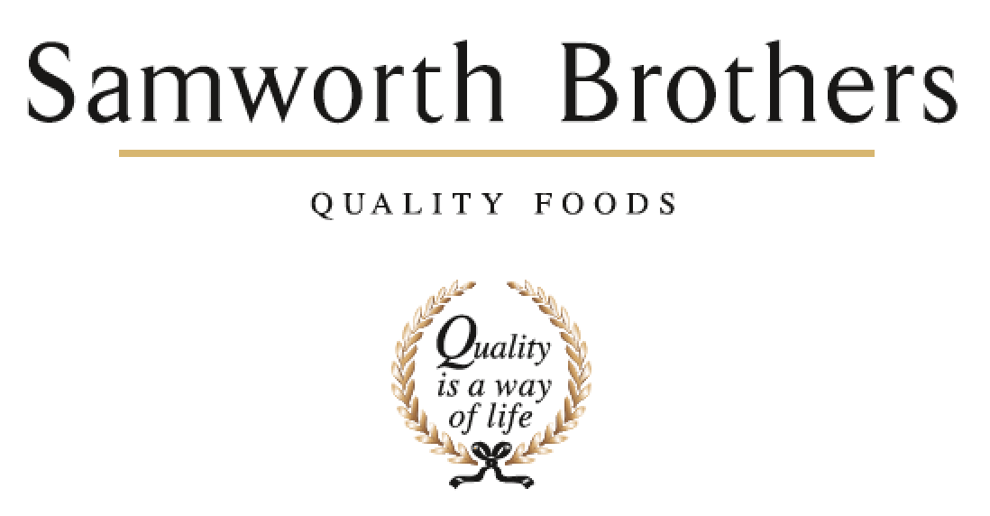

|  |  |  |  |
| --- | --- | --- | --- |
| ROLE PROFILE | | | |
| Job title | Operations Manager | Date | March 2023 |
| Business | Meals | | |
| Department | Operations | | |
| Location | Kettleby Foods | | |
| ROLE SUMMARY | | | |
| To lead the operations and hygiene functions for Kettleby Foods. To deliver the site’s targeted KPI performance (across people, process and products) and provide inspirational leadership across all departments and shifts..  To exhibit and promote the Samworth Brothers Values and Purpose at all times.  A key member of the site’s Senior Management Team this position will have a leading role in the building of a business plan which will deliver our vision alongside the site’s safety, quality and financial targets.  To drive people engagement across the operational population to keep people safe, engaged and focused to delivery against the site’s strategy.  Working with relevant departments ensure all new capital investments and future projects  deliver to best operational performance. | | | |
| REPORTING STRUCTURE | | | |
| Reports to | Site Director | | |
| Deputy | Depending on circumstance either Production Manager, Hygiene Manager or Site Director | | |
| Direct & indirect reports | Nightshift Production Manager / 3 x Production Managers / Hygiene and Environmental Manager / Bakery Training department | | |
| Key internal stakeholders | All operations departments: manufacturing; supply chain; engineering; health and safety; hygiene  All indirect departments: technical and process development; people teams; finance; NPD and commercial | | |
| Key external stakeholders | Meals Customers, Meals Division, Samworth Brothers Group and the local community | | |
| KEY ACCOUNTABILITIES AND RESPONSIBILITIES | | | |
| 1. To lead the continuous development of the Health, Safety and Environmental culture within the Operations population. Proactively drive H&S control across the department ensuring resource for monitoring, audit and investigations. 2. To deliver products and services to all internal and external food safety and customer standards. Procedures in place to identify non conformance or a drop in performance. Control corrective actions when necessary 3. To constantly develop a set of operational KPI’s which monitor all people, process and cost expectations and deliver improvements in quality, performance and profit 4. Working to the divisional and site strategy set the direction for the Operations team 5. Inspire and lead the Production / Hygiene / Area Managers and training department teams creating opportunities for them to develop to their full potential 6. Ensure communications are maintained within and across the shift teams ensuring well informed teams. Manage day to day information flow so that immediate issues are resolved as rapidly as possible and best practises shared amongst the wider operational population 7. To engage with NPD and Process development to provide efficient and innovative solutions for new products 8. To work closely with Business Development and group Manufacturing Excellence to identify and implement continuous improvement opportunities 9. To identify and prioritise capital projects that support the delivery of operational performance 10. To contribute and support other Senior Management team member initiatives and to deputise for the Site Director role | | | |
| QUALIFICATIONS, EXPERIENCE, TECHNICAL SKILLS / KNOWLEDGE | | | |
| Previous experience of leading manufacturing teams in a chilled environment  Previous experience of being accountable for customer compliance  The ability to plan and lead the management of initiatives in large business (preferably within a divisional/group)  Experience of leading large, diverse teams in a fast-moving manufacturing environment  A passion to motivate, coach and develop a team  The ability to influence cross functional teams  Proven ability to drive sustainable improvements  Excellent literacy and numerical skills, the ability to understand, communicate and report clearly in English  HACCP Level 3 minimum  Food Safety Level 3 minimum  IOSH Managing Safely  Green belt six sigma | | | |
| CORE COMPETENCIES, ATTRIBUTES & BEHAVIOURS FOR SUCCESS | | | |
| **Competency** | **Descriptors** | | |
| Values People | *Demonstrates the belief that people are our most important asset and central to the success of the organisation. Everybody should be treated with dignity and respect at all times.* | | |
| Customer Focus | *Demonstrates the understanding that the satisfaction of our internal and external customers is the foundation of our success* | | |
| Collaborative Team Working | *The willingness to act as part of a team and work towards achieving shared objectives through adopting best practice in line with PQP and Federalism.* | | |
| Flexibility & Adaptability | *The ability to change and adapt own behaviour or work procedures when there is a change in the work environment, for example as a result of changing customer needs.* | | |
| Initiative & taking ownership | *Steps up to take on personal responsibility and accountability for tasks and actions in line with PQP and Federalism.* | | |
| People Management | *The ability to understand people and their motivations, build good relationships with them and help them unlock their potential.* | | |
| Empowering others | *Creates an environment where people feel required and enabled to take ownership and responsibility* | | |
| Coaching for Performance | *The ability to help others achieve more through two way feedback, clear direction and enabling* | | |
| Analysis and Planning | *The ability to take a range of information, think things through logically and prioritise work to meet commitments aligned with organisational goals* | | |