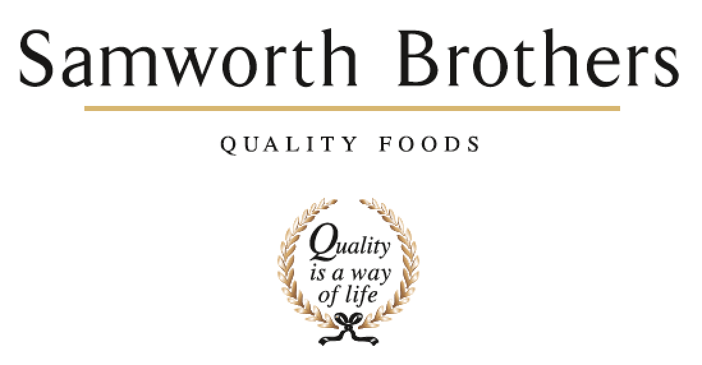

|  |  |  |  |
| --- | --- | --- | --- |
| ROLE PROFILE | | | |
| Job title | Hygiene Area Manager Lynher | Date | June 2025 |
| Business | The Cornwall Bakery | | |
| Department | Technical | | |
| Location | Callington, Cornwall | | |
| ROLE SUMMARY | | | |
| Reporting to the Lynher Bakery Hygiene Manager, leading a motivated shift-based team in achieving departmental and business Key Performance Indicators in line with departmental and company objectives, whilst maintaining H&S, Food Safety and GMP standards. | | | |
| REPORTING STRUCTURE | | | |
| Reports to | Lynher Bakery Hygiene Manager | | |
| Deputy | Lynher Bakery Hygiene Manager | | |
| Direct & indirect reports | Shift-based Team Leaders, Operators | | |
| Key internal stakeholders | Production, Packing, Preparation, Despatch functions, Planning | | |
| Key external stakeholders | Hygiene suppliers; Pest Control; Environmental systems, Hygiene Contractors | | |
| KEY ACCOUNTABILITIES AND RESPONSIBILITIES | | | |
| Thursday 1500-1700  Friday - Sunday 0600-1800  Monday 0830-1230  (flexibility across shifts)   * Line Management of the Lynher Bakery 3 Days and 3 Nights Hygiene Team Leaders and Operators, responsible for all ‘People’ processes within area of responsibility. * Manage all aspects of training and developing direct reports to include maintaining skills matrices, implementation of SOP’s, identifying skills gaps, developing training plans, maintenance of core training, consistent delivery of shop floor training, maintenance of training records and involvement in specific role related training. * Supporting the bakery Hygiene Manager in recruitment, staff movements and succession planning activities. * Effective performance management of direct reports ensuring consistency in approach and correct application of performance management processes (Disciplinary/Absence Management procedures/Praise & Recognition). Ensures appraisals are carried out for team * Investigating and hearing grievance and managing disciplinary meetings in which the outcomes may result in a sanction but not dismissal. * Deputise for the management of the People Portal to include team rota, time management system, holidays and absenteeism procedures. * Ensuring communication channels within area of responsibility are robust and delivers the right messages in a timely manner to all staff as required. * Creating a positive culture to foster good morale and good working conditions for colleagues. * Support the Hygiene Systems Coordinator and bakery Hygiene Manager to develop Hygiene task and manning plans, including forward planning for periodical tasks. * Evaluate shift performance against pre-determined Hygiene plans throughout the shift and drive clear and collaborative recovery actions where variances between planned and actual performance arise. Escalating where necessary. * Support the shift-based Team Leaders to ensure safe behaviours, CIC compliance including cleaning methodologies and equipment testing and accurate recording keeping is achieved through compliance audits and colleague feedback, coaching and mentoring. * Attend daily Operational meetings – reporting on Hygiene measures and contributing a collaborative approach to the success of the bakery operation. * Manage leadership handovers with the bakery Hygiene Manager and Hygiene Coordinator effectively, ensuring a well communicated transition into the week. * Conduct reviews of risk assessments and document safe systems of work for all Hygiene tasks, coordinated by the Hygiene Systems Coordinator. * Support the Hygiene Manager to drive Hygiene opportunities and subsequent projects forward to deliver best in class performance, including facilitating the development of the Hygiene Management System including CIC’s, SOP’s and Safe Systems of Work, administrated by the Hygiene Systems Coordinator. * Engage with the sites H&S audit and action framework managed through SHE Assure. Conduct monthly H&S audits. Investigate and action H&S incidents promptly and within agreed timescales. * Action Food Safety and compliance non-conformances raised, ensuring investigations, corrective actions and preventive actions are thorough and effective. * Drive a culture of change by engaging, coaching, and implementing the Samworth Values. * Deputise for the bakery Team Leaders when required. | | | |
| QUALIFICATIONS, EXPERIENCE, TECHNICAL SKILLS / KNOWLEDGE | | | |
| * Competent computer skills including Microsoft Word, Excel, Powerpoint, Microsoft Teams * Demonstrable experience within food manufacturing hygiene leadership | | | |
| CORE COMPETENCIES, ATTRIBUTES & BEHAVIOURS FOR SUCCESS | | | |
| **Competency** | **Descriptors** | | |
| Values People | *Demonstrates the belief that people are our most important asset and central to the success of the organisation. Everybody should be treated with dignity and respect at all times.* | | |
| Customer Focus | *Demonstrates the understanding that the satisfaction of our internal and external customers is the foundation of our success* | | |
| Collaborative Team Working | *The willingness to act as part of a team and work towards achieving shared objectives through adopting best practice in line with PQP and Federalism.* | | |
| Flexibility & Adaptability | *The ability to change and adapt own behaviour or work procedures when there is a change in the work environment, for example as a result of changing customer needs.* | | |
| Initiative & taking ownership | *Steps up to take on personal responsibility and accountability for tasks and actions in line with PQP and Federalism.* | | |
| Drive for Excellence | *Knows the most effective and efficient processes for getting things done, with a focus on continuous improvement.* | | |
| Resource Management | *Effectively manages resources and cost drivers to achieve sustainable productivity and profitability.* | | |
| Technical Expertise | *Has the skills, knowledge and experience required to excel in own area of specialism and the willingness to further grow and develop.* | | |
| Self-Management | *Uses a combination of feedback and reflection to gain insight into personal strengths and weaknesses, so that own time, priorities and resources can be managed to achieve goals.* | | |