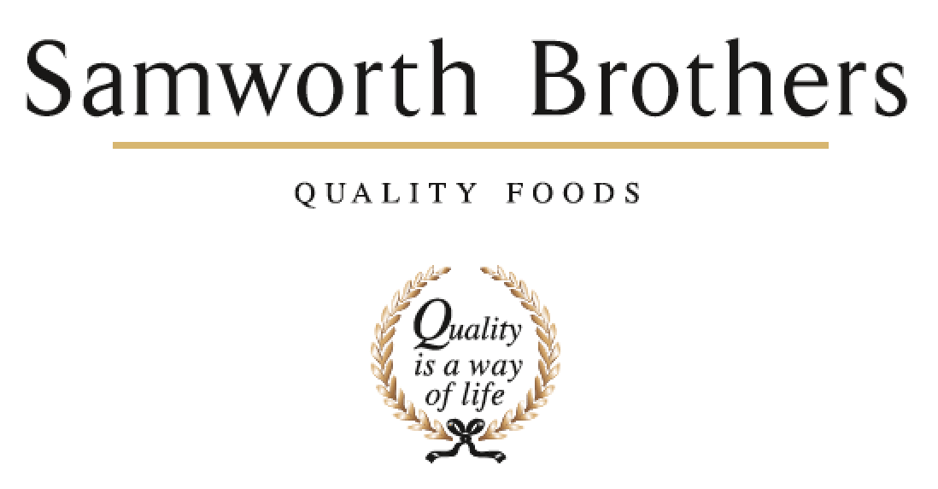

ROLE PROFILE
Job title | QA Technician | Date | 05/05/2020
Business | Samworth Brothers
Department | Technical
Location | Manton Wood
ROLE SUMMARY
The role is based in a fast paced chilled food environment, which requires the use of initiative and “thinking on your feet”. A QA Technician is expected to be key role in ensuring that the internal quality systems and customer code of practice are maintain and adhered to. The QA Technician is also expected to provide support and guidance to the Man Tech, as well as identifying and improving on current manufacturing practices.

REPORTING STRUCTURE
Reports to | QA Lead
Direct & indirect reports | NA
Key internal stakeholders | QA Team, Raw Materials Team, Department Heads
Key external stakeholders | Suppliers, laboratories

KEY ACCOUNTABILITIES AND RESPONSIBILITIES
This is not an exhaustive list and the role will require you to accept additional responsibilities.

- Ensure micro sampling plans are maintained; collected / tested and any adverse results are investigated and closed out.
- Ensure product quality is monitored, trends Identified and actions plans generated and agreed with relevant departments to address the issues.
- Audits are conducted to schedule ( internal audit / Customer Codes of Practice, HACCP / CCP, GMP, FB , Hygiene Fabrication, Glass, plastic etc).
- Traceability exercises to schedule which include forward & backwards traceability, mass balance provenance and packaging).
- Coordination of taste panels
- Calibration schedule is maintained.
- Ensure that product launches are prepared for and have a smooth transition from process to production.
- Support and mentor the Man Techs
- You must demonstrate quality systems and COPs compliance.
- Provide a key subject matter resource for factory level factory Good Manufacturing Practice, HACCP and Quality.
- Be proactive in problem solving, being part of the manufacturing team identifying easier / better ways of manufacturing, mentoring and supporting Line Managers/Man Techs.
- Actively aim to reduce number of customer complaints, customer visit non conformance, internal audit non conformance, quality fails and micro non-conformances.

QUALIFICATIONS, EXPERIENCE, TECHNICAL SKILLS / KNOWLEDGE
CORE COMPETENCIES, ATTRIBUTES & BEHAVIOURS FOR SUCCESS
Competency | Descriptors
Values People | Demonstrates the belief that people are our most important asset and central to the success of the organisation. Everybody should be treated with dignity and respect at all times.
Customer Focus | Demonstrates the understanding that the satisfaction of our internal and external customers is the foundation of our success
Collaborative Team Working | The willingness to act as part of a team and work towards achieving shared objectives through adopting best practice in line with PQP and Federalism.
Flexibility & Adaptability | The ability to change and adapt own behaviour or work procedures when there is a change in the work environment, for example as a result of changing customer needs.
Initiative & taking ownership | Steps up to take on personal responsibility and accountability for tasks and actions in line with PQP and Federalism.
People Management | The ability to understand people and their motivations, build good relationships with them and help them unlock their potential.
Empowering others | Creates an environment where people feel required and enabled to take ownership and responsibility.
Coaching for performance | The ability to help others achieve more through two-way feedback, clear direction and enabling.
Analysis & Planning | The ability to take a range of information, think things through logically and prioritise work to meet commitments aligned with organisational goals.
Drive for Excellence | Knows the most effective and efficient processes for getting things done, with a focus on continuous improvement.

