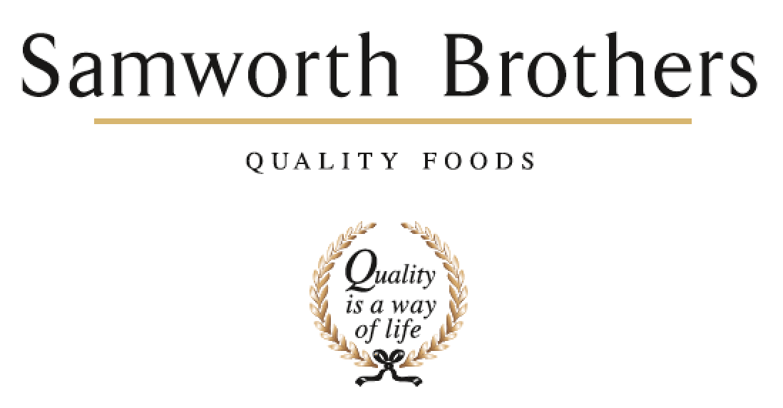

|  |  |  |  |
| --- | --- | --- | --- |
| ROLE PROFILE | | | |
| Job title | Development Chef | Date | 12.8.19 |
| Business | Samworth Brothers Meals | | |
| Department | Commercial | | |
| Location | Kettleby Foods | | |
| ROLE SUMMARY | | | |
| To manage and maintain the ongoing development of new and existing quality products, with the NPD Team, in a fast-paced environment, through idea generation and development of new products. To help generate & drive new business in existing and emerging categories through creative and innovative thinking. The role requires regular customer interaction as well as with internal colleagues, to ensure customer briefs are met with commercial and technical requirements.  Passion for food is essential with a drive to challenge and improve processes and product quality | | | |
| REPORTING STRUCTURE | | | |
| Reports to | NPD Manager | | |
| Direct & indirect reports | Kitchen Porters/Junior Chef | | |
| Key internal stakeholders | NPD Manager, Snr Development Technologist, Development Technologists, Senior Chef, Snr Development Chef, Junior Chef, Commercial & Category Teams, Costing Teams, Technical and Process  Ingredient Sourcing Specialist, Account Manager. | | |
| Key external stakeholders | Product Managers & Retail Chefs | | |
| KEY ACCOUNTABILITIES AND RESPONSIBILITIES | | | |
| * Responsibility for product innovation and development in line with customer brief, but also the ability to take a blue-sky approach to development opportunities. * Develop products from ideation to approval in line with customer brief and brand values and business strategy for growth. Ensuring commercially viable, creative and innovative products which enable the business to keep ahead of the competition. * Maintain awareness of market, consumer, restaurant trends, competitor activity and confidentiality of recipes always. * Liaise closely within the Commercial, Production, Technical/Process and other departments to ensure consistency and feasibility with the development of new products, and improvement of existing products. Ensure these are safe and takes account of the capability and capacity available within the production areas. * Undertake effective liaison with external, internal customers/contacts, to support product development activities whilst maintaining the necessary confidentiality requirements. * Manage direct report colleagues and own workload, in a motivational and organised way to ensure smooth running of the development kitchen and NPD worksteam. * Present clearly, accurately and persuasively to achieve the level of culinary excellence throughout the business. * Liaise with Ingredient sourcing and/or group procurement colleagues for raw materials, which add value to the product whilst maintaining the necessary margins. * Be responsible for communicating accurate recipes and methods, with QCCP for product launches and recipe changes. * Build and sustain knowledge of current products and processes for all Samworth Meals sites involved in development for the customer, challenge to improve where necessary. * Ensure all aspects of the development process are carried out within the given budget expectation, looking for cost savings/improvements wherever possible. * Organise and prepare food samples, to include ordering of materials, costings, practical application and dispatch of product, assisting the team with the other projects where necessary. * Work to set timescales and deadlines as outlined in the critical path. * Ensure excellent Hygiene and Safety standards are always maintained in the NPD kitchen. * Support the Development Technologists to ensure that all relevant product information is provided on time and in full for internal and external meetings/requests in line with the development process. * Provided hospitality / restaurant quality meals and service for senior visitors or meetings/events. | | | |
| QUALIFICATIONS, EXPERIENCE, TECHNICAL SKILLS / KNOWLEDGE | | | |
| * Minimum of 5 years experience as a chef, working within a quality restaurant/hotel environment, with at least 2 years manufacturing experience within a chilled food environment desirable * Be able to demonstrate natural flair and passion for food and knowledge of a variety of cuisines. * Be able to demonstrate practical cooking demonstrations to a high level. * Demonstrate a natural ability to be creative and innovative in terms of recipes, marketing ideas and packaging solutions. * Be able to present new products and improvements of existing products. * Computer literate with a working knowledge of Microsoft Excel, PowerPoint and Word. * Full Driving Licence required * Proactive team player, able to perform under pressure and within tight timeframes * Have a flexible approach to work and working hours, in order to meet the needs of the business. | | | |
| CORE COMPETENCIES, ATTRIBUTES & BEHAVIOURS FOR SUCCESS | | | |
| **Competency** | **Descriptors** | | |
| Values People | *Demonstrates the belief that people are our most important asset and central to the success of the organisation. Everybody should be treated with dignity and respect at all times.* | | |
| Customer Focus | *Demonstrates the understanding that the satisfaction of our internal and external customers is the foundation of our success* | | |
| Collaborative Team Working | *The willingness to act as part of a team and work towards achieving shared objectives through adopting best practice* | | |
| Flexibility & Adaptability | *The ability to change and adapt own behaviour or work procedures when there is a change in the work environment, for example as a result of changing customer needs.* | | |
| Initiative & taking ownership | *Steps up to take on personal responsibility and accountability for tasks and actions* | | |
| Drive for Excellence | *Knows the most effective and efficient processes for getting things done, with a focus on continuous improvement.* | | |
| Resource Management | *Effectively manages resources and cost drivers to achieve sustainable productivity and profitability.* | | |
| Technical Expertise | *Has the skills, knowledge and experience required to excel in own area of specialism and the willingness to further grow and develop.* | | |
| Self-Management | *Uses a combination of feedback and reflection to gain insight into personal strengths and weaknesses, so that own time, priorities and resources can be managed to achieve goals.* | | |