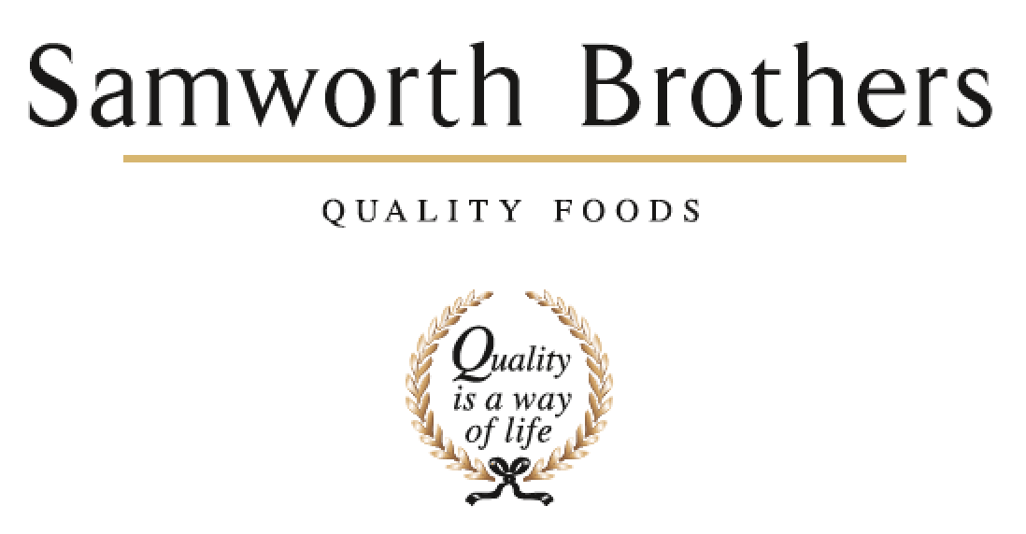

|  |  |  |  |
| --- | --- | --- | --- |
| ROLE PROFILE | | | |
| Job title | Customer Services Assistant | Date | August 2025 |
| Business | Food for Now | | |
| Department | Customer Services | | |
| Location | Radar Road | | |
| ROLE SUMMARY | | | |
| To act as the first line of support in the Customer Service Team at Food for Now.  Administration and call handling, helping to set up new accounts and resolve queries, linking in with Commercial colleagues to manage the customer base and fulfil operational support tasks. | | | |
| REPORTING STRUCTURE | | | |
| Reports to | Saleema Parkar | | |
| Deputy | None | | |
| Direct & indirect reports | None | | |
| Key internal stakeholders | All Commercial colleagues, some Operational colleagues | | |
| Key external stakeholders | All Food for Now (FFN) customers | | |
| KEY ACCOUNTABILITIES AND RESPONSIBILITIES | | | |
| * Call Handling – taking calls from customers, resolving queries and taking down clear and concise messages, including complaint handling & delivery enquiries * Manual order processing - including taking orders over the phone / email and manual entry onto our online portal, as required * Customer credit Process – * logging credit requests from customers / Commercial team * Validate with relevant parties to confirm claims * Raise support tickets for valid credits * Confirm details of credits to customer * New account queries, via email – logging onto relevant systems / spreadsheets for the Commercial Team * New account courtesy calls - follow up with new accounts assisting them in getting up and running | | | |
| QUALIFICATIONS, EXPERIENCE, TECHNICAL SKILLS / KNOWLEDGE | | | |
| |  |  | | --- | --- | | Qualifications | N/A | | Experience | Customer care and call handling | | Skills/ Knowledge | Working knowledge of using Microsoft applications | | | | |
| PERSONAL ATTRIBUTES & BEHAVIOURS | | | |
| Flexible working approach  Calm under pressure  Organised  Dedicated  Self-starter | | | |
|  | | | |
| CORE COMPETENCIES, ATTRIBUTES & BEHAVIOURS FOR SUCCESS | | | |
| **Competency** | **Descriptors** | | |
| Values People | Demonstrates the belief that people are our most important asset and central to the success of the organisation. Everybody should be treated with dignity and respect at all times. | | |
| Customer Focus | Demonstrates the understanding that the satisfaction of our internal and external customers is the foundation of our success | | |
| Collaborative Team Working | The willingness to act as part of a team and work towards achieving shared objectives through adopting best practice in line with PQP and Federalism. | | |
| Flexibility & Adaptability | The ability to change and adapt own behaviour or work procedures when there is a change in the work environment, for example as a result of changing customer needs. | | |
| Self-Management | Uses a combination of feedback and reflection to gain insight into personal strengths and weaknesses, so that own time, priorities and resources can be managed to achieve goals. | | |