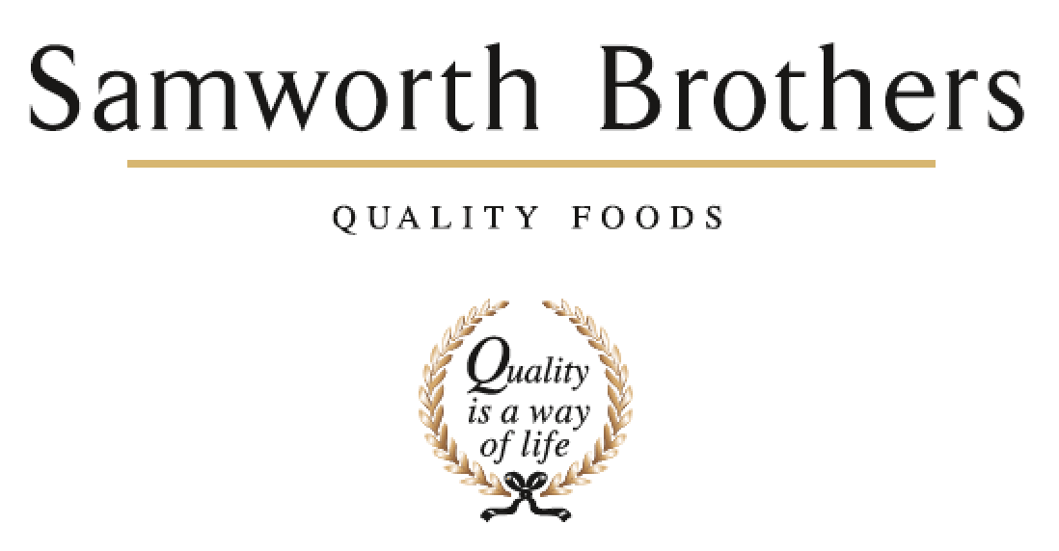

|  |  |  |  |
| --- | --- | --- | --- |
| ROLE PROFILE | | | |
| Job title | SHE Coordinator / Technician | Date | 23/03/2024 |
| Business | Samworth Brothers | | |
| Department | Health & Safety | | |
| Location | Manton Wood | | |
| ROLE SUMMARY | | | |
| * To provide support to the SHE Manager and the Manton Wood site in planning, measuring, implementing, auditing, and reviewing Health, Safety and Environmental activities to meet legal requirements and company standards * To provide advice and assistance on minimum standards of Health, Safety and Environmental Practices where needed to help everyone achieve their Health, Safety and Environmental responsibilities * To support the implementation of robust Health, Safety and Environmental management systems * To represent the Health, Safety and Environment department and operate within Tier Meeting systems (and monitor the effectiveness of SHE on site) * Keep up to day with new legislation, company and other safety information * Compile reports / statistics and brief the site teams accordingly * To ensure all departmental Health, Safety and Environmental plans are up-to-date, and actions are tracked, generated, and completed * Effective communications with internal site, internal group & external bodies including contractors, regulatory authorities, etc. | | | |
| REPORTING STRUCTURE | | | |
| Reports to | SHE Manager | | |
| Direct & indirect reports | NA | | |
| Key internal stakeholders | Department Heads | | |
| Key external stakeholders | Training Providers, Group H&S Function, Contractors | | |
| KEY ACCOUNTABILITIES AND RESPONSIBILITIES | | | |
| This is not an exhaustive list and the role will require you to accept additional responsibilities.   * Document & cascade site policies, procedures, assessments, etc. * Identification of risks, support of risk assessments, etc. * Complete the Health, Safety and Environment scheduled tasks as required * Support Health, Safety and Environment Training and SOP development * Logging and trending of accident & incident reports * Co-ordinating departmental auditing schedules * Auditing of site & contractor activity to ensure compliance with statutory requirements and company standards * Support implementation of site H&S policy * Significant support of the Nights H&S meeting * Distribute and action external & group information updates and hazards alerts as required * Group & internal KPI Accident, incident & fire Reporting * Support claims management, investigations & reporting * Ensure all departmental Health, Safety and Environmental plans are up-to-date, and actions are tracked, generated and completed * Cascade Emergency procedures * Ensure compliance with statutory duties * Co-ordinate the Champions in energy efficiency & environmental activities | | | |
| QUALIFICATIONS, EXPERIENCE, TECHNICAL SKILLS / KNOWLEDGE | | | |
| * Minimum NEBOSH National General Certificate*.* Potentially willing to train the right candidate if they display exceptional skills highlighted below. * Excellent working knowledge & experience of Health, Safety and Environment, preferably within Food or FMCG environment * Excellent knowledge of Microsoft office - Outlook, Excel, Word & PowerPoint   The ideal candidate will provide direction ensuring productive relationships and have the following traits:   * Action orientated with a ‘hands on’ approach, happy with spending significant time in the bakery * Excellent team engagement must be approachable, understanding, and supportive * Driven and strong willed * Strong interpersonal skills * Effective interpretation and translation of information * Flexible work (this role will be permanent nights, with some requirement to work days for meetings, training, etc). The first month of the role will be days until comfortable to work nights on their own   Working knowledge of the following would be desirable:   * ISO14001, environmental permitting, packaging regulations, and similar environmental legal and other requirements | | | |
| CORE COMPETENCIES, ATTRIBUTES & BEHAVIOURS FOR SUCCESS | | | |
| **Competency** | **Descriptors** | | |
| Values People | *Demonstrates the belief that people are our most important asset and central to the success of the organisation. Everybody should be treated with dignity and respect at all times.* | | |
| Customer Focus | *Demonstrates the understanding that the satisfaction of our internal and external customers is the foundation of our success* | | |
| Collaborative Team Working | *The willingness to act as part of a team and work towards achieving shared objectives through adopting best practice in line with PQP and Federalism.* | | |
| Flexibility & Adaptability | *The ability to change and adapt own behaviour or work procedures when there is a change in the work environment, for example as a result of changing customer needs.* | | |
| Initiative & taking ownership | *Steps up to take on personal responsibility and accountability for tasks and actions in line with PQP and Federalism.* | | |
| People Management | *The ability to understand people and their motivations, build good relationships with them and help them unlock their potential.* | | |
| Empowering others | *Creates an environment where people feel required and enabled to take ownership and responsibility.* | | |
| Coaching for performance | *The ability to help others achieve more through two-way feedback, clear direction and enabling.* | | |
| Analysis & Planning | *The ability to take a range of information, think things through logically and prioritise work to meet commitments aligned with organisational goals.* | | |
| Drive for Excellence | *Knows the most effective and efficient processes for getting things done, with a focus on continuous improvement.* | | |