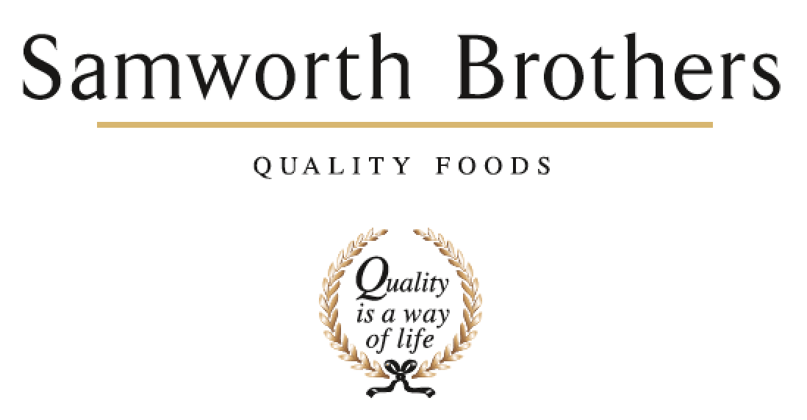

|  |  |  |  |
| --- | --- | --- | --- |
| ROLE PROFILE | | | |
| Job title | Assistant Technical Manager | Date | Mar 2022 |
| Business | Bradgate Bakery | | |
| Department | Technical | | |
| Location | Bradgate Bakery – Madeline Road | | |
| ROLE SUMMARY | | | |
| To ensure that all aspects of food safety, quality and legality for the products manufactured are complied with ensuring that the technical integrity of the site is maintained. | | | |
| REPORTING STRUCTURE | | | |
| Reports to | Technical Manager | | |
| Direct & indirect reports | 4 (Approx 25) | | |
| Key internal stakeholders | Ops Mgr, Hygiene Mgr, People Dept | | |
| Key external stakeholders | Customers / Samworth Group Technical Teams | | |
| KEY ACCOUNTABILITIES AND RESPONSIBILITIES | | | |
| * Responsibility for managing the MR QA team department as a whole and managing and developing the team as individuals as well as a Tech Services Team working on specifications. * Responsibility for liaising and communicating with customers / external bodies on all aspect of technical issues for the site * Ensuring that the Quality Management system is in place, maintained, reviewed and continually approved * Ensuring that the HACCP system for the site is maintained, updated and regularly reviewed to ensure the due diligence of the site is maintained. * Ensuring that the Internal Audit system for the site is maintained effectively * Ensuring that all systems, procedures, practices, testing regimes and audits are effective to ensure that the due diligence of the site is maintained * To ensure that the site maintains BRC accreditation (any related modules) and maintains successful EHO /TSO / customer / external audits and visits . * To ensure that all new products to be introduced into the business are technically sound in relation to all food safety, quality and legality aspects * To ensure that all customer product specifications and artwork comply with all legal / food safety / quality requirements * To oversee the supplier approval system for raw materials and packaging suppliers potentially entering the business and to ensure all are risk assessed and approved prior to purchasing approval * Ensuring that high standards of technical KPIs are established - achieved through monitoring and trending microbiological performance, customer complaints and quality standards to ensure that the site is being proactive and continually striving to improve * To work alongside and advise the hygiene teams to ensure that all technical aspects of hygiene within the site are satisfactorily maintained and that environmental microbiological performance is monitored, reviewed and improved where necessary * To advise the company on all current legislation relating to the safety and legality of food manufacture and give advice and impart knowledge on all relevant technical issues to the operational teams. * Responsible for assessing new opportunities to drive the business forward / review potential new product areas * Responsible for advising on new developments for the site / new equipment / new process flows – to ensure security of technical integrity is maintained * Responsible for health and safety of the department * Responsible for budgetary control of the department * Deputise for the Technical Manager | | | |
| QUALIFICATIONS, EXPERIENCE, TECHNICAL SKILLS / KNOWLEDGE | | | |
| * Significant experience in quality/technical management roles in fast paced, chilled, food manufacturing environments. * Technical knowledge and expertise within chilled food. * A good technical knowledge of supermarkets food safety requirements plus a working knowledge of their IT systems. * Experience of Tesco (TFMS audits) and BRC * HACCP Level 4 * Food Safety Level 4 * Proven skills in developing and leading teams * Proven skills in coaching and mentoring * Excellent verbal and written communication skills * Strong influencing skills * The ability to deliver a compelling vision for technical quality at all levels both internally and externally * Excellent knowledge of MS Office – Word / Excel / PowerPoint. * Strong communication and interpersonal skills including both written and verbal communication * Flexible approach | | | |
| CORE COMPETENCIES, ATTRIBUTES & BEHAVIOURS FOR SUCCESS | | | |
| **Competency** | **Descriptors** | | |
| Values People | *Demonstrates the belief that people are our most important asset and central to the success of the organisation. Everybody should be treated with dignity and respect at all times.* | | |
| Customer Focus | *Demonstrates the understanding that the satisfaction of our internal and external customers is the foundation of our success* | | |
| Collaborative Team Working | *The willingness to act as part of a team and work towards achieving shared objectives through adopting best practice in line with PQP and Federalism.* | | |
| Flexibility & Adaptability | *The ability to change and adapt own behaviour or work procedures when there is a change in the work environment, for example as a result of changing customer needs.* | | |
| Initiative & taking ownership | *Steps up to take on personal responsibility and accountability for tasks and actions in line with PQP and Federalism.* | | |
| People Management | *The ability to understand people and their motivations, build good relationships with them and help them unlock their potential.* | | |
| Empowering others | *Creates an environment where people feel required and enabled to take ownership and responsibility.* | | |
| Coaching for performance | *The ability to help others achieve more through two-way feedback, clear direction and enabling.* | | |
| Analysis & Planning | *The ability to take a range of information, think things through logically and prioritise work to meet commitments aligned with organisational goals.* | | |
| Drive for Excellence | *Knows the most effective and efficient processes for getting things done, with a focus on continuous improvement.* | | |