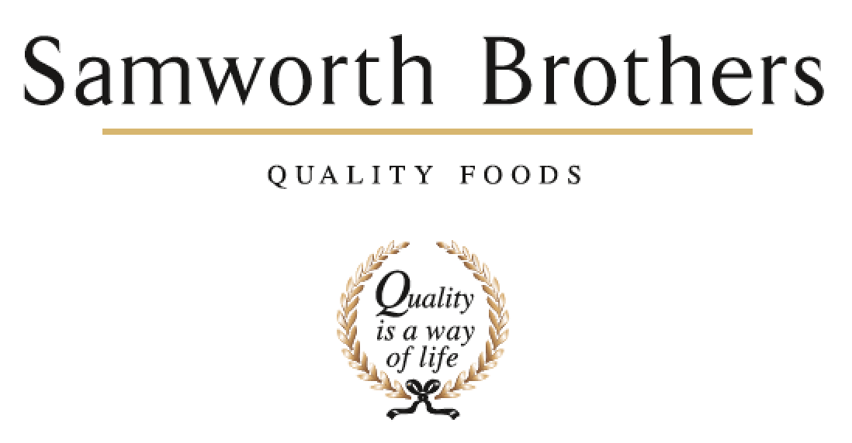

ROLE PROFILE
Job title | Technical Account Manager - FFFN | Date | May 2024
Business | Food to Go
Department | Technical
Location | Fresh Food For Now (FFFN) (Leicester)
ROLE SUMMARY
- To understand all FFFN branded products (e.g. Urban Eat, Leaf & Loaf, West Cornwall Pasty Company) within Samworth Brothers, supporting the operations, technical and commercial teams to deliver all stakeholders expectations.
- Support the delivery of FFFN Products through the Concept to Launch process, review launched products and ensure products meet the required internal and external expectations.
- To drive the quality agenda on FFFN, products and packaging, ensuring that all stakeholders are communicated with, regarding action plans etc. this will involve completing visiting internal and external manufacturing sites, store visits and benchmarking panels.
- This role will be the day-to-day product and quality contact between Samworth Brothers and the external manufacturing sites producing our branded products, delivering updates on action plans, improvement plans and potential issues.
- To work in conjunction with all relevant departments to provide guidance and coaching to ensure compliance against the Samworth Brand standards.
- Supporting the commercial teams with necessary technical and product information to support customer presentations, tenders and adhoc requests.
- To internally report on monthly KPI data for all FFFN brands; tracking trends, complaint levels and then working with the supplier to deliver actions and improvements.
REPORTING STRUCTURE
Reports to | Head of Technical & Responsible Business
Direct & indirect reports | Direct /Indirect - None
Key internal stakeholders | Commercial Mgrs (FFFN team), FFFN Operations Teams, FFFN & FTG Technical Team, NPD Team
Key external stakeholders | 3rd Party manufacturers

KEY ACCOUNTABILITIES AND RESPONSIBILITIES
- To investigate FFFN quality non-conformances (product and raw material) and ensure that the necessary corrective actions are taken. To agree actions to be taken for non-conforming product or components.
- To ensure that branded standards (raw material sourcing, microbiological & quality standards) are monitored and maintained at any internal and external manufacturing sites during the development process.
- To ensure that there is effective communication with external customers (e.g. WHSmith) on any quality / concept to launch issues as necessary.
- To ensure all products are developed to meet Samworth Brothers Brand Standards, and ensure all artwork and specifications are accurate to meet all stakeholders’ requirements.
- To be an integral member of the FFFN management team, working closely with the Technical Manager - FFFN as well as other functions, including, commercial and operations across FTG.
- To participate in taste panels, both at Samworth Brothers / External Manufacturers and at customers premises. To ensure that the panels are conducted at the agreed frequency and that corrective actions / follow up activities are carried out on a timely basis.
- To participate in customer (e.g WHSmith) site quality / product development visits inc. factory tours and to ensure that visit reports are written up and closed off on a timely basis.
- Ensure all Branded Product information systems / data sets are up to date to ensure accuracy for internal and external communications.

QUALIFICATIONS, EXPERIENCE, TECHNICAL SKILLS / KNOWLEDGE
- Degree or equivalent qualification in a science based subject is preferable.
- Experience of the product development cycle from concept to launch.
- RIPH Level 2 or equivalent Intermediate Certificate in Applied Haccp Principles desirable
- Formal Internal Audit Training is also desirable
- Experienced in a technical / QA role within food manufacturing (chilled preferable but not essential)
- Organisational / prioritisation skills & ability to respond rapidly to changes in priorities
- Effective communication skills with external stakeholders
- Ability to ensure attention to detail even when under pressure
- Excellent team working skills
- Problem solving & decision-making skills
- Ability to use word, excel, powerpoint.
- Must be competent in written English and basic Maths
- Ability to negotiate, influence & recognise others view points
- Ability to develop effective relationships with other areas across multiple sites
- Ability to work unsupervised & on own initiative with a varied workload
- Full driving Licence required

CORE COMPETENCIES, ATTRIBUTES & BEHAVIOURS FOR SUCCESS
Competency | Descriptors
Values People | Demonstrates the belief that people are our most important asset and central to the success of the organisation. Everybody should be treated with dignity and respect at all times.
Customer Focus | Demonstrates the understanding that the satisfaction of our internal and external customers is the foundation of our success
Collaborative Team Working | The willingness to act as part of a team and work towards achieving shared objectives through adopting best practice in line with PQP and Federalism.
Flexibility & Adaptability | The ability to change and adapt own behaviour or work procedures when there is a change in the work environment, for example as a result of changing customer needs.
Initiative & taking ownership | Steps up to take on personal responsibility and accountability for tasks and actions in line with PQP and Federalism.
Drive for Excellence | Knows the most effective and efficient processes for getting things done, with a focus on continuous improvement.
Resource Management | Effectively manages resources and cost drivers to achieve sustainable productivity and profitability.
Technical Expertise | Has the skills, knowledge and experience required to excel in own area of specialism and the willingness to further grow and develop.
Self-Management | Uses a combination of feedback and reflection to gain insight into personal strengths and weaknesses, so that own time, priorities and resources can be managed to achieve goals.

