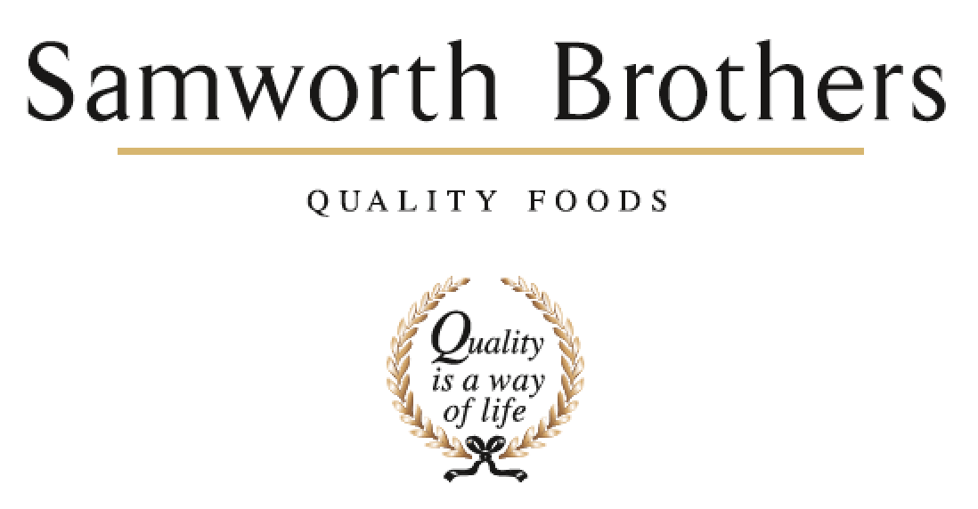

|  |  |  |  |
| --- | --- | --- | --- |
| ROLE PROFILE | | | |
| Job title | Compliance Manager | Date | 25/08/25 |
| Business | Samworth Brothers | | |
| Department | Technical | | |
| Location | Bradgate Bakery | | |
| ROLE SUMMARY | | | |
| The Compliance Manager is responsible for ensuring that all products, processes, and systems meet regulatory, customer, and business requirements in relation to food safety, legality, quality, and integrity. This role will lead the management and development of the Quality Management System (QMS), provide compliance oversight across site, and drive continuous improvement in line with customer and industry standards.  The role is based in a fast-paced chilled food environment, which requires the use of initiative and “thinking on your feet”.  This role will report to the Technical Manager. | | | |
| REPORTING STRUCTURE | | | |
| Reports to | Technical Manager | | |
| Direct & indirect reports | Senior Specification Technologist and Specification Technologists, Senior Systems Analyst, System Analyst, Compliance Technologist | | |
| Key internal stakeholders | QA Team, Raw Materials Team, Department Heads, Group Technical | | |
| Key external stakeholders | Suppliers, Laboratories, Customers, 3rd Party Auditors, Regulatory Bodies | | |
| KEY ACCOUNTABILITIES AND RESPONSIBILITIES | | | |
| * Manage and develop the QMS (including HACCP, TACCP, VACCP, Quality Manual, document control process) ensuring documentation is up to date, relevant, controlled, and compliant with legislation, industry standards, Samworth Brothers requirements, and customer codes of practice. * Maintain and review compliance with customer, business, and industry codes of practice, presenting action plans to Technical and Operational teams to drive continuous improvement. * Ensure robust due diligence within the QMS to support site readiness for customer and third-party audits, including gap analyses against site systems. * Act as the primary point of contact for regulatory bodies, auditors, and external stakeholders. * Manage the internal audit process, ensuring audits are completed to schedule by competent auditors in line with customer and audit body requirements. Identify non-conformances and work with relevant teams to ensure timely corrective actions. * Ensure non-conformances are investigated and closed out in a timely manner. * Manage all external audit schedules and payments; support the Technical Manager during third-party and customer audits. * Chair the Food Defence Team (with the Raw Material Manager) to ensure documented TACCP/VACCP plans are maintained and compliant with customer and third-party audit standards. * Manage the Technical Systems and Specification teams, ensuring that the Customer complaints, KPI boards, customer databases, and artwork are completed accurately and on time. Compliance-related documentation, policies, and procedures are accurate, controlled, and up to date. * Manage the Customer Specification Team, ensuring artwork is completed accurately and on time. * Manage the Technical Systems Team, overseeing internal audit programmes, customer complaints, KPI boards, and customer databases. * Lead site procedures improvement, including future development of paperless systems. * Provide training and guidance to staff on compliance, food safety, and legal requirements. * Develop and coach the Technical Compliance Team, working collaboratively with QAMs, Group Technical and other technical leads to strengthen controls and standards across the bakery. * Collate and communicate information on food industry issues, incidents, and emerging risks to the Technical Manager and key business stakeholders. Work closely with FTG Compliance and Raw Material teams to align strategies and compliance practices. * Prepare reports for senior management on compliance performance, audit outcomes, KPI data, and regulatory updates. * Positively communicate technical issues and updates using appropriate channels to ensure clarity and engagement across site. * Engage with the raw materials team to identify opportunities for responsible business and sustainability initiatives at site. * Support the Site Incident Management Team when required. * Operate flexibly, adapting to changing priorities and scenarios to deliver compliance objectives. * Operate in a safe working manner, supporting continuous improvement in health, safety, and environmental performance across site. | | | |
| QUALIFICATIONS, EXPERIENCE, TECHNICAL SKILLS / KNOWLEDGE | | | |
| * Degree in Food science or equivalent experience within the food industry * Strong knowledge of food safety legislation, BRCGS, and customer codes of practice (Tesco, Asda, Morrisons, Waitrose etc). * Proven experience in a compliance, technical, or quality management role within the food industry. Experienced in managing QMS, audits (internal and external), and compliance processes within the food industry. * HACCP Level 4, Food Safety and Food Legislation training (desirable). * Excellent attention to detail, analytical thinking, and risk assessment skills * Experience within chilled ready to eat multi component food manufacturing * Strong organisational, communication, and leadership skills. Strong communication skills with the ability to influence and engage at all levels. * Experience in developing teams, driving compliance improvements, and influencing cross-functional stakeholders. * Excellent knowledge of MS Office – Word / Excel / Powerpoint / Power BI * Experience in managing audits, certification schemes, and regulatory inspections. | | | |
| CORE COMPETENCIES, ATTRIBUTES & BEHAVIOURS FOR SUCCESS | | | |
| **Competency** | **Descriptors** | | |
| Values People | *Demonstrates the belief that people are our most important asset and central to the success of the organisation. Everybody should be treated with dignity and respect at all times.* | | |
| Customer Focus | *Demonstrates the understanding that the satisfaction of our internal and external customers is the foundation of our success* | | |
| Collaborative Team Working | *The willingness to act as part of a team and work towards achieving shared objectives through adopting best practice in line with PQP and Federalism.* | | |
| Flexibility & Adaptability | *The ability to change and adapt own behaviour or work procedures when there is a change in the work environment, for example as a result of changing customer needs.* | | |
| Initiative & taking ownership | *Steps up to take on personal responsibility and accountability for tasks and actions in line with PQP and Federalism.* | | |
| People Management | *The ability to understand people and their motivations, build good relationships with them and help them unlock their potential.* | | |
| Empowering others | *Creates an environment where people feel required and enabled to take ownership and responsibility.* | | |
| Coaching for performance | *The ability to help others achieve more through two-way feedback, clear direction and enabling.* | | |
| Analysis & Planning | *The ability to take a range of information, think things through logically and prioritise work to meet commitments aligned with organisational goals.* | | |
| Drive for Excellence | *Knows the most effective and efficient processes for getting things done, with a focus on continuous improvement.* | | |