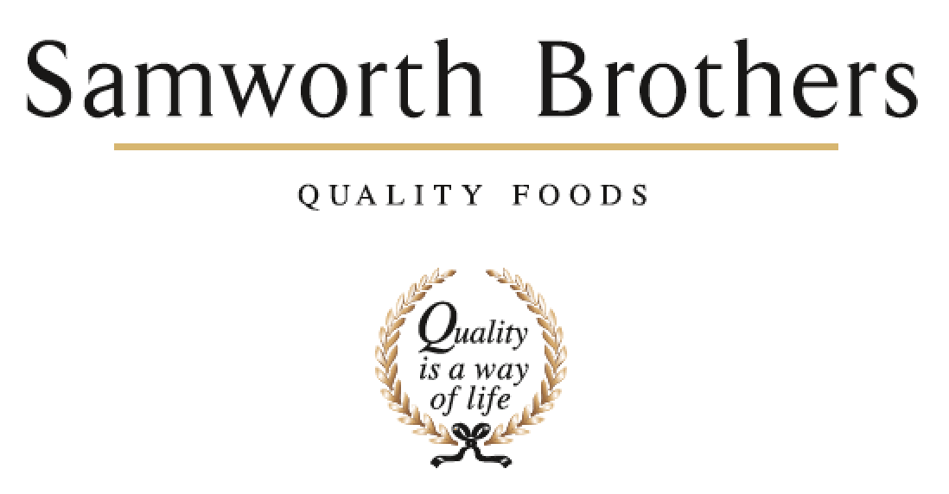

|  |  |  |  |
| --- | --- | --- | --- |
| ROLE PROFILE | | | |
| Job title | Commercial Counsel | Date | 11/07/2024 |
| Business |  | | |
| Department |  | | |
| Location | Hybrid based at Oak Meadow, Leicester | | |
| ROLE SUMMARY | | | |
| Working closely with the General Counsel, the successful candidate is expected to coordinate and help ensure the Legal function delivers ‘best in class’ service to the Group, with specific responsibility for day-to-day legal matters across the various functions within the Group and with particular emphasis on commercial law, contract drafting/negotiation and contract management, thereby ensuring that the Group remains legally compliant and that commercial and regulatory risk is mitigated effectively.  Subject to hybrid working, this post is based at Oak Meadow in Leicester (3-4 days per week).  Some meetings will require travel within the UK (primarily Leicestershire).   The role will report to the Group General Counsel and will also work closely with other team members. | | | |
| REPORTING STRUCTURE | | | |
| Reports to | Sunita Kaushal, Group General Counsel & Company Secretary | | |
| Direct & indirect reports | None | | |
| Key internal stakeholders | GEB, GHB | | |
| Key external stakeholders |  | | |
| SKILLS & ABILITIES | | | |
| * Develop and maintain close working relationships across the business and take time to understand Samworth Brothers strategy and commercial goals * Provide general and commercial legal support to businesses in the Group, including advice on tender proposals; contract drafting, review and negotiation; dealing with ad-hoc customer/supplier complaints; data protection matters; supporting with intellectual property and IT matters; and providing first level support in relation to dispute resolution. * General commercial legal advice. * Providing advice on existing and proposed commercial arrangements * Drafting commercial contracts and other commercial documents. * Manage external advisors on discreet matters * Support with the monitoring and communication of legal updates/training across the Group and advocate best practice * Proactively drive continuous improvement in the wider legal team including the use of technology and other solutions to drive process improvements and manage risk. * Commercial dispute resolution where necessary (pre-litigation). * Ability to help raise the profile and influence of the legal function across the group. | | | |
| KNOWLEDGE & UNDERSTANDING | | | |
| * Inquisitive, with a thirst to learn and proactive approach to personal development * Adaptable to working in a small team * Practical and commercial approach to problem solving * Possesses strong analytical skills * Excellent oral and written communications skills including:   + The ability to engage and build rapport with stakeholders   + Communicating information in a clear and commercial manner   + Adapting style and content for different audiences * Excellent business acumen and strong commercial and financial awareness * Able to work at pace whilst maintaining an accurate, high quality output * Highly organised with a well-developed approach to prioritisation * Possesses a positive and collegiate attitude * Able to adapt swiftly with a willingness to undertake challenging tasks to ensure stakeholder satisfaction | | | |
| QUALIFICATIONS, EXPERIENCE, TECHNICAL SKILLS / KNOWLEDGE | | | |
| * UK qualified solicitor with between 6 to 8 year’s post qualification experience; * Experience in a non-contentious commercial role. In-house exposure would be an advantage. This is a demanding role and will require somebody with substantial in-house experience to help navigate challenges. | | | |
| CORE COMPETENCIES, ATTRIBUTES & BEHAVIOURS FOR SUCCESS | | | |
| **Competency** | **Descriptors** | | |
| Values People | *Demonstrates the belief that people are our most important asset and central to the success of the organisation. Everybody should be treated with dignity and respect at all times.* | | |
| Customer Focus | *Is passionate about quality, striving to continuously make a positive difference for our customers and our consumers.* | | |
| Collaborative Team Working | *The willingness to act as part of a team and work towards achieving shared objectives through adopting best practice in line with our Purpose Statement and Company Values.* | | |
| Flexibility & Adaptability | *The ability to change and adapt own behaviour or work procedures when there is a change in the work environment, for example as a result of changing customer needs.* | | |
| Initiative & Taking ownership | *Steps up to take on personal responsibility and accountability for tasks and actions in line with our Purpose Statement and Company Values.* | | |
| People Management | *The ability to understand people and their motivations, build good relationships with them and help them unlock their full potential.* | | |
| Decision Making & Judgement | *In line with our Purpose statement and Company Values, makes timely and informed decisions that keep the organisation moving forward, taking into account the facts, goals, constraints, and risks.* | | |
| Commercial Awareness | *Demonstrates an understanding of the impact decisions and actions have on the organisation in line with our Purpose statement and Company Values.* | | |
| Developing Partnerships | *The ability to establish formal and informal relationships inside and outside the organisation, and to anticipate and balance the needs of those whose cooperation is needed for the long-term success of the business.* | | |
| Engaging Others through Change | *The ability to communicate a compelling vision, generating genuine motivation and commitment and to act as a sponsor of change.* | | |
| Focussing on the Future | *Demonstrates enthusiasm about our future by identifying strategic issues, opportunities to drive sustainable, profitable growth, and managing risk. Clearly communicates links between team and organisational goals.* | | |