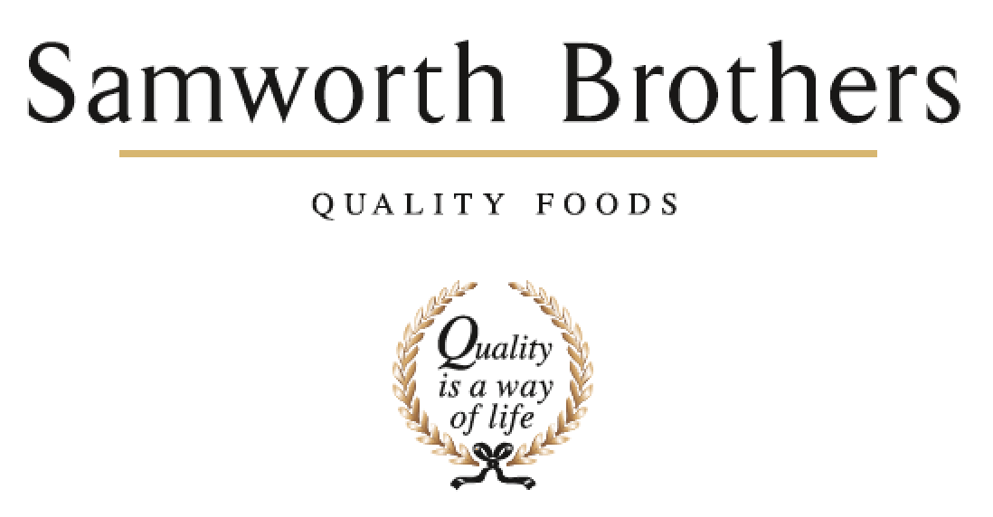

|  |  |  |  |
| --- | --- | --- | --- |
| ROLE PROFILE | | | |
| Job title | Process Manager | Date | August 2025 |
| Business | The Cornwall Bakery | | |
| Department | Technical | | |
| Location | Callington | | |
| ROLE SUMMARY | | | |
| Responsibility for ensuring products are trialled successfully and in a timely manner for launch along with all the relevant documentation being in place in correlation with the set critical path.  Responsible for the progression and completion of the Recipe Professor Project workflow.  Liaise with external customers, operations/supply chain/NPD & commercial to ensure the critical path is achieved in relation to any process or packaging tasks.  Maintain close and effective cross-functional links between Process, Development, Technical, Operations and Continuous Improvement.  Management of Senior Process Techs, Process Techs and Packaging Techs | | | |
| REPORTING STRUCTURE | | | |
| Reports to | TCB Technical Manager | | |
| Direct & indirect reports | Senior Process Techs, Process Technologists, Packaging Technologists | | |
| Key internal stakeholders | Operations team, Technical Team, NPD Team, Commercial | | |
| Key external stakeholders | Customers | | |
| KEY ACCOUNTABILITIES AND RESPONSIBILITIES | | | |
| Effective planning and management of the process team as a key business resource and function. Leadership of effective trials.  Attend feasibility meetings and feedback or escalate any builds/observations in a timely manner.  Management of the Packaging Technologists ensuring adequate technical specifications exist for all packaging. Associated databases are up to date at all times and any additional supplier controls are monitored.  Management of the maintenance of required trial records. This will include all information required for recipes, specifications and costings. Ensure a ’Product File’ is completed for each product and that data is provided for the final product specification within relevant time scales including technical requirements and in accordance with the customer and site critical path.  Ensure Recipe Professor Workflow projects are completed in line with critical path.  Manage the interaction with the finance department in providing information to achieve accurate product costings, communicating any NPD or EPD recipe changes.  Interface with relevant internal departments and customer technologists to ensure products are presented and meet quality standards demanded and agreed.  Plan and manage effective and professional customer pre-production visits and launches with clear plans, agendas, objectives and actions recorded.  Ensure achievable and detailed QAS / Quality contract sheets are created by team to fit customer and bakery requirements.  To be proactive in dealing with any production issues following recently launched products in conjunction with other departments.  Ensure customer deadlines for trials and samples are met and that customers are sent samples of trials for assessment – Includes packaging trials and transit trial management.  Liaise closely with the technical teams, purchasing teams and finance teams to achieve technical compliance for all products, ensure raw materials and ingredients are ordered on time, technical validation of micro and shelf life.  Maintain the appropriate systems for new product and new process trials  Build a strong relationship with the manufacturing teams, NPD teams and customers to ensure ownership and pride in the launch of new products from the first trial. | | | |
| QUALIFICATIONS, EXPERIENCE, TECHNICAL SKILLS / KNOWLEDGE | | | |
| * Degree/HND or equivalent in a science subject. * Previous Technical experience of FMCG food related manufacturing operations. (Essential) * Proven track record of managing a team and diverse technical and process activities. * Ability to interact with high profile customers * Previous experience of retail stage and gate processes. * Knowledge of cook/cool validation processes. | | | |
| CORE COMPETENCIES, ATTRIBUTES & BEHAVIOURS FOR SUCCESS | | | |
| **Competency** | **Descriptors** | | |
| Values People | *Demonstrates the belief that people are our most important asset and central to the success of the organisation. Everybody should be treated with dignity and respect at all times.* | | |
| Customer Focus | *Demonstrates the understanding that the satisfaction of our internal and external customers is the foundation of our success* | | |
| Collaborative Team Working | *The willingness to act as part of a team and work towards achieving shared objectives through adopting best practice in line with PQP and Federalism.* | | |
| Flexibility & Adaptability | *The ability to change and adapt own behaviour or work procedures when there is a change in the work environment, for example as a result of changing customer needs.* | | |
| Initiative & taking ownership | *Steps up to take on personal responsibility and accountability for tasks and actions in line with PQP and Federalism.* | | |
| People Management | *The ability to understand people and their motivations, build good relationships with them and help them unlock their potential.* | | |
| Empowering others | *Creates an environment where people feel required and enabled to take ownership and responsibility.* | | |
| Coaching for performance | *The ability to help others achieve more through two-way feedback, clear direction and enabling.* | | |
| Analysis & Planning | *The ability to take a range of information, think things through logically and prioritise work to meet commitments aligned with organisational goals.* | | |
| Drive for Excellence | *Knows the most effective and efficient processes for getting things done, with a focus on continuous improvement.* | | |