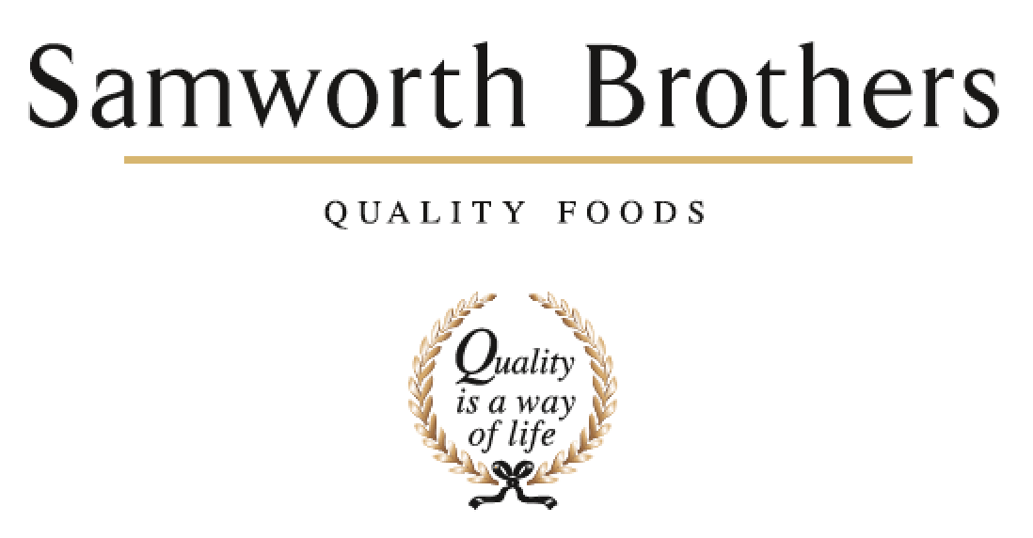

ROLE PROFILE
Job title | Quality Administrator | Date | Aug 23
Department | Technical
Location | Soreen
ROLE SUMMARY
Summarise in one or two sentences the highlights of the job in terms of its purpose and overall responsibility.
The role of Quality Administrator is to ensure all process related documentation is completed and compliant, to include: production records, internal audits, as examples, before being filed away. Compile reports and input data based on KPI measures. Respond and close out any customer complaints daily. Carry out other administration duties at the request of their line manager. Work closely with the production management team to discuss any potential errors which may have occurred on process paperwork.

REPORTING STRUCTURE
Reports to | Compliance Manager
Key internal stakeholders | Wider Operations Team (Technical, Production etc)

KEY ACCOUNTABILITIES AND RESPONSIBILITIES
- Management of customer complaint responses and letter writing
- Perform daily paperwork compliance checks and identify key failures to assist with root cause analysis
- Complete record keeping, filing & archiving and ensure document control. Assist the team with technical issue resolution and continuous development of food safety & quality
- Complete site internal audits (CCP, GMP, Glass and plastic, hygiene etc)
- Collect and coordinate samples for routine micro/analytical analysis
- Actively reinforce company good manufacturing practices and hygiene policies by advising colleagues on good practices when necessary and reporting non conformances to managers. Investigation of non conformances with actions
- Attend and contribute to technical team meetings for the development of food safety systems
- Maintain a collaborative working relationship with managers, operatives and other relevant departments to successfully drive quality and safety forward
- Support traceability exercises and support mock recalls

- The above list is not exhaustive, the post holder may be required to undertake duties as may be reasonably expected.
- All technical colleagues are required to be flexible and co-operative to meet business needs

QUALIFICATIONS, EXPERIENCE, TECHNICAL SKILLS / KNOWLEDGE
List the skills gained through education and experience required to effectively function in the position
Essential
- At least 1 years’ experience in similar role with a clear track record of achievement.
- IT proficient with good knowledge and understanding of Excel and word.
- A good communicator who can network at all levels
- A highly motivated, determined and enthusiastic individual with the ability to work on their own initiative and a ‘can do’ attitude.
- The ability and resilience to thrive in a pressurised environment, prioritising workload to ensure delivery of a professional technical leading service to the Site.
Desirable
- Awareness of HACCP
- Audit trained
ATTRIBUTES & BEHAVIOURS FOR SUCCESS
Behaviour | Descriptors
Focused on developing people | - Consistently demonstrates that people are the top business priority.  - Devotes a significant % of time to supporting and coaching their people.  - People related activities are consistently placed high on the “to do” list.  - Always make themselves available to support team members, regardless of how busy they are.
Builds strong relationships | - Demonstrates they are a good listener who can take on board other points of view.  - Demonstrates trust in other teams and other colleagues.  - Displays a high level of emotional intelligence to understand how to improve a relationship.  - Willing to be the “better person” for the sake of building or maintaining a relationship.  - Consciously aware of key relationships which require more work to improve.
Courage to make tough decisions | - Demonstrates they can make a positive decision when none of the alternatives are attractive.  - Is able to make quick decisions when needed even if the data is not complete.  - Is able to take the “hard / right” decision (which will upset some people) rather than always opting for the “easy / but wrong” decisions.  - Consistently demonstrates high standards and does not drop standards just because the implications are challenging.
Calmness during challenging times | - The more challenging the situation the calmer we want our people to be.  - Does not get over-emotional when things go wrong.  - Recognises that challenging times call for the best kind of leadership.  - Focuses on the issue…….not the person who made a mistake or who discovered a problem.
Leads by example | - We should “walk the walk” as well as “talk the talk”.  - Displays a consistent approach in how they deal with everyone in the business regardless of their level.  - Demonstrates an unshakeable positive attitude regardless of how challenging the circumstances.  - Appreciates the views of everyone in the business and welcomes new ideas and challenges.

