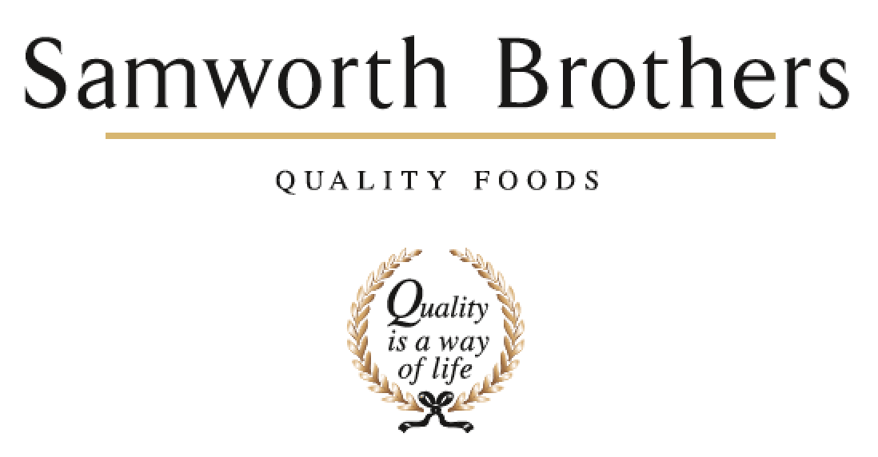

|  |  |  |  |
| --- | --- | --- | --- |
| ROLE PROFILE | | | |
| Job title | Senior Management Accountant | Date | June 2025 |
| Business | Shared Services | | |
| Department | General Ledger | | |
| Location | Callington, Cornwall | | |
| ROLE SUMMARY | | | |
| The Finance Shared Services team is responsible across all business categories for all aspects of transactional finance. This role sits within the Management Accounting team under General Ledger where the key focus is accurate and timely financial reporting. The right candidate will be accountable for journals, reconciliations and accounting support for the Samworth Brothers business alongside wider reporting requirements whilst also managing a small team. Ideally nearly or newly qualified ACCA/CIMA/ACA, this role would suit someone who has some management experience, has worked in finance for a medium to large organisation in the past and is willing to embrace and drive change. | | | |
| REPORTING STRUCTURE | | | |
| Reports to | Finance & Operations Manager | | |
| Direct & indirect reports | Management Accountants & Assistant Management Accountants | | |
| Key internal stakeholders | Shared Services Teams, Site Finance Business Partners, Group Finance, IT | | |
| Key external stakeholders | Auditors, Suppliers, Customers, Tax Advisors, HMRC | | |
| KEY ACCOUNTABILITIES AND RESPONSIBILITIES | | | |
| * Managing the Management Accounting team, including recruitment, objective setting, performance reviews, personal & professional development, etc * Ensuring compliance with the month-end timetable and managing Site relationships with regard to management accounting activities * Reviewing prepayments, accruals, payroll and other journals as required * Ensuring intercompany recharges are processed correctly and on a timely basis * Review of monthly balance sheets and P&Ls and, in some cases, full accounts for business review * Reviewing balance sheet reconciliations prepared by the Management Accounting team and supporting the review of wider balance sheet reconciliations as needed * Driving actions from GRNI review * Supporting Site teams with budget preparation and year-end reporting requirements * Preparation and review of KPI presentations for all SSC teams * Reviewing weekly payment runs and approval of manual payments as needed * Providing technical accounting support to the wider Shared Services team as required * Liaison with internal and external auditors * Driving and supporting continuous improvement initiatives and project work * Ad hoc management accounting related tasks | | | |
| QUALIFICATIONS, EXPERIENCE, TECHNICAL SKILLS / KNOWLEDGE | | | |
| * Nearly or newly qualified ACCA/CIMA/ACA * Previous experience of managing a small team * Previous experience of working in a finance team within a medium to large organisation * Strong Excel skills and good working knowledge of ERP systems with MS Dynamics AX/365 desirable | | | |
| CORE COMPETENCIES, ATTRIBUTES & BEHAVIOURS FOR SUCCESS | | | |
| **Competency** | **Descriptors** | | |
| Values People | *Demonstrates the belief that people are our most important asset and central to the success of the organisation. Everybody should be treated with dignity and respect at all times.* | | |
| Customer Focus | *Is passionate about quality, striving to continuously make a positive difference for our customers and our consumers.* | | |
| Collaborative Team Working | *The willingness to act as part of a team and work towards achieving shared objectives through adopting best practice in line with our purpose statement and Company values.* | | |
| Flexibility & Adaptability | *The ability to change and adapt your behaviour or work procedures when there is a change in the work environment, for example as a result of changing customer needs.* | | |
| Initiative & Taking Ownership | *Steps up to take personal responsibility and accountability for tasks in line with our purpose statement and our Company values.* | | |