 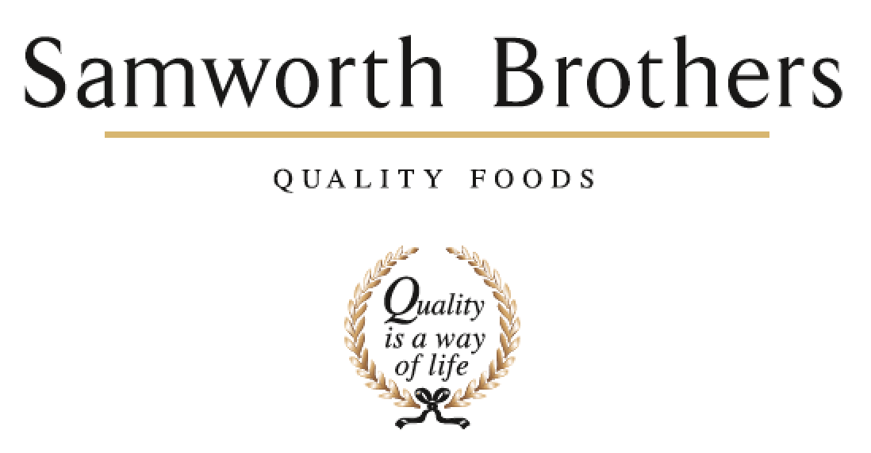

|  |  |  |  |
| --- | --- | --- | --- |
| **ROLE PROFILE** | | | |
| Job title | People Advisor | Date | March 2023 |
| Department | People | | |
| Location | Soreen | | |
| **ROLE SUMMARY**  Summarise in **one or two sentences** the highlights of the job in terms of its purpose and overall responsibility. | | | |
| To provide professional and efficient People support to line management on site in line with Group People Policies and Procedures. To provide sound and workable solutions to day to day employee relations and resourcing issues. To work flexibly and collaboratively with other colleagues in the People and site Management team, proactively identifying areas for service improvement within the function and other departments. | | | |
| **REPORTING STRUCTURE** | | | |
| Reports to | People Lead | | |
| Key internal stakeholders | All departments in Soreen, Samworth Brothers People team, HSE team & responsible business | | |
| Key external stakeholders | Agencies, Training Companies | | |
| KEY ACCOUNTABILITIES AND RESPONSIBILITIES | | | |
| * To co-ordinate the site recruitment activities – advertising, collating CVs, organising interviews, feedback. * To undertake and manage the HR administration of starters and leavers and contractual changes, including the preparation of contractual documentation, references, collating information for solicitors * To organise and co-ordinate the onboarding process for new starters, updating colleague records and filing * To be the first point of contact for all colleagues for all employee relations issues and provide advice and guidance in line with company policies and procedures, employment law and best practice. * Support managers on all employee relation meetings i.e. disciplinaries, absence reviews, grievances, capability * Partner with line managers to review employee relations, performance management, resourcing and staff management * To proactively manage short and long-term sickness absence to ensure that levels are kept to a minimum. * Assist in the running and management of the people survey * Liaise and monitor agencies used for temporary labour including audits * Where appropriate to coordinate training for employees by external providers * To be the key user of our People database * Producing weekly and monthly reports on a range of People KPIs. Analyse KPIs for any patterns and feedback back to business. * Management of occupational health service including audits * To assist with the internal communications on site – presentations for bakery TVs, Updates at the Huddle meetings, Comms app and noticeboards * To support and assist the People Lead on a range of HR projects and initiatives. * To manage the day to day running of the on site canteen services * Other adhoc duties as required. | | | |
| QUALIFICATIONS, EXPERIENCE, TECHNICAL SKILLS / KNOWLEDGE List the skills gained through education and experience required to effectively function in the position | | | |
| * Exceptional organisational and administrative skills * Experience in an HR environment (3 years +) * Advising and working with senior members of staff * IT programmes and HR systems (must be proficient user of Microsoft Excel, with familiarity with other business software relating to Microsoft Office) * Personable with strong communication and relationship building capabilities across all levels of the business; with a high level of confidentiality, and ability to demonstrate tact and diplomacy in the working environment * Driven and determined * Practical and logical; able to solve problems quickly * Qualified to CIPD Level 5 | | | |
| **ATTRIBUTES & BEHAVIOURS FOR SUCCESS** | | | |
| **Behaviour** | **Descriptors** | | |
| **Focused on developing people** | * Consistently demonstrates that people are the top business priority. * Devotes a significant % of time to supporting and coaching their people. * People related activities are consistently placed high on the “to do” list. * Always make themselves available to support team members, regardless of how busy they are. | | |
| **Builds strong relationships** | * Demonstrates they are a good listener who can take on board other points of view. * Demonstrates trust in other teams and other colleagues. * Displays a high level of emotional intelligence to understand how to improve a relationship. * Willing to be the “better person” for the sake of building or maintaining a relationship. * Consciously aware of key relationships which require more work to improve. | | |
| **Courage to make tough decisions** | * Demonstrates they can make a positive decision when none of the alternatives are attractive. * Is able to make quick decisions when needed even if the data is not complete. * Is able to take the “hard / right” decision (which will upset some people) rather than always opting for the “easy / but wrong” decisions. * Consistently demonstrates high standards and does not drop standards just because the implications are challenging. | | |
| **Calmness during challenging times** | * The more challenging the situation the calmer we want our people to be. * Does not get over-emotional when things go wrong. * Recognises that challenging times call for the best kind of leadership. * Focuses on the issue…….not the person who made a mistake or who discovered a problem. | | |
| **Leads by example** | * We should “walk the walk” as well as “talk the talk”. * Displays a consistent approach in how they deal with everyone in the business regardless of their level. * Demonstrates an unshakeable positive attitude regardless of how challenging the circumstances. * Appreciates the views of everyone in the business and welcomes new ideas and challenges. | | |