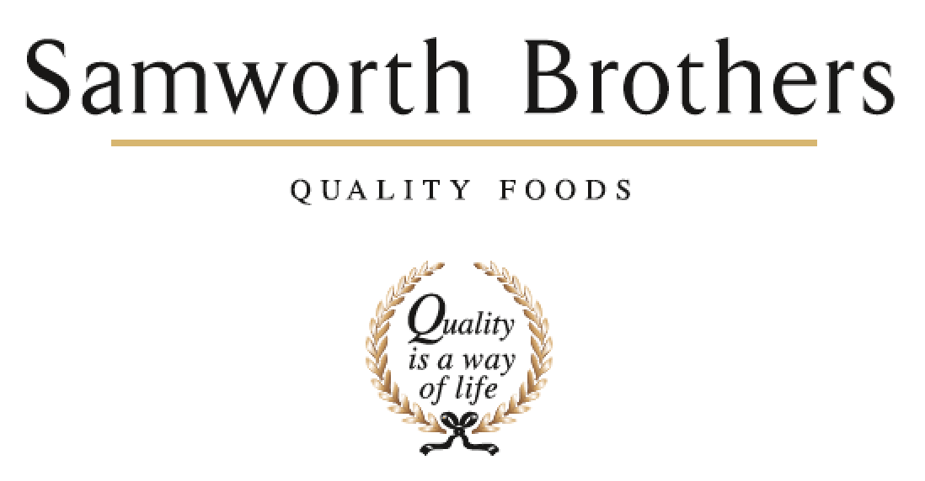

|  |  |  |  |
| --- | --- | --- | --- |
| ROLE PROFILE | | | |
| Job title | Events and Administration Coordinator | Date | June 2025 |
| Business | YOPPS | | |
| Department |  | | |
| Location | Melton Mowbray | | |
| ROLE SUMMARY | | | |
| The Corporate Hospitality Coordinator at the Craft Centre is responsible for leading and coordinating all internal events, ensuring a high-quality customer experience from planning through to execution. This role serves as the primary Front of House contact, providing a welcoming presence by meeting and greeting internal colleagues and external visitors. As the dedicated facilitator of all hosted events, the Coordinator ensures seamless delivery, professional service, and an environment that reflects the Craft Centre’s standards of excellence. | | | |
| REPORTING STRUCTURE | | | |
| Reports to | Operations Manager | | |
| Direct & indirect reports | N/A | | |
| Key internal stakeholders | Bakery Team / Finance / Innovation Kitchen / Shoppe Team | | |
| Key external stakeholders | Customers & Audits | | |
| KEY ACCOUNTABILITIES AND RESPONSIBILITIES | | | |
| 1. To be the owner and facilitator of all internal events at the Craft Centre to ensure seamless hosting and quality customer experience. 2. To be the Front of House contact for all events – to meet, greet internal colleagues or external visitors. 3. Own the calendars and ensure that events are planned well in advance, dealing with any booking conflicts, and preparing ahead of time. 4. Make any necessary arrangements to ensure the success of the event (refreshments, catering, equipment, room layout, parking, technology, health and safety, signage). 5. To also provide administrative support to Ye Olde Pork Pie Shoppe, the Production area and, Innovation Kitchen to facilitate the smooth running of the business. Administrative tasks along the lines of making bookings, printing, completing monthly expenses, KPI reporting as examples, Pie Demos, generating the YOPPS briefs and preparing information for the Samworth Standard. 6. General admin including wifi, parking information and other information of the centre ensuring smooth day to day with POC from arrival to departure / fire registers / site rules 7. Conduct post meeting event evaluations, and make room for improvements 8. General maintenance of the building (external and internal) 9. Support and attend external events to set up and serve the public representing Ye Olde Pork Pie Shoppe in delivering events outside of the Shoppe, be they in the town or local area. 10. Data input of Bakery information to include Make, Bake, Costs, Panels | | | |
| QUALIFICATIONS, EXPERIENCE, TECHNICAL SKILLS / KNOWLEDGE | | | |
| Key Skills   * Proven ability to organise multiple tasks and prioritise. * Confident, personable, and professional communicator. * Demonstrate high standards and attention to detail. * Responsive and able to move quickly in a dynamic environment. * Self-motivated with a can-do, pro-active attitude. * Can work well on own but also within a team. * Must have a full UK driving licence. * Must be able to work flexibly. * Good basic MS Office.   Qualifications   * Good level of English & maths (must be numerate) * Educated to GCSE / ‘A’ Level | | | |
| CORE COMPETENCIES, ATTRIBUTES & BEHAVIOURS FOR SUCCESS | | | |
| **Competency** | **Descriptors** | | |
| Values People | Demonstrates the belief that people are our most important asset and central to the success of the organisation. Everybody should be treated with dignity and respect at all times. | | |
| Customer Focus | Demonstrates the understanding that the satisfaction of our internal and external customers is the foundation of our success | | |
| Collaborative Team Working | The willingness to act as part of a team and work towards achieving shared objectives through adopting best practice in line with PQP and Federalism. | | |
| Flexibility & Adaptability | The ability to change and adapt own behaviour or work procedures when there is a change in the work environment, for example as a result of changing customer needs. | | |
| Initiative & taking ownership | Steps up to take on personal responsibility and accountability for tasks and actions in line with PQP and Federalism. | | |
| **Attributes & Behaviours** | Accept responsibility for work of self and others  Adopt a collaborative approach, wanting to work well with internal colleagues at all levels  Adopt a professional approach to work and maintain confidentiality  Adopt on-going commitment to quality, safety and hygiene standards, and never turns a blind eye  Adopt a flexible approach to business requirements  Willing to listen and consider the views of others  Demonstrates the ability to think ahead to prioritise tasks  Demonstrate you are tasks orientated and focused on objectives  Demonstrating you are willing and able to accept and adapt to change; including changing demands or objectives, willing to turn your hand to anything and never says, “That’s not my job”  Adopt an organised approach to work  Treat people as equals and generate a rapport build on trust and honesty | | |