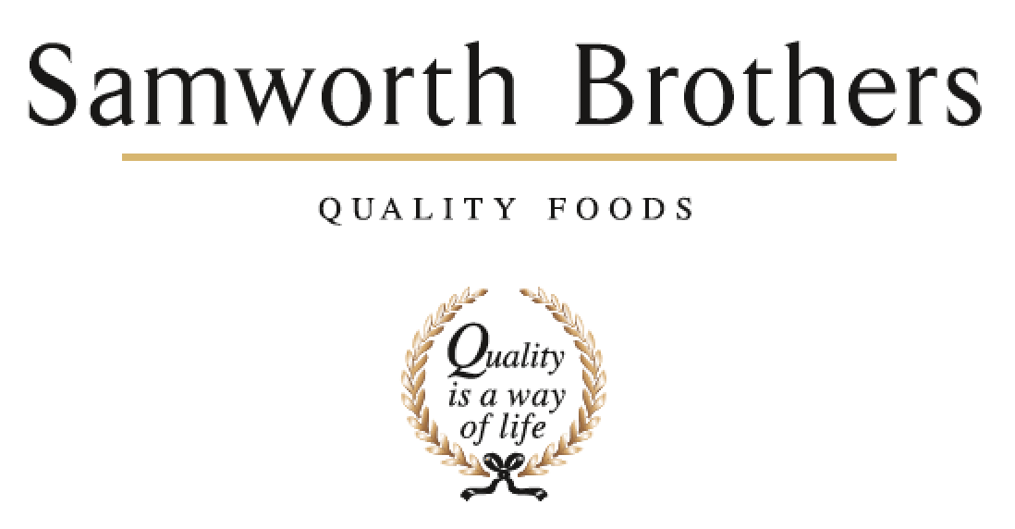

|  |  |  |  |
| --- | --- | --- | --- |
| ROLE PROFILE | | | |
| Job title | NPD Technologist | Date | 16/07/2024 |
| //Business | Walkers Deli and Sausage | | |
| Department | Commercial | | |
| Location | 78 - 88 Cobden Street Cobden Street Industrial Estate Leicester LE1 2LB | | |
| ROLE SUMMARY | | | |
| To facilitate the concept development process from receipt of product brief to handover to the business. Follows product through the duration of its life from concept to launch | | | |
| REPORTING STRUCTURE | | | |
| Reports to | NPD Manager | | |
| Direct & indirect reports | Indirect report of IPA/Grad | | |
| Key internal stakeholders | Commercial, Technical, Production, Process | | |
| Key external stakeholders | Tesco, Waitrose, M&S, Aldi, Sainsburys. | | |
| KEY ACCOUNTABILITIES AND RESPONSIBILITIES | | | |
| * To support the development team with the development of recipes from receipt of the product brief from the customers to the handover of recipes to the business for launch. * To co-ordinate and organise with the relevant business teams new raw materials and packaging materials to achieve the product brief. * To support recipe development and sample preparation as necessary. * To prepare all documentation in preparation for presentation to customers. * To prepare all approved recipes for handover to the business for launch. * Ensure compliance with all relevant Health and Safety, Environmental and Hygiene legislation and procedures * Liaising with the chefs and NPD assistants to ensure all product sample requests are met * Present facts and ideas clearly and accurately to customers in a supporting role * Overall awareness of comparative products from all major retailers * Assists In the monitoring and benchmarking of product quality of new and existing products. Communicates any product concerns or Issues found during quality checks with the relevant departments * Supports trials, pre pros and first production of products to ensure product quality has transferred from kitchen to factory * Has a supporting role for Innovation days and customer site visit * Leads and organises internal panels with the relevant departments * NPD nutritional samples and paperwork in collaboration with the relevant chef * Build strong relationships with internal and external customers to ensure communication is clear and effective. * Responsible for co-ordinating weekly product benchmarking sessions by preparing the panels, capturing the results and sharing the outcomes with the relevant stakeholders. * Product Development - Assist in designing, developing, and testing new food. * Facilitate extra production trials when required and communicate with the business * To create photo standards for the products * Factory Trials – Attend first factory trials and assist in recording the results * Completion of all stages of validation are carried out, including organoleptic analysis, shelf life, nutritional validations, transit trials etc, in accordance to customer codes of practice * You will help the team to co-ordinate factory trials and collate the necessary samples required for customer submission and validations * Work with R&D to challenge current processes and WOW. Look for ‘alternative’ and ‘Innovative’ ways to produce new and exciting products as well as improving our current methods to take the business to the next level and achieve the goal of becoming the Best and most respected in the industry * Assist in the creation and approval of pack copies and artwork * Creation of draft product manuals * Has a demonstrated interest in food | | | |
| QUALIFICATIONS, EXPERIENCE, TECHNICAL SKILLS / KNOWLEDGE | | | |
| * A good working knowledge of the chilled food industry and knowledge of cured, cooked and processed meat products would be an advantage. * Have the confidence and ability to work with people at all levels, including customers with the ability to understand the external and internal customer. * Have basic levels of IT, numeracy and literacy. * Have a current full clean driving licence * Good presentation skills required * Excellent communication skills – verbal, written and listening * Excellent team working, planning and organising skills * Have enthusiasm and the ability to use your own initiative under pressure * Be able to show initiative and be able to work within a small team * Have a flexible attitude to working hours * Be able to work to deadlines within the critical path. | | | |
| CORE COMPETENCIES, ATTRIBUTES & BEHAVIOURS FOR SUCCESS | | | |
| **Competency** | **Descriptors** | | |
| Values People | *Demonstrates the belief that people are our most important asset and central to the success of the organisation. Everybody should be treated with dignity and respect at all times.* | | |
| Customer Focus | *Demonstrates the understanding that the satisfaction of our internal and external customers is the foundation of our success* | | |
| Collaborative Team Working | *The willingness to act as part of a team and work towards achieving shared objectives through adopting best practice in line with PQP and Federalism.* | | |
| Flexibility & Adaptability | *The ability to change and adapt own behaviour or work procedures when there is a change in the work environment, for example as a result of changing customer needs.* | | |
| Initiative & taking ownership | *Steps up to take on personal responsibility and accountability for tasks and actions in line with PQP and Federalism.* | | |
| Drive for Excellence | *Knows the most effective and efficient processes for getting things done, with a focus on continuous improvement.* | | |
| Resource Management | *Effectively manages resources and cost drivers to achieve sustainable productivity and profitability.* | | |
| Technical Expertise | *Has the skills, knowledge and experience required to excel in own area of specialism and the willingness to further grow and develop.* | | |
| Self-Management | *Uses a combination of feedback and reflection to gain insight into personal strengths and weaknesses, so that own time, priorities and resources can be managed to achieve goals.* | | |