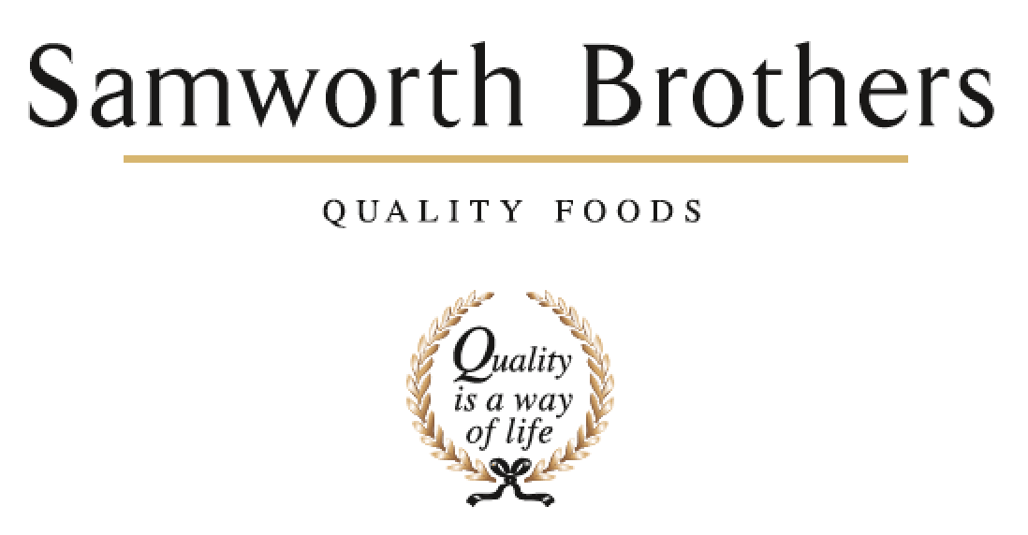

|  |  |  |  |
| --- | --- | --- | --- |
| ROLE PROFILE | | | |
| Job title | NPD Buyer | Date | 24.04.2025 |
| Business | FTG | | |
| Department | Commercial – NPD & Innovation | | |
| Location | Ashton Green | | |
| ROLE SUMMARY | | | |
| We’re looking for a sharp, proactive, and commercially minded NPD Buyer to play a pivotal role in our innovation journey. This is a highly strategic role that sits at the centre of how we bring new products to life. You’ll lead ingredient sourcing for key categories, working cross-functionally with NPD, Technical, Process, Planning and Commercial teams to deliver impactful, timely launches.  As a key partner to the business, you’ll manage supplier relationships, negotiate contracts, track market trends, and help shape the future of our innovation pipeline.  If you enjoy working at the intersection of creativity, commercial value, and delivery—this role is for you. | | | |
| REPORTING STRUCTURE | | | |
| Reports to | Strategic Innovation Senior NPD Manager | | |
| Deputy | None | | |
| Direct & indirect reports | None | | |
| Key internal stakeholders | NPD, Technical, Process, Planning, Commercial | | |
| Key external stakeholders | Suppliers | | |
| KEY ACCOUNTABILITIES AND RESPONSIBILITIES | | | |
| **Strategic Ingredient Sourcing & Supplier Management**   * Lead sourcing for key ingredient categories across NPD projects * Negotiate pricing, lead times, and terms to secure optimal commercial outcomes * Build and manage strong, long-term supplier partnerships aligned with our quality, cost, sustainability, and innovation goals * Liaise with group procurement, ensuring preferred supplier use and flagging supply chain risks early * Lead strategic EPD ingredient projects with NPD & Procurement * Attend supplier meetings, upskilling sessions, trials, and pre-productions to support launch readiness where required   **Cross-Functional Collaboration**   * Act as a strategic partner to NPD, Technical, Process, Planning and Commercial teams—bringing a sourcing lens to innovation planning * Participate in project meetings, innovation workshops, and cross-team reviews to ensure strong integration * Proactively track food industry and ingredient trends to support innovation with future-facing sourcing options * Identify emerging ingredients or supplier capabilities that could unlock new product opportunities * Attend trade shows and supplier forums to build knowledge and spot innovation early   **Data & Project Management**   * Maintain accurate supplier and ingredient data in business systems (costs, lead times, MOQs, risk level) | | | |
| QUALIFICATIONS, EXPERIENCE, TECHNICAL SKILLS / KNOWLEDGE | | | |
| * Background in buying, procurement, or supply chain—ideally in food, FMCG, or a fast-paced commercial environment * Confident working with suppliers and influencing internal teams * Detail-orientated * Proactive, organised, and comfortable managing multiple priorities * Curiosity and commercial thinking—comfortable exploring trends, markets, and future opportunities * Great time management, systems proficiency (especially Excel), and a structured approach to managing projects * A collaborative, solutions-focused mindset with a “can do” attitude * Full UK driving licence | | | |
| CORE COMPETENCIES, ATTRIBUTES & BEHAVIOURS FOR SUCCESS | | | |
| **Competency** | **Descriptors** | | |
| Values People | *Demonstrates the belief that people are our most important asset and central to the success of the organisation. Everybody should be treated with dignity and respect at all times.* | | |
| Customer Focus | *Demonstrates the understanding that the satisfaction of our internal and external customers is the foundation of our success* | | |
| Collaborative Team Working | *The willingness to act as part of a team and work towards achieving shared objectives through adopting best practice in line with PQP and Federalism.* | | |
| Flexibility & Adaptability | *The ability to change and adapt own behaviour or work procedures when there is a change in the work environment, for example as a result of changing customer needs.* | | |
| Initiative & taking ownership | *Steps up to take on personal responsibility and accountability for tasks and actions in line with PQP and Federalism.* | | |
| Drive for Excellence | *Knows the most effective and efficient processes for getting things done, with a focus on continuous improvement.* | | |
| Resource Management | *Effectively manages resources and cost drivers to achieve sustainable productivity and profitability.* | | |
| Technical Expertise | *Has the skills, knowledge and experience required to excel in own area of specialism and the willingness to further grow and develop.* | | |
| Self-Management | *Uses a combination of feedback and reflection to gain insight into personal strengths and weaknesses, so that own time, priorities and resources can be managed to achieve goals.* | | |