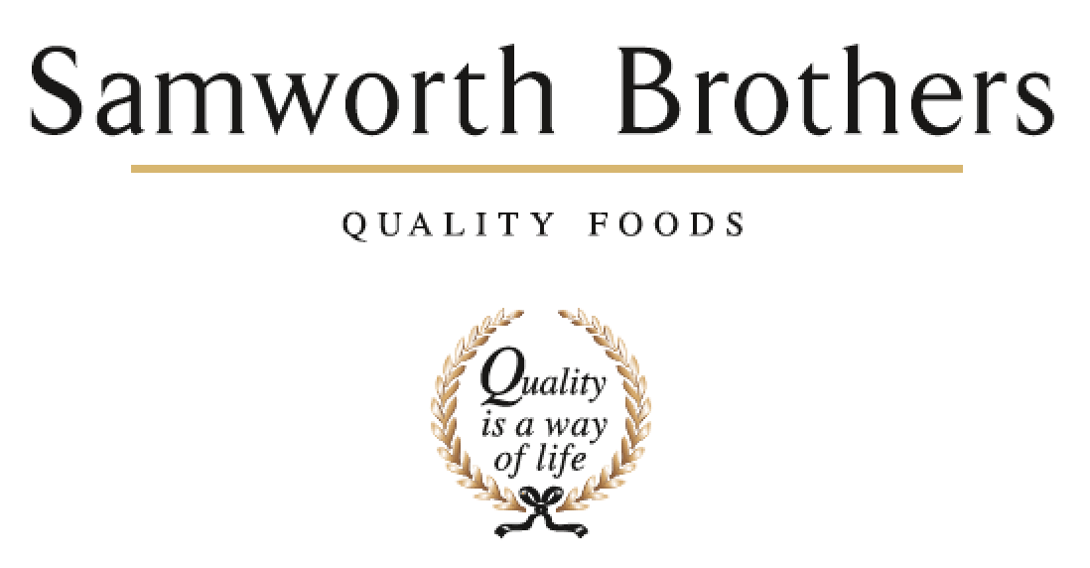

ROLE PROFILE
Job title | Development Technologist | Date | 15/4/24
Business | Fresh Food For Now
Department | Commercial
Location | Leicester
ROLE SUMMARY
Key member of the NPD team supporting the launch process from concept to launch.
Creating briefs and working with internal bakeries and external contract manufactures across FTG & Savoury Pastry primarily across our brands Urban Eat, Leaf & Loaf & West Cornwall Pasty Company
Delivering Innovation that is driven by consumer and customer insight.
The role may require extensive travel around the UK from time to time meeting key customers and suppliers

REPORTING STRUCTURE
Reports to | NPD Manager
Deputy
Direct & indirect reports
Key internal stakeholders | NPD, Category, Commercial, Technical, Production, Process
Key external stakeholders | Customers, Suppliers and Contract Manufactures

KEY ACCOUNTABILITIES AND RESPONSIBILITIES
- Continuously develop and introduce new and improved products to meet strategic objectives of the business and expectations of customers.
- Generating internal and external briefs ensuring innovative and technologically sound product designs are generated in line with customer and category expectations, operational constraints, and commercial needs of the business.
- Market research to investigate and identify customer needs, upcoming trends, and gaps in the marketplace with the aim of being one step ahead of competitors to take advantage of potential business opportunities.
- Make up samples by following recipes to the detail as appropriate.
- Recipe development and reformulation to achieve an end product that meets customer expectations and that is financially and technically feasible.
- New product costings including determination of costs for ingredients, packaging, labour and distribution and analysis of new product production costs vs gross margin.
- Working with new and current suppliers to source new, high quality and cost-effective ingredients and assist in the approval of new suppliers / ingredients by gathering all necessary data including product specifications, quality certification, HACCP and traceability documents allergen information and costs.
- Cooking instruction development for all new hot eating products to ensure that the food is safe to consume and of a high quality for consumers when cooked.
- Assists in the monitoring and benchmarking of product quality of new and existing products. Communicates any product concerns or Issues found during quality checks with the relevant departments.
- Supports trials, pre pros and first production of products to ensure product quality has transferred from kitchen to factory.

QUALIFICATIONS, EXPERIENCE, TECHNICAL SKILLS / KNOWLEDGE
A good working knowledge of the chilled food industry.
Have the confidence and ability to work with people at all levels, including customers with the ability to understand the external and internal customer.
Have basic levels of IT, numeracy, and literacy.
Have a current full clean driving licence.
Good presentation skills required

CORE COMPETENCIES, ATTRIBUTES & BEHAVIOURS FOR SUCCESS
Competency | Descriptors
Values People | Demonstrates the belief that people are our most important asset and central to the success of the organisation. Everybody should be treated with dignity and respect at all times.
Customer Focus | Demonstrates the understanding that the satisfaction of our internal and external customers is the foundation of our success
Collaborative Team Working | The willingness to act as part of a team and work towards achieving shared objectives through adopting best practice in line with PQP and Federalism.
Flexibility & Adaptability | The ability to change and adapt own behaviour or work procedures when there is a change in the work environment, for example as a result of changing customer needs.
Initiative & taking ownership | Steps up to take on personal responsibility and accountability for tasks and actions in line with PQP and Federalism.
Drive for Excellence | Knows the most effective and efficient processes for getting things done, with a focus on continuous improvement.
Resource Management | Effectively manages resources and cost drivers to achieve sustainable productivity and profitability.
Technical Expertise | Has the skills, knowledge and experience required to excel in own area of specialism and the willingness to further grow and develop.
Self-Management | Uses a combination of feedback and reflection to gain insight into personal strengths and weaknesses, so that own time, priorities and resources can be managed to achieve goals.

