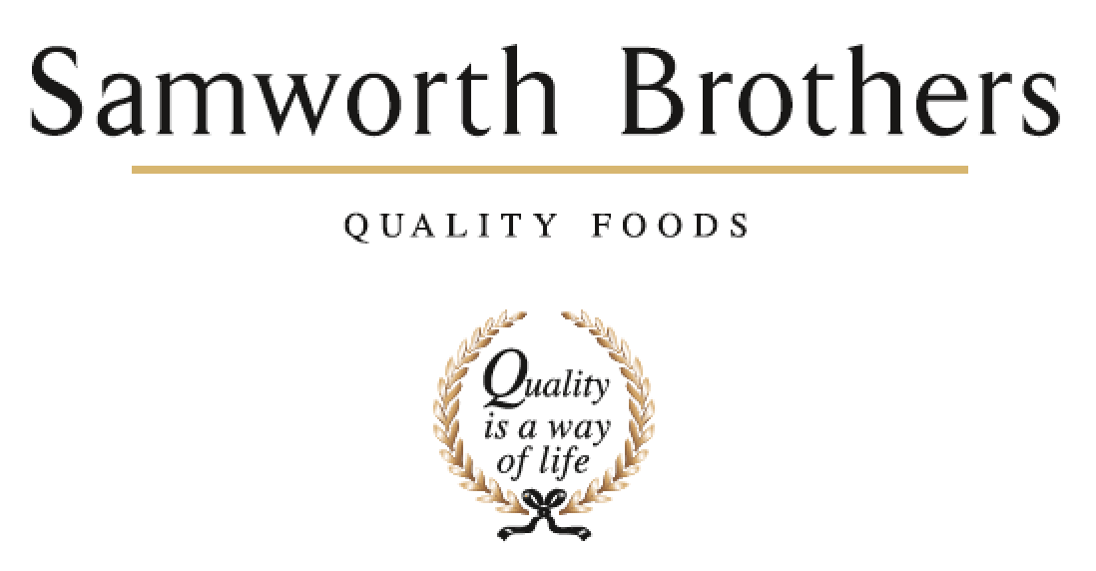

|  |  |  |  |
| --- | --- | --- | --- |
| ROLE PROFILE | | | |
| Job title | Raw Materials technologist | Date | 29.09.23 |
| Business | Bradgate Bakery | | |
| Department | Raw Materials | | |
| Location | Madeline road | | |
| ROLE SUMMARY | | | |
| The role is based in a fast paced chilled food environment, which requires the use of initiative and “thinking on your feet”. A Raw Materials technologist is expected to be a key role in ensuring that the materials within the factory are safe, approved, monitored and driven actions are put in to prevent reoccurrence of poor quality materials | | | |
| REPORTING STRUCTURE | | | |
| Reports to | Nicola Fenning – Raw Materials Manager | | |
| Deputy | Zoe Wall – Senior Raw materials Technologist | | |
| Direct & indirect reports | N/A | | |
| Key internal stakeholders | Commercial  Finance  Operations  Planning  Development  Technical | | |
| Key external stakeholders | Customers and suppliers to Bradgate Bakery | | |
| KEY ACCOUNTABILITIES AND RESPONSIBILITIES | | | |
| * Support in approving Bradgate’s raw material portfolio, including packaging to ensure the legality, food safety, integrity, and quality of all incoming raw materials. * Support NPD, procurement, process development, operational, planning and quality teams on site with the raw material management. * Ensure appropriate and documented controls are in place to assure right first-time delivery of all raw materials including clear and agreed specifications, confirmation of quality standards, targeted goods in inspections and KPI management of supplier performance. * Understand and apply all relevant Bradgate / Samworth Brothers, customer and legal standards to all issues relating to raw materials and packaging. * Undertake raw material supplier visits / audits to follow up on any issues and as part of the approval process where necessary. Report findings and manage supplier response to ensure improvement. * Manages the due diligence scheduling as part of Raw Materials risk assessments outcomes and contribute to the WIP and finished product shelf-life studies on site with the elements of VACCP / integrity risk calculation as relevant. * Manage the sites raw materials specifications, supplier approval, risk assessments and processes working collaboratively with Group technical teams and Food to Go site teams using both site systems and online foods connected platform. * Agree and maintain up to date clear, food safe and quality appropriate specifications for all raw materials. * To also ensure that any raw material requirements are met e.g. Tesco Nurture / Global Gap / TWA / RSPCA / RSPO / MSC etc. * Maintain Foods Connected and Recipe Professor systems plus other as relevant in line with the business expectation. * Build effective relationships with the suppliers and contribute to day to day supplier communication. * Work with the raw materials team to look for opportunities to engage in responsible business strategies at site. * To regularly review customer approved supplier lists to ensure that all raw material requirements are met. * To operate in a safe working manner and support the site/business on continuous improvement relating to health, safety and the environment. | | | |
| QUALIFICATIONS, EXPERIENCE, TECHNICAL SKILLS / KNOWLEDGE | | | |
| * Good team working skills * Effective communication skills across all levels * Experience of managing other people’s expectations * Organisational/prioritising skills & ability to respond to changes * Problem solving & decision making skills * Ability to negotiate, influence & recognise other view points * Ability to develop effective relationships with other areas across the site * Working knowledge of computer systems, use of excel | | | |
| CORE COMPETENCIES, ATTRIBUTES & BEHAVIOURS FOR SUCCESS | | | |
| **Competency** | **Descriptors** | | |
| Values People | *Demonstrates the belief that people are our most important asset and central to the success of the organisation. Everybody should be treated with dignity and respect at all times.* | | |
| Customer Focus | *Demonstrates the understanding that the satisfaction of our internal and external customers is the foundation of our success* | | |
| Collaborative Team Working | *The willingness to act as part of a team and work towards achieving shared objectives through adopting best practice in line with PQP and Federalism.* | | |
| Flexibility & Adaptability | *The ability to change and adapt own behaviour or work procedures when there is a change in the work environment, for example as a result of changing customer needs.* | | |
| Initiative & taking ownership | *Steps up to take on personal responsibility and accountability for tasks and actions in line with PQP and Federalism.* | | |
| Drive for Excellence | *Knows the most effective and efficient processes for getting things done, with a focus on continuous improvement.* | | |
| Resource Management | *Effectively manages resources and cost drivers to achieve sustainable productivity and profitability.* | | |
| Technical Expertise | *Has the skills, knowledge and experience required to excel in own area of specialism and the willingness to further grow and develop.* | | |
| Self-Management | *Uses a combination of feedback and reflection to gain insight into personal strengths and weaknesses, so that own time, priorities and resources can be managed to achieve goals.* | | |