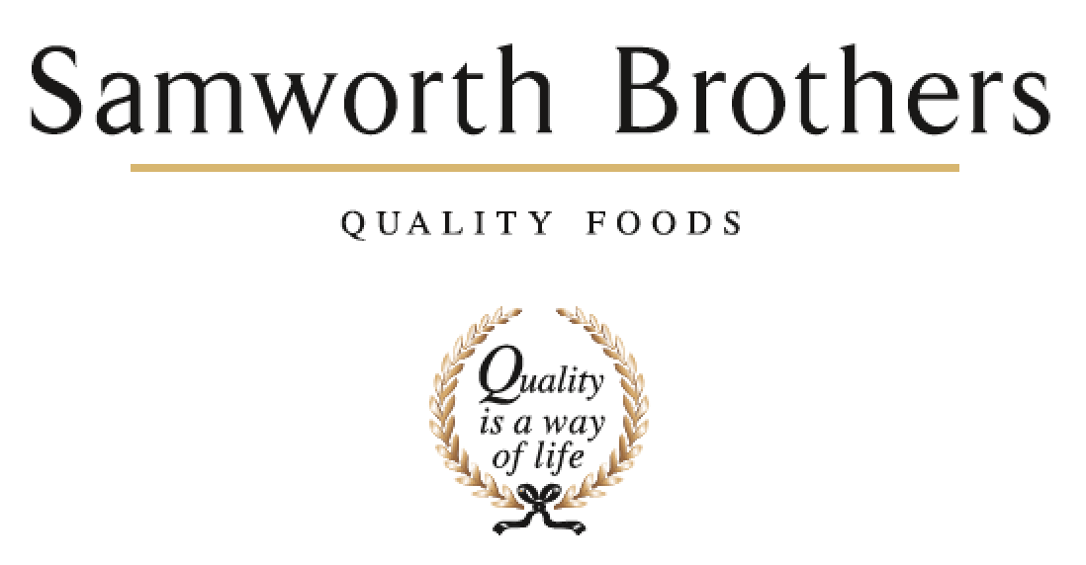

ROLE PROFILE
Job title | Area Manager | Date | Sept 2023
Department | Operations
Location | Soreen
ROLE SUMMARY
Summarise in one or two sentences the highlights of the job in terms of its purpose and overall responsibility.
Responsible for managing a plant from end to end, ensuring efficient operations and performance in line with HSE, GMP, quality standards and successful people management.

REPORTING STRUCTURE
Reports to | Production Manager
Key internal stakeholders | Operations, technical, engineering, HSE, people team
Key external stakeholders | Agencies, Auditors

KEY ACCOUNTABILITIES AND RESPONSIBILITIES
Leadership & Management
• Act as a role model for our Values and Ways of Working and encourage teams to share in our Purpose of “We do GOOD things with GREAT food”.
• Work collaboratively with other line managers to build a values-based culture, delivering on the Culture Framework and ensuring that results are achieved with people at the heart of every decision, and consistent focus is given to providing a positive experience for Colleagues.
• Build good relationships ensuring everyone in the team is treated equally and with respect. Ensure relations between shifts and department teams are positive, and build effective relationships with key internal stakeholders.
• Guide the team through change, encouraging them to view change as a necessary and valuable part of business progress. Consider the effect of changes on the department and identify ways to maximise benefit and minimise any negative impact.
• Pro-actively takes on personal responsibility and accountability to fully understand challenges, seek solutions, and work collaboratively. Looks to Line Manager for guidance as appropriate. Provide cover for Line Manager as required.
• Continually look to improve own performance and capability by linking personal objectives to support the business, and seeks learning and development opportunities.

Health & Safety & Environment, Responsible Business
• Ensure safety, health and environmental factors are well managed. This includes preventative action, identifying and assessing hazards, encouraging near miss reporting, conducting accident investigations, escalation of significant issues in a timely manner, contributing to the delivery and improvement of our HSE & responsible business plan and ensuring team behaviours align with the required standards.
• Ensuring team are adhering to required PPE standards, management of risk assessments and periodic inspections.
• Set a good example of responsible behaviour. Challenge any unsafe behaviours and lead the team to improve standards.

Food Safety & Quality
• Be responsible for food safety and quality issues in the area, and take decisive action when required to halt production activity if food safety is compromised. Work closely with Technical, Hygiene and Engineering colleagues to prevent, resolve and follow up on food safety concerns. Responsible for ensuring compliance to QAS standards including required audits in a timely manner.
• Oversee equipment is set up and operated in accordance with Standard Operating Procedures (SOP’s), line and operating standards, and daily care routines. Carry out periodic audits to ensure standards deliver required performance. In the event that a process cannot be fully adhered to take ownership to identify a satisfactory solution, which may include halting production until the issue can be resolved.
• Take ownership of operational practices in the area, ensuring that team behaviours align with required standards and procedures. Routinely spot check that team members are fully trained to carry out the assigned tasks according to their role.
• Work closely with Technical team to design and amend processes, and to write SOP's.
• Ensure new product trials are fully supported in alignment with the NPD gate process, providing clear feedback and guidance around production capabilities and constraints, and contribute information for costings, technical processes, etc.
• Participate in food quality reviews, taste panels, buy- backs, etc and take required action as identified.

Production Operations & Performance
• Ensure the production plan is followed in relation to quantity and schedule. Look ahead to anticipate any potential delays and review plan accordingly, identifying solutions and escalating for support as required.
• Monitor machine efficiency against agreed running standards and work with Engineering to optimise. In the event of fault or breakdown, liaise with Engineering to resolve, and to identify any trends, root cause and/or solution which could prevent future issues.
• Manage teams and co-ordinate between departments and cross-function to effectively manage labour and materials according to prescribed standards and plan, to control costs and drive performance against agreed KPI's.
• Conduct routine spot checks to ensure that the teams are working to audit ready standards every day, and always be prepared to host an unannounced visitor / auditor.
• Support in auditor visits and other visitors to the area, and demonstrate a thorough knowledge and understanding of the people, processes, and standards. Involve team members, where appropriate, to demonstrate team engagement and empower others.
• Ensure that systems and records are accurately maintained so that real time information is correct. Ensure all materials flowing in and out of production are recorded accurately. Provide information and updates to Planning and Supply Chain, Commercial and management to support efficiency across the broader business processes.
• Routinely review operational performance against KPI's to identify any trends or issues which impact performance, and create action plans. Re-evaluate and review operational priorities where necessary to deliver targets.
• Identify areas for improvement of food safety, quality, and operational efficiency. Deliver Continuous Improvement (CI) projects and Profit Improvement Plan (PIP) objectives through improvement teams, ensuring recommendations are implemented.

People Management
• Delegate and communicate work instructions clearly, ensuring team is fully briefed on plans and anticipated challenges.
• Management of the People system e.g. signing off timesheets, inputting absences, managing sign off of holiday
• Ensure fair task allocation according to job grade/role, job rotation and micropauses are well managed.
• Address any Employee Relations (ER) issues promptly and in line with Company values, People policies and processes, and best practice. Conduct stage one ER meetings/outcomes – absence, disciplinary
• Assess production demands to plan labour requirements, considering the need to ensure adequate cover for skills required.
• Plan ahead for labour cover and overtime, to ensure that colleague leave, breaks and additional hours are managed with fairness and in line with Company rules and Working Time Directive.
• Take responsibility for overall attendance - review absence patterns, lead on absence review meetings and identify where reasonable support / adjustments can be offered taking into account Occupational Health guidance. Consider flexible working requests. Ensure that colleague wellbeing is a clear priority for the teams and encourage an open and supportive culture.
• Ensure that all team members receive ongoing support for their development through consistent Performance Enhancement (time with your manager), 1-1s, training, and coaching, starting with a quality induction and probationary period training, through to job progression.
• Develop and deliver the skills plan for the area in line with job grades and business strategy which will include identifying training needs and proactively managing the delivery of these needs.
• Encourage high performance through positive recognition and coaching. Challenge any underperformance promptly with clarity, providing pro-active support to help team members unlock their full potential. Formally manage any pattern of poor performance promptly and fairly in line with policy and good practice, with support from the People team as required.
• Lead the team in continuous improvement projects, involving and engaging others to contribute to H&S, Operational and Quality improvement plans, manage progress on actions and implementation.
• Be responsible for agency labour, planning requirements, placing orders, etc in line with SLA terms. Liaise with agency contacts to ensure workers receive the induction, training and support they need.
• Identify recruitment needs and act as 'hiring manager', to select and onboard new colleagues adhering to the relevant processes and policies including seeking authority, liaising with the Resourcing team, conducting interviews and work trials, making start date and induction arrangements e.g., Buddy, PPE, lockers.
• Be pro-active in retaining colleagues by delivering an overall work-life experience in which each colleague feels that they matter, and putting the people management tools, policies and processes provided to full use.

Communication
• Communicate effectively and with clarity, using written, verbal, and digital means, and adjusting tone and approach according to the audience and context. Appropriately manage confidentiality and sensitive information.
• Organise briefings to ensure teams are well-informed and receive useful feedback on performance. Be pro-active in communicating relevant, valuable information to other departments and senior colleagues, and take part in routine meetings. Ensure that shift handovers are effective and comprehensive, and reflect key measurables.

QUALIFICATIONS, EXPERIENCE, TECHNICAL SKILLS / KNOWLEDGE
List the skills gained through education and experience required to effectively function in the position
- Experience in a FMCG environment with people management experience.
- Analytical approach to problem solving and numerate with he ability to take a logical approach to decision making.
- Experience of developing and improving team performance
- A highly motivated enthusiastic individual with strong leadership and team building qualities
- The ability and resilience to thrive in a pressurised environment
- The ability to build successful relationships and influence in a positive way
- Ability to positively adapt and change behaviours dependent on situation/person.
- Strong verbal and written communication skills to communicate at all levels

ATTRIBUTES & BEHAVIOURS FOR SUCCESS
Behaviour | Descriptors
Focused on developing people | - Consistently demonstrates that people are the top business priority.  - Devotes a significant % of time to supporting and coaching their people.  - People related activities are consistently placed high on the “to do” list.  - Always make themselves available to support team members, regardless of how busy they are.
Builds strong relationships | - Demonstrates they are a good listener who can take on board other points of view.  - Demonstrates trust in other teams and other colleagues.  - Displays a high level of emotional intelligence to understand how to improve a relationship.  - Willing to be the “better person” for the sake of building or maintaining a relationship.  - Consciously aware of key relationships which require more work to improve.
Courage to make tough decisions | - Demonstrates they can make a positive decision when none of the alternatives are attractive.  - Is able to make quick decisions when needed even if the data is not complete.  - Is able to take the “hard / right” decision (which will upset some people) rather than always opting for the “easy / but wrong” decisions.  - Consistently demonstrates high standards and does not drop standards just because the implications are challenging.
Calmness during challenging times | - The more challenging the situation the calmer we want our people to be.  - Does not get over-emotional when things go wrong.  - Recognises that challenging times call for the best kind of leadership.  - Focuses on the issue…….not the person who made a mistake or who discovered a problem.
Leads by example | - We should “walk the walk” as well as “talk the talk”.  - Displays a consistent approach in how they deal with everyone in the business regardless of their level.  - Demonstrates an unshakeable positive attitude regardless of how challenging the circumstances.  - Appreciates the views of everyone in the business and welcomes new ideas and challenges.

Internal area managers - Knowledge & understanding

Leadership & Management
• Show clear understanding of your role and how, as line manager, you are a role model for the Samworth Brothers Values and Ways of Working.
• Demonstrate an understanding of the business you work for including an awareness of the part other functions play.
• Demonstrate an awareness of operational objectives and the goals of other functions and departments to foster collaboration and mutual support for progress
• Show a flexible approach to change, and knows how to coach and support others to adapt to change.
• Knows how to use forward planning to mitigate risk and enhance efficiency, and can apply problem-solving skills in a fast-paced production environment.
• Understands the importance of continued personal and professional development (CPD).

Health & Safety & Environment, Responsible Business
• Demonstrate an understanding of the Health & Safety and Environmental management procedures: - Safe Systems of Work, Risk Assessment, Accident Investigation & Reporting, Auditing Skills, Near Miss System, COSHH, Emergency procedures and behavioural safety approach.
• Demonstrate knowledge of environmental sustainability and factors at play in the operation.
• Know how to use the H&S and environmental management IT system.
• Demonstrate a good understanding of own responsibilities as a manager of health, safety, and environment as per Company policy and can carry out the SSOW's, SOP's and procedures.
• Know the Occupational Health control measures relevant to own operational areas and teams.

Food Safety & Quality
• Demonstrate a good understanding of the Food Safety and Quality Management Systems, Process Control documentation, Hygiene schedules and processes, HACCP, Audit standards, Personal Hygiene as they relate to the team and area.
• Be fully conversant with the manufacturing process and all quality aspects to be observed, with particular focus on Critical Control Points.

Production Operations & Performance
• Demonstrate clear understanding of all the Standard Operating Procedures (SOP's) and Key 5 Performance Indicators (KPI's) within the team / area.
• Have a good knowledge of the job roles, training elements and baseline headcount for the team /area.
• Show a good level of product knowledge including understanding the ingredients involved to the customer specifications.
• Demonstrate the ability to take a range of information, think things through logically and prioritise workload, planning ahead to manage any risk to delivering the required results.
• Demonstrate an understanding of Lean Manufacturing and Continuous Improvement principles and methodologies, and how and when to use appropriate tools and techniques.
• Knows how to manage resources to achieve business objectives.
• Can demonstrate awareness of all relevant audit standards and customer Codes of Practice.
• Understand the importance of your role on delivering customer satisfaction and maintaining critical standards.
• Has awareness of financial implications of decisions and actions.
• Can demonstrate an understanding of what drives cost within the area.
• Has good levels of numeracy; is able interpret numerical and statistical data and then take any necessary action.
• Demonstrate an understanding of appropriate IT software programmes and tools.
• Understands how KPI's and measures are used to drive results in manufacturing processes.

People Management
• Knows how to manage people in a respectful, fair, and inclusive way in line with our Values.
• Can demonstrate an understanding of the Samworth Brothers People Policies and Processes, job roles and structure, and how to use the People Portal system.
• Knows how to manage in line with the Working Time Directive, Company policy and clocking system rules on working hours, as well as an awareness of the Ethical Trade Initiative (ETI) Base Code.
• Knows how to apply the absence management policy and processes in a pro-active and supportive way to enhance colleague attendance.
• Understands the factors which impact colleague wellbeing and knows how to support colleagues in ways which balance with business needs, and how to signpost to additional support when needed.
• Knows how to utilise the Samworth Brothers Performance Enhancement process including Ways of Working, Learning Toolkit and training and development opportunities.
• Knows how to use a coaching style to support others to take ownership of their challenges, solutions and achievements.
• Knows the key terms of the agency contracts and service level agreements, and how to work closely with agency contacts to ensure that agency workers are well-supported.
• Understands how to conduct a fair and equitable selection process, mitigating personal bias, to hire the most suitable candidate for the requirements of the role.
• Knows how to use the Samworth Brothers Recruitment and onboarding tools and processes.

Communication
• Understands how to communicate effectively, the importance of active listening and clear feedback to ensure effective communications in the workplace.
• Has good levels of literacy; able to write and produce reports and documentation relevant for the role

