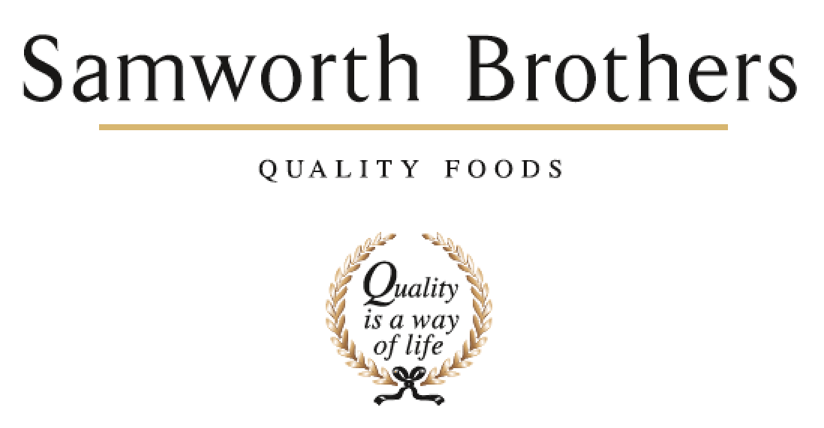

|  |  |  |  |
| --- | --- | --- | --- |
| ROLE PROFILE | | | |
| Job title | Senior Commercial Manager – Morrisons (12 month maternity cover) | Date | Jan 2026 |
| Business | Savoury Pastry | | |
| Department | Commercial | | |
| Location | Flexible - Leicester / home based – will also include some interaction with The Cornwall Bakery. | | |
| ROLE SUMMARY | | | |
| Working in the fast-paced world of own label grocery retail, you’ll take a leading role within the Commercial function & cross functional teams to continue to build a close & trusted relationship with Morrisons, in order to deliver against sales & profit targets. Fundamental to success will be the effective management of NPD/EPD launches, end to end activity, promotional & pricing strategies and day to day contact with Morrisons, including administrative tasks such as maintaining forecasts and management of cost and flow through models. Working closely with the HOC, you will help deliver the JBP and the SP OL strategy. | | | |
| REPORTING STRUCTURE | | | |
| Reports to | Head of Commercial | | |
| Direct & indirect reports | Commercial exec | | |
| Key internal stakeholders | Development, NPD, Supply Chain, Production, Finance, Technical, Procurement, Personnel | | |
| Key external stakeholders | Retail customer’s commercial, development, technical & supply chain teams | | |
| KEY ACCOUNTABILITIES AND RESPONSIBILITIES | | | |
| * Deliver sales & profit in line with operating plan budgets. * Responsible for the accuracy of the 52 week rolling commercial forecast * In partnership with the Category team, drive our share of the savoury pastry market by setting effective range strategies by format to optimise sales through clear understanding of the category dynamics & shopper motivations to purchase. * Lead the relationship with customers through effective commercial management & the execution of a cross functional Joint Business Plan. * Set an effective promotional plan, in line with the total business strategy, & complete post promotional & post launch analysis * With & through team collaboration identify new product development, interpreting market data to form actionable insight. * Proactively drive customer efficiency improvements to drive our profit & maintain our competitiveness * Working with Commercial Finance, help to maintain the flow through commodity cost model * Ensure that all customer & business administrative tasks are completed accurately & in a timely manner | | | |
| QUALIFICATIONS, EXPERIENCE, TECHNICAL SKILLS / KNOWLEDGE | | | |
| * Experience of working within FMCG with major retailer knowledge * Experienced within FMCG with Food Manufacturing * Strong commercial acumen * Excellent at building rapport can demonstrate influencing skills understanding the nuances of internal and external behaviours * Strong interpersonal & communication skills to lead and manage the customer agenda across our internal business functions & with our retail customers. * Excellent organisational skills with the ability to manage multiple projects simultaneously * Proficient in analysing data, gaining insights & using these insights to inform decisions. * Degree educated or equivalent preferred * Full clean driving licence. | | | |
| KEY SKILLS | | | |
| * Commercial acumen * Negotiation * Logical decision making * Strong communication & influencing skills * Analytical skills * Team working, relationship builder * Customer management * Planning & prioritisation / Attention to detail. | | | |
| CORE COMPETENCIES, ATTRIBUTES & BEHAVIOURS FOR SUCCESS | | | |
| **Competency** | **Descriptors** | | |
| Values People | *Demonstrates the belief that people are our most important asset and central to the success of the organisation. Everybody should be treated with dignity and respect at all times.* | | |
| Customer Focus | *Demonstrates the understanding that the satisfaction of our internal and external customers is the foundation of our success* | | |
| Collaborative Team Working | *The willingness to act as part of a team and work towards achieving shared objectives through adopting best practice in line with PQP and Federalism.* | | |
| Flexibility & Adaptability | *The ability to change and adapt own behaviour or work procedures when there is a change in the work environment, for example as a result of changing customer needs.* | | |
| Initiative & taking ownership | *Steps up to take on personal responsibility and accountability for tasks and actions in line with PQP and Federalism.* | | |
| People Management | *The ability to understand people and their motivations, build good relationships with them and help them unlock their potential.* | | |
| Empowering others | *Creates an environment where people feel required and enabled to take ownership and responsibility.* | | |
| Coaching for performance | *The ability to help others achieve more through two-way feedback, clear direction and enabling.* | | |
| Analysis & Planning | *The ability to take a range of information, think things through logically and prioritise work to meet commitments aligned with organisational goals.* | | |
| Drive for Excellence | *Knows the most effective and efficient processes for getting things done, with a focus on continuous improvement.* | | |