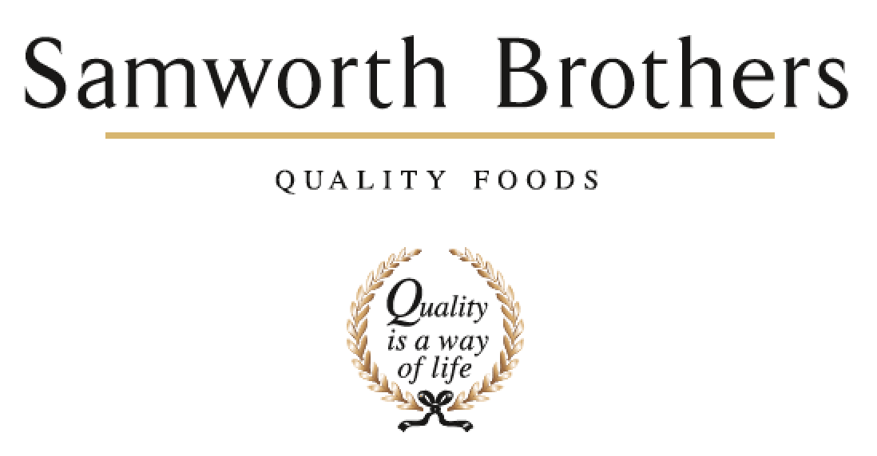

|  |  |  |  |
| --- | --- | --- | --- |
| ROLE PROFILE | | | |
| Job title | Head of Innovation | Date | Jan 2025 |
| Business | Samworth Brothers Meals | | |
| Department | Commercial | | |
| Location | Kettleby | | |
| ROLE SUMMARY | | | |
| The Head of Innovation will set a clear vision and strategy for new product development that aligns with the company’s broader business objectives, market opportunities, and long-term growth goals. Ensure the NPD strategy complements the company’s overall mission and competitive positioning in the market. The successful candidate will also have a strong commercial focus, with extensive experience in writing capital business cases that deliver incremental net sales and gross margin growth. As the Head of Innovation you will work alongside operational teams to enhance performance and inspire cultural transformation. You will lead the manufacturing excellence agenda utilising your experience in driving continuous improvements to deliver growth and technical capabilities. | | | |
| REPORTING STRUCTURE | | | |
| Reports to | TBC | | |
| Direct & indirect reports | Senior Development Managers | | |
| Key internal stakeholders | Senior Technologists, Development Technologists, Senior Chef, Development Chef, Junior Chef, Commercial & Category Teams, Costing Teams, Technical and Process, NPD Sourcing Specialists & Procurement | | |
| Key external stakeholders | Senior product leaders, Retailer Product Managers, Chefs & Technologists. Suppliers. | | |
| KEY ACCOUNTABILITIES AND RESPONSIBILITIES | | | |
| **Strategic Leadership**   * Set and execute the product development and innovation strategy for our branded and own brand portfolio ensuring alignment with the category plans and aspirations for growth This includes creating a strategic roadmap that prioritises high-impact projects and ensures a continuous flow of innovative products into the pipeline. Ensuring the product flow is underpinned by seamless use of technologies and processes which deliver outputs in a timely manner, supporting the evolution and refining of processes as business-as-usual activity * Lead the creation and management of the brand innovation pipeline that inspires the customer, ensuring that new product ideas are consistently aligned with partners brand identity, values, and positioning. Focus on fostering innovation that strengthens the brand, enhances customer engagement, and delivers sustainable competitive advantage. * Build strong stakeholder relationships leveraging influence at all levels both internally and externally to support growth * Ensure future focussed positioning for the category - staying ahead of trends, using your passion for food and food innovation to “predict” trends or direction of the market. Using customer insights and data to inform your thinking   **Innovation and Product Development:**   * Lead and own the end-to-end product development process from idea generation, concept development, and feasibility through to commercialisation. * Utilise Demand Moments to drive innovation within the ready meals category. * Utilise existing technologies and processes to maximise efficiency and accelerate speed to market. * Work cross-functionally with marketing, sales, operations, and supply chain teams to ensure successful product launches. Demonstrating a deep knowledge of launch processes, governance, food regulatory requirements, project management principles and commerciality.   **Commercialisation of Innovation:**   * Develop and execute strategies to commercialise new products, ensuring alignment with customer needs, market trends, and business objectives. * Partner with key stakeholders to create products that drive profitable growth, delivering measurable business impact. * Create, own, and manage the raw material utilisation process to ensure efficient use of resources, maximizing profitability, and driving cost-effective production . * Ensure that new products align with the company’s margin targets, optimize material usage, and contribute to incremental growth in net sales and gross margin.   **Capital Business Case Development:**   * Proactively lead the development of capital business cases for new product initiatives, clearly articulating the commercial rationale and return on investment (ROI). * Analyse potential business opportunities and their financial impact, including sales forecasts, margin analysis, and capital expenditure requirements. * Collaborate with finance, operations, and other relevant teams to ensure robust financial modelling and risk assessment. | | | |
| QUALIFICATIONS, EXPERIENCE, TECHNICAL SKILLS / KNOWLEDGE | | | |
| * A food based degree of equivalent experience. Proven experience (8+ years) in a senior NPD role within the ready meals or FMCG sector. * Demonstrated ability to provide highly effective leadership in a large, complex environment with a focus on putting people at the heart of the operation. * Proven experience of leading cultural transformation and inspiring others fostering a culture of continuous improvement and innovation. * Strong strategic planning skills, with the ability to align plans with business, it’s customers and longer-term strategic intents of the site * Strong commercial acumen with a track record of writing capital business cases resulting in sales and margin growth. * Extensive knowledge of food manufacturing processes, technologies, and regulatory requirements. * Demonstrated success in leading product innovation and commercialising new products from concept to market launch. * Experience in managing cross-functional teams and working closely with finance, operations, and sales teams. * Strong project management skills with the ability to manage multiple priorities in a fast-paced environment. | | | |
| CORE COMPETENCIES, ATTRIBUTES & BEHAVIOURS FOR SUCCESS | | | |
| **Competency** | **Descriptors** | | |
| Values People | *Demonstrates the belief that people are our most important asset and central to the success of the organisation. Everybody should be treated with dignity and respect at all times.* | | |
| Customer Focus | *Demonstrates the understanding that the satisfaction of our internal and external customers is the foundation of our success* | | |
| Collaborative Team Working | *The willingness to act as part of a team and work towards achieving shared objectives through adopting best practice in line with PQP and Federalism.* | | |
| Flexibility & Adaptability | *The ability to change and adapt own behaviour or work procedures when there is a change in the work environment, for example as a result of changing customer needs.* | | |
| Initiative & taking ownership | *Steps up to take on personal responsibility and accountability for tasks and actions in line with PQP and Federalism.* | | |
| Drive for Excellence | *Knows the most effective and efficient processes for getting things done, with a focus on continuous improvement.* | | |
| Resource Management | *Effectively manages resources and cost drivers to achieve sustainable productivity and profitability.* | | |
| Technical Expertise | *Has the skills, knowledge and experience required to excel in own area of specialism and the willingness to further grow and develop.* | | |
| Self-Management | *Uses a combination of feedback and reflection to gain insight into personal strengths and weaknesses, so that own time, priorities and resources can be managed to achieve goals.* | | |