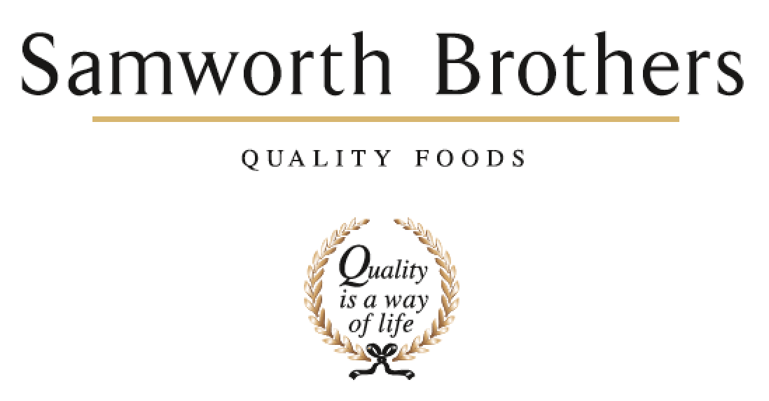

|  |  |  |  |
| --- | --- | --- | --- |
| ROLE PROFILE | | | |
| Job title | People Advisor (National) | Date | June 2025 |
| Business | FFN | | |
| Department | People Team | | |
| Location | Flexible – mobile, some travel expected | | |
| ROLE SUMMARY | | | |
| As first port of call for People related matters you will act as an advisor to line managers as they lead their teams through change and enhance colleague engagement and performance. You will support with recruitment, talent management, employee relations, performance management, absence management, employee wellbeing, recognition, reward, and benefits.  You will deliver proactive and flexible generalist support in line with company values, and you will be able to produce and interpret key People metrics, data, insight and explain what they mean for business performance.  Your business areas look to you as a skilled advisor in People matters, and you will offer coaching and guidance on policies, procedures, and best practice across all areas of people management, ranging from transactional to complex.  In this role you will be expected to support Line Managers and some Senior Managers at sites across the country when needed, so some travel is expected. You will also be expected to deputise for the People Lead in their absence and also cover for the People Administrator in their absence | | | |
| REPORTING STRUCTURE | | | |
| Reports to | People Lead | | |
| Deputy | People Administrator | | |
| Direct & indirect reports | N/A | | |
| Key internal stakeholders | All managers in FFN (Depots, Warehouse and all support teams) People Portal support, Group Payroll, Group Resourcing | | |
| Key external stakeholders | Occupational Health, GoodShape, Driving licence checking (DAVIS system), Alphabet, Sopp & Sopp | | |
| SKILLS & ABILITIES | | | |
| * Provide constructive commercially driven advice and guidance to all line managers on policies, procedures, and employment matters, taking time to identify any opportunities and risks to ensure great solutions for the business * Work in partnership with the line managers of the business to build a values-based culture, delivering on the Culture Framework * Manage and support with the delivery of colleague relations casework including absence management, disciplinary and grievance cases as required. Coach and provide guidance to line managers to improve capability and to ensure cases are managed effectively and constructively, and with sensitivity to the colleague experience. * Support line managers to effectively manage individual cases of underperformance in a timely manner, with clarity, taking a constructive approach. * Ensure that People systems, information and data are accurate, up to date, and managed and held in a format which follows current legislation (e.g., GDPR) and customer standards / codes of practice. * Promote and implement colleague wellbeing & engagement activities * As required, assist with the assembly and ongoing activities of the Consultative Committee, in a way which supports meaningful two-way discussion and builds trust, in line with group procedures and ways of working. * Support with Performance Enhancement practice, coaching line managers and colleagues in the use of these tools to unlock potential, enhance engagement and develop behaviours in line with the Samworth Ways of Working. * Support the annual Colleague Engagement Survey by working with the business and line managers to target areas for improvement and celebrate successes * Support recruitment for both Monthly and Weekly paid roles and connect with all outgoing colleagues for an exit interview, analysing trends and providing feedback where appropriate to management. * Record, maintain and report accurate data and information to inform People related decisions * Support on the preparation for and delivery of internal and external audits including Ethical audit and routine customer and governing body audits and assist in close out of any People-related non-conformances in a timely manner. * Actively engage with reliable sources to update and enhance own knowledge and understanding of new developments, best practice and fresh perspectives in the marketplace, industry, and the People profession. * Play an active part in encouraging diversity and respectful inclusive behaviours, identifying and removing barriers to equality. Act as a role model by ensuring own knowledge is current, managing own biases and behaviours and providing guidance to others. * As required, be responsible for any other tasks, projects, duties, and work streams which contribute to the success of the People team in supporting the business in day-to-day people management activity | | | |
| KNOWLEDGE & UNDERSTANDING | | | |
| * Knows how to effectively communicate, influence, and work collaboratively with colleagues and stakeholders, including how to provide feedback and positively challenge when necessary. * Takes a coaching approach with colleagues and internal stakeholders, empowering others to deliver results and develop understanding through personal accountability. * Is fully conversant with a Culture Framework, it's function as an enabler of the Purpose & Values, and how it is delivered in a business. * Understands how to effectively deliver training, facilitate learning, and lead a group session to upskill, inform and inspire. * Maintains an up-to-date knowledge of key legislation, precedents, and best practice (employment, ETI Base Code, GDPR, SB policies & procedures, etc) and has a good awareness of other areas relevant to business operations (food safety, H&S, finance, etc). * Understands how to deliver business change plans, including the process of communication and consultation with individuals and collective groups, ensuring that a planned and co-ordinated approach results in effective and timely outcomes. * Understand drivers of, and barriers to diversity & inclusion * Is aware of the importance of colleague wellbeing and the uses of an Occupational Health provider * Understands the purpose of colleague forums and how these are delivered * Can articulate the principles of a fair, effective, and equitable recruitment and selection process from job role planning through to screening, interviewing, and profiling candidates and has the knowledge to support and guide managers through these steps. * Understands the importance of taking a 'mediation and resolution' approach to employee relations, has the knowledge to manage cases this way in practice and to role model / coach this approach to others. * Understands the importance of accurate, up-to-date information and data in the People and business context. Knows how to select, analyse, and interpret data and ways in which results can be effectively presented to others. * Understands the importance of continued personal and professional development (CPD). | | | |
| QUALIFICATIONS & EXPERIENCE | | | |
| CIPD L3 People Management   * Advising and coaching line managers * Managing ER caseload * Managing LTS caseload * Excellent written and oral communication * Able to use own initiative, work independently and manage own diary - essential * Coaching/Training experience * Full Driving Licence - essential | | | |
| CORE COMPETENCIES, ATTRIBUTES & BEHAVIOURS FOR SUCCESS | | | |
| **Competency** | **Descriptors** | | |
| Core |  | | |
| Values People | *Demonstrates the belief that people are our most important asset and central to the success of the organisation. Everybody should be treated with dignity and respect at all times.* | | |
| Customer Focus | *Demonstrates the understanding that the satisfaction of our internal and external customers is the foundation of our success* | | |
| Collaborative Team Working | *The willingness to act as part of a team and work towards achieving shared objectives through adopting best practice in line with PQP and Federalism.* | | |
| Flexibility & Adaptability | *The ability to change and adapt own behaviour or work procedures when there is a change in the work environment, for example as a result of changing customer needs.* | | |
| Initiative & taking ownership | *Steps up to take on personal responsibility and accountability for tasks and actions in line with PQP and Federalism.* | | |
| Individual Contributor |  | | |
| Drive for Excellence | *Knows the most effective and efficient processes for getting things done, with a focus on continuous improvement.* | | |
| Resource Management | *Effectively manages resources and cost drivers to achieve sustainable productivity and profitability.* | | |
| Technical Expertise | *Has the skills, knowledge and experience required to excel in own area of specialism and the willingness to further grow and develop.* | | |
| Self-Management | *Uses a combination of feedback and reflection to gain insight into personal strengths and weaknesses, so that own time, priorities, and resources can be managed to achieve goals.* | | |