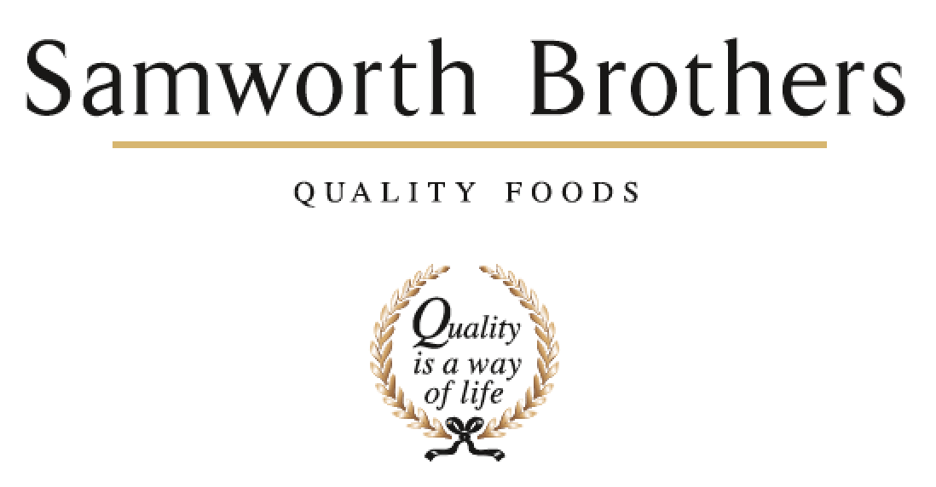

|  |  |  |  |
| --- | --- | --- | --- |
| ROLE PROFILE | | | |
| Job title | People Administrator | Date | Jan 2022 |
| Business |  | | |
| Department | People Team | | |
| Location |  | | |
| ROLE SUMMARY | | | |
| The People Administrator delivers a proactive and flexible administrative service to the business and People team, supporting their agenda to improve business performance and deliver People plans in line with the Samworth Brothers Purpose, Culture & Values.  You will manage all administrative aspects of the employee lifecycle, and as first point of contact for People queries you will offer timely resolutions and information as required to underpin the smooth and efficient delivery of People management activities. You will be able to produce key People metrics and data.  You’ll be instrumental in ensuring that managers and People team colleagues have the accurate, up-to-date, and comprehensive information they need to deliver business results with People at the heart of the agenda, and to enable every decision and action to be taken with the Colleague experience as a key consideration. | | | |
| REPORTING STRUCTURE | | | |
| Reports to |  | | |
| Deputy |  | | |
| Direct & indirect reports |  | | |
| Key internal stakeholders |  | | |
| Key external stakeholders |  | | |
| SKILLS & ABILITIES | | | |
| * Support and collaborate with the People team to collectively deliver our purpose of ‘Doing GOOD things with GREAT food’ for all of our colleagues; ensuring we welcome all colleagues into our family and providing opportunities for all of our people to grow, improve their prospects and achieve their full potential. * Support the People team and line managers to build a values-based culture, delivering on the Culture Framework, and to provide a positive experience for Colleagues. * Provide comprehensive and highly accurate administrative support to the wider People team, being responsible for overseeing the entire employee lifecycle. Ensuring that the people administration processes are efficient and effective, be the go-to person for People related data and information. Act as first point of contact for colleagues approaching the People team for support and signpost onward as appropriate. * Work in a way which positively represents the People Team and builds engagement with, and support for, the overall People plans and strategy. * As appropriate, assist on any other tasks, projects, duties, and work streams which contribute to the success of the People team in supporting the business in day-to-day people management activity and in delivering on the objectives of the agreed annual strategic People plan. * Where required, play an active role in supporting change to assist the business in achieving its goals whilst upholding our values and maintaining a positive experience for colleagues. * Play an active part in encouraging diversity and respectful inclusive behaviours. Act as a role model by ensuring own knowledge is current, managing own biases and behaviours and providing guidance to others. * Wherever possible, promote and support colleague wellbeing, both as an ethical priority and as a key factor in colleague performance, satisfaction, and retention. * Where required, assist in delivering the internal communications plan for the business, helping to create a strong sense of belonging and identity for Colleagues, and ensuring key information is effectively shared. * Support the annual Colleague Engagement Survey process to ensure a high response rate. * Assist with the recruitment process for all employees, including issuing contracts, and with all other site new starter and leaver activity. * Where appropriate, support less complex colleague relations matters. * Record, maintain and report accurate data and information to inform People related decisions and activity, enhance stakeholder engagement and evidence business progress and ROI. * Support on the preparation for and delivery of internal and external audits including Ethical audit and routine customer and governing body audits and assist in close out of any People-related non-conformances in a timely manner. * Follow required ways of working to ensure People team activities are compliant and to ‘audit ready’ standards. * Ensure that People systems, information and data are accurate, up to date, and managed and held in a format which follows current legislation (e.g., GDPR) and customer standards / codes of practice. * Work collaboratively with People Team colleagues, sharing knowledge and supporting others, to provide effective and efficient People partnering support to the business, it’s line managers and colleagues, working in alignment with the group Purpose & Values, People strategy and business’ People plans. * Actively engage with reliable sources to update and enhance own knowledge and understanding of the marketplace, industry, and the People profession. | | | |
| KNOWLEDGE & UNDERSTANDING | | | |
| * Knows the Samworth Brothers Purpose & Values, how these were conceived and have evolved as the group has grown and developed over the years. * Is fully conversant with the Culture Framework, it's function as an enabler of the Purpose & Values, and how it is delivered in the business. * Understands the way business operates and how the moving parts, including people aspects, work together to make it successful. Understands the dynamics of the People team and how it contributes to broader business strategy. * Knows how to effectively communicate and work collaboratively with colleagues and stakeholders. * Maintains an awareness of key People legislation, precedents, and best practice (employment, ETI Base Code, GDPR, Samworth Brothers policies & procedures, etc) and has an appreciation of other areas relevant to our business operations (food safety, H&S, finance, etc). * Is fully conversant with the Samworth Brothers People Toolkit - policies, processes, learning & development programmes, etc and their relevance to business operations and objectives. * Is aware of the factors which drive, and create barriers to, diversity & inclusion, and mechanisms of individual bias and how to mitigate and positively challenge * Appreciates the importance of colleague wellbeing in overall engagement and performance, and the positive impact on wider business results. Is aware of the various physical, mental and emotional factors contributing to resilience and wellbeing, and how these are supported / impacted in the business operation. * Has an appreciation of the SB Wellbeing strategy, it's function as an enabler of the Purpose & Values and overall business performance, and how it is delivered in the business. * Has an appreciation of the internal communications strategy for the business area. Understands key factors such as the audience segmentation, available channels, and main themes and messages. * Demonstrates understanding of critical thinking and objective decision-making methodology. * Understands the importance of accurate, up-to-date information and data in the People and business context. Knows how to select, analyse, and interpret data and ways in which results can be effectively presented to others. * Knows the Samworth Brothers business processes and procedures relevant to their role which must be adhered to for safety, quality, and legal compliance e.g., Health & Safety procedures. * Has full working knowledge of the key information systems used by the People Team - People Portal, clocking & attendance, AX, Sharepoint, etc. * Understands how the people function operates within the wider business context, including the factors which build positive reputation and influence. * Understands the importance of continued personal and professional development (CPD). | | | |
| QUALIFICATIONS & EXPERIENCE | | | |
| L2 Business Administration or equivalent   * People function administrative support * Prioritising an administrative workload * Manufacturing / Food Industry experience | | | |
| CORE COMPETENCIES, ATTRIBUTES & BEHAVIOURS FOR SUCCESS | | | |
| **Competency** | **Descriptors** | | |
| Values People | *Demonstrates the belief that people are our most important asset and central to the success of the organisation. Everybody should be treated with dignity and respect at all times.* | | |
| Customer Focus | *Demonstrates the understanding that the satisfaction of our internal and external customers is the foundation of our success* | | |
| Collaborative Team Working | *The willingness to act as part of a team and work towards achieving shared objectives through adopting best practice in line with PQP and Federalism.* | | |
| Flexibility & Adaptability | *The ability to change and adapt own behaviour or work procedures when there is a change in the work environment, for example as a result of changing customer needs.* | | |
| Initiative & taking ownership | *Steps up to take on personal responsibility and accountability for tasks and actions in line with PQP and Federalism.* | | |