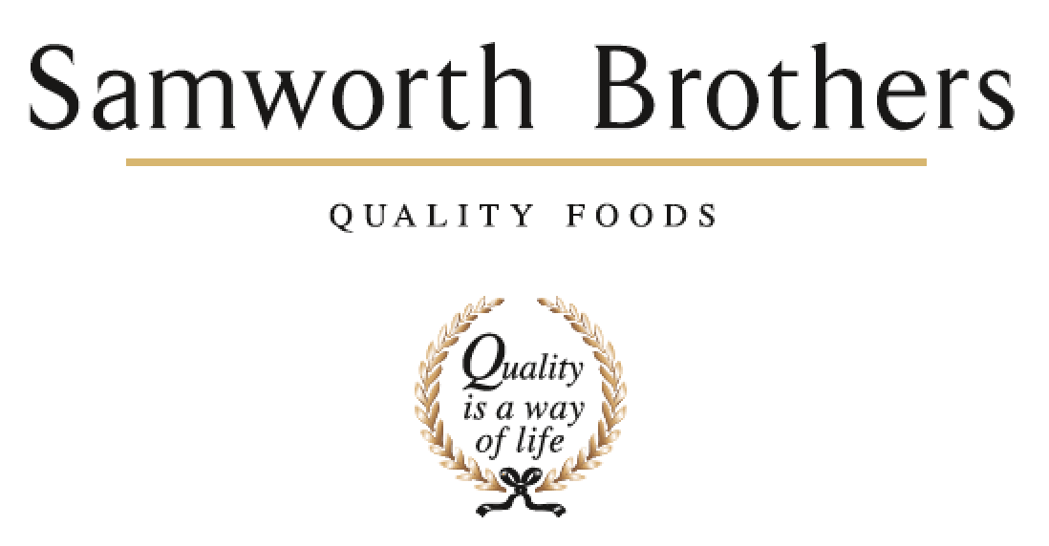

|  |  |  |  |
| --- | --- | --- | --- |
| ROLE PROFILE | | | |
| Job title | Production Manager | Date | September 2024 |
| Business | Samworth Brothers | | |
| Department | Operations / Production | | |
| Location | Bradgate Bakery | | |
| ROLE SUMMARY | | | |
| As a Production Manager you will be involved with the planning, coordination and control of manufacturing processes. You will be responsible for effectively managing all aspects of the site to ensure optimum operational performance. You will be expected to identify, own and project manage process and KPI improvements as well as ensuring compliance with all Manufacturing, Food safety and Health and Safety compliance requirements. As a key role within operations, you will be expected to set a clear example of the Group competencies and values and will develop a talent pipeline within the areas under your remit. | | | |
| REPORTING STRUCTURE | | | |
| Reports to | Site Operations / Manufacturing Manager | | |
| Deputy | Production Manager | | |
| Direct & indirect reports | Area / Zone Managers | | |
| Key internal stakeholders | Departmental Heads / Leads, Production, Technical, Planning, Hygiene,  Finance, SHE Team, People Team, Engineering | | |
| Key external stakeholders | Customers, Tesco’s, Co-op, Starbucks and Auditors. Group Functions. | | |
| SKILLS & ABILITIES | | | |
| * Acts as a role model for the Samworth Brothers Values and Ways of Working and encourages teams to share in our Purpose of “We do GOOD things with GREAT food”. * Works collaboratively with other line managers to build a values-based culture, delivering on the Culture Framework and ensuring that results are achieved with people at the heart of every decision, and consistent focus is given to providing a positive experience for Colleagues. * Builds good relationships ensuring everyone in the team is treated equally and with respect. Ensures relations between shifts and departments are positive and build effective relationships with key internal and external stakeholders. * Leads the teams through change, co-ordinating with managers of other areas to plan communication and anticipate challenges and sensitivities, and identify ways to maximise benefit and minimise any negative impact. Encourages the view that change is a necessary and valuable part of business progress. * Pro-actively takes on personal responsibility and accountability to fully understand challenges, seek solutions, and work collaboratively. Looks to Line Manager for guidance as appropriate. Provides cover for Line Manager as required. * Continually looks to improve own performance and capability by linking personal objectives to support the business and seeks learning and development opportunities for themselves and the team. * Champions, coaches, and leads on continuous improvement initiatives through teams to realise opportunities, establish and embed best practice, and achieve tangible business results * Ensures continuous compliance with Health Safety and Environmental (SHE), procedures and good practices as per the H&S policy. * Ensures that all colleagues are aware of the hazards in the workplace and that risk assessments are considered for all activities, routine and non-routine. * Acts as part of a pro-active team to undertake safety audits, ensuring that matters identified are closed against agreed timescales. * Sets a good example of responsible behaviour. Challenges any unsafe behaviours and leads the teams to improve standards. * Be accountable for food safety, ensuring any corrective action identified through incident follow-up, audit or CI is delivered promptly as a sustainable solution. * Monitors overall operating performance, identifying and resolving any issues with equipment performance or operating procedure which inhibits full achievement of food safety, quality, or performance KPI. Takes responsibility for governance of standards and procedures, ensuring that all settings and standards are adhered to. * Ensures the department delivers food safety & quality, efficiency, colleague safety and customer satisfaction, through robust, repeatable, and consistent improving processes, updating, or creating new processes where the requirement to do so is identified. Routinely review team adherence to SOP's and overall training compliance. Routinely review SOP's to ensure continued relevance. * Ensures new product trials are fully supported, providing clear feedback and guidance around production capabilities and constraints. Driving ownership across multifunctional teams. * Works closely with the technical team – to highlight any trending food technical issues, provide feedback on any product quality concerns, and run root cause analysis to identify and deliver solutions. * Identifies areas for improvement of food safety, quality, and operational efficiency. Delivers Continuous Improvement (CI) projects and Profit Improvement Plan (PiP’s) objectives through improvement teams, ensuring recommendations are implemented. * Works collaboratively and cross-functionally to ensure production plans are attainable and include any necessary contingency provision, creating and driving departmental and shared action plans to achieve business objectives. * Works closely with Engineering to optimise machine efficiency and to agree planned preventative maintenance (PPM) schedule. * Manages operational teams and shares insight to/from cross-functional teams to manage resources and co-ordinate plans to achieve maximum operational performance. * Ensures continuous preparedness for internal and 3rd party audits and achievement of the highest grade against external standards, and to demonstrate this at audit. * Hosts auditors and visitors to the department, and demonstrates a thorough knowledge and understanding of the people, processes, and standards. Involves team members, where appropriate, to demonstrate team engagement and empower others. * Monitors and reviews data on production costs, materials, etc. Identify and manage any particular challenges, trends, or repeating issues. * Conducts analysis and evaluation of available operation data to identify opportunities within the department to increase profitability and/or enhance performance, create action plans and drive progress through structured meetings. * Ensures communication channels within department are robust and deliver timely information in a manner which involves and engages the teams. * Addresses any Employee Relations (ER) issues promptly and in line with Company values, People policies and processes, and best practice and coach line managers to do the same. * Assesses forecasted production demands to develop a labour plan which meets short-medium term need and provides for future skills requirements. Anticipates peak labour demand and periods of low availability and plan ahead accordingly for overtime, agency labour requirements and escalate any particular challenges or concerns. * Takes accountability for fair and ethical management of labour in line with Company rules and Working Time Directive, ensuring line managers are taking a forward-thinking and supportive approach to the management of colleague leave, breaks, overtime and working hours. * Takes accountability for overall attendance and wellbeing across the department. Coach line managers to be pro-active and supportive in encouraging attendance and managing absence. Manage complex and long-term absence cases with support from People team and Occupational Health. Ensure that colleague wellbeing is a clear priority for the teams and encourage an open and supportive culture. * Monitors progress of the team against the overall development and succession plans, coaching line managers to support individual colleague development by offering opportunities for them to develop their experience, knowledge and skills taking into account their Personal Development Plans (PDP's) and departmental succession plans. * Routinely reviews team and individual performance with line managers, coaching them to adopt strategies to enhance results through positive recognition and motivation, or, where a pattern of unsatisfactory performance persists, to challenge through a fair and objective formal process. * Monitors and regularly reviews level of agency use vs overall labour requirements to sustain acceptable ratio and provide routine forecasting information and feedback to assist in managing agency labour supply. Takes accountability for the agency worker experience, ensuring adequate support is given for induction, training, etc. Promptly addresses any issues pertaining to agency workers or agency labour supply. * Develops high performing teams through effective people management and development, recruitment, retention, and succession planning, using the toolkit of People processes and practices and coaching line managers to do the same. Is pro-active in creating a culture in which each colleague feels that they matter. Reviews exit interview responses and take appropriate action. * Communicates effectively and with clarity, using written, verbal, and digital means, and adjusting tone and approach according to the audience and context. * Leads routine departmental line manager briefings and contribute to cross-functional and inter-departmental meetings. Ensure that information is effectively cascaded. Prepare material for departmental team briefings to ensure messages are clear, relevant, and positioned positively. Promptly resolve any challenges around shift handovers or inter-departmental communication. | | | |
| KNOWLEDGE & UNDERSTANDING | | | |
| * Shows clear understanding of own role and how, as line manager, you are a role model for the SB Values and Ways of Working. * Demonstrates knowledge of the Culture Framework and how it is delivered in the business. * Understands the broader business outside of own function and the interdependencies between own department and others. * Demonstrates an awareness of operational and wider business objectives and the goals of other functions and departments to drive active support for progress * Knows how to lead and support change. * Knows how to use forward planning to mitigate risk and enhance efficiency and can apply problem-solving skills in a fast-paced production environment. * Demonstrates knowledge of the principles and methodologies of CI and how and when to use appropriate tools and techniques * Has full knowledge of the SHE management procedures: - Safe Systems of Work, Risk Assessment, Accident Investigation & Reporting, Auditing Skills, Near Miss System, COSHH, Emergency procedures and behavioural safety approach. * Demonstrates knowledge of environmental sustainability and Food Waste Intensity and how relevant factors at play in the operation are managed to deliver improvements. * Knows how to use the H&S and environmental management system. * Demonstrates a full understanding of own responsibilities as a manager of health, safety and environment as per Company policy and can carry out the SSOW's, SOP's and procedures. * Knows the Occupational Health control measures relevant to own operational areas and teams. * Demonstrates full understanding of the Food Safety and Quality Management Systems, Process Control documentation, Hygiene schedules and processes, HACCP, Audit standards, Personal Hygiene as they relate to the teams and area. * Is fully conversant with the manufacturing process and all quality aspects to be observed, with particular focus on Critical Control Points and known key areas of challenge. * Demonstrates clear understanding of all the Standard Operating Procedures (SOP's) and Key Performance Indicators (KPI's) within the team / area. * Fully understands the job roles, training elements and baseline headcount for the team /area. * Shows a good level of product knowledge, from understanding the ingredients involved to the customer specifications. * Knows how to make plans, and to identify and mitigate any risk to required results using critical thinking and contingency planning approach. * Demonstrates knowledge of Lean Manufacturing principles and methodologies. * Knows how to manage resources to achieve business objectives. * Can demonstrate knowledge of all relevant audit standards and customer Codes of Practice. * Understands the importance of own role on delivering customer satisfaction and maintaining critical standards. * Has clear understanding of financial implications of decisions and actions. * Knows what factors drive cost within the area. * Has good levels of numeracy; is able interpret variances and financial and statistical data and then take any necessary action. * Knows how to use all relevant IT software programmes and tools * Has a good knowledge of KPI's and measures are how these are used to drive results in manufacturing processes. * Knows how to manage people in a respectful, fair, and inclusive way in line with our Values. * Can demonstrate knowledge and understanding of the Samworth Brothers People Policies and Processes, job roles and structure, and People Portal system. * Knows how to manage in line with Working Time Directive, Company policy and clocking system rules on working hours, as well as the Ethical Trade Initiative (ETI) Base Code. * Knows how to apply the absence management policy and processes in a pro-active and supportive way to enhance colleague attendance. * Understands the factors which impact colleague wellbeing and knows how to support colleagues in ways which balance with business needs, and how to signpost to additional support when needed. * Knows how to utilise the Samworth Brothers Performance Enhancement process including Ways of Working, Learning toolkit and training and development opportunities. * Understands how to use a coaching style to support others to take ownership of their challenges, solutions, and achievements. * Knows the terms of the agency contracts and service level agreements, and how to work closely with agency contacts to ensure that agency workers are well-supported. * Knows how to conduct a fair and equitable selection process, mitigating personal bias, to hire the most suitable candidate for the requirements of the role. * Can demonstrate knowledge and understanding of the Samworth Brothers Recruitment tools and process, talent & succession toolkit and exit interviews process. * Understands how to communicate effectively, the importance of active listening and clear feedback to ensure effective communications in the workplace. * Has good levels of literacy; can write and produce reports and documentation relevant for the role. * Understands the importance of continued personal and professional development (CPD). | | | |
| QUALIFICATIONS, EXPERIENCE, TECHNICAL SKILLS | | | |
| * Literacy/Numeracy to National Level 2 Standards * HACCP Level 3 * Food Safety Level 3 * IOSH Managing Safely or equivalent | | | |
| CORE COMPETENCIES, ATTRIBUTES & BEHAVIOURS FOR SUCCESS | | | |
| **Competency** | **Descriptors** | | |

|  |  |
| --- | --- |
| Values People | *Demonstrates the belief that people are our most important asset and central to the success of the organisation. Everybody should be treated with dignity and respect at all times.* |
| Customer Focus | *Is passionate about quality, striving to continuously make a positive difference for our customers and our consumers.* |
| Collaborative Team Working | *The willingness to act as part of a team and work towards achieving shared objectives through adopting best practice in line with our Purpose Statement and Company Values.* |
| Flexibility & Adaptability | *The ability to change and adapt own behaviour or work procedures when there is a change in the work environment, for example as a result of changing customer needs.* |
| Initiative & Taking ownership | *Steps up to take on personal responsibility and accountability for tasks and actions in line with our Purpose Statement and Company Values.* |
| People Management | *The ability to understand people and their motivations, build good relationships with them and help them unlock their full potential.* |
| Decision Making & Judgement | *In line with our Purpose statement and Company Values, makes timely and informed decisions that keep the organisation moving forward, taking into account the facts, goals, constraints, and risks.* |
| Commercial Awareness | *Demonstrates an understanding of the impact decisions and actions have on the organisation in line with our Purpose statement and Company Values.* |
| Developing Partnerships | *The ability to establish formal and informal relationships inside and outside the organisation, and to anticipate and balance the needs of those whose cooperation is needed for the long-term success of the business.* |
| Engaging Others through Change | *The ability to communicate a compelling vision, generating genuine motivation and commitment and to act as a sponsor of change.* |
| Focussing on the Future | *Demonstrates enthusiasm about our future by identifying strategic issues, opportunities to drive sustainable, profitable growth, and managing risk. Clearly communicates links between team and organisational goals.* |