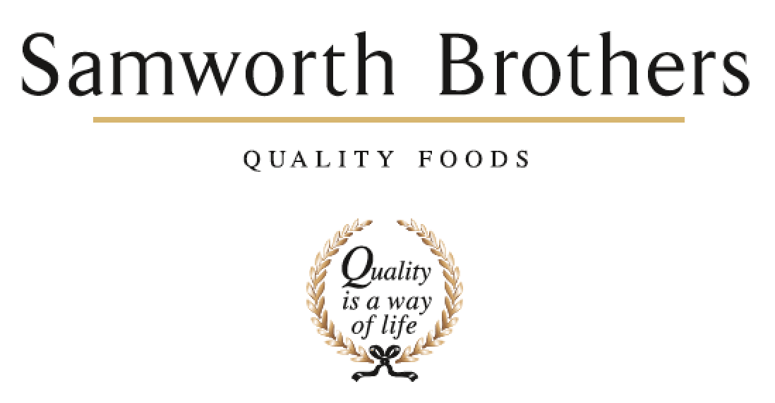

|  |  |  |  |
| --- | --- | --- | --- |
| ROLE PROFILE | | | |
| Job title | Raw Material Technologist | Date | 22/02/24 |
| Business | The Cornwall Bakery | | |
| Department | Technical | | |
| Location | Callington, Cornwall | | |
| ROLE SUMMARY | | | |
| You will be responsible for ensuring that customer, company and legal requirements for raw materials and supplier quality assurance are achieved in conjunction with the Raw Materials Manager. You will manage raw materials specifications, maintain supplier assurance systems, monitor supplier performance and analyse data and trends. | | | |
| REPORTING STRUCTURE | | | |
| Reports to | Raw Material Manager | | |
| Deputy | N/A | | |
| Direct & indirect reports | N/A | | |
| Key internal stakeholders | Procurement,NPD Chefs, Process Team, Operations | | |
| Key external stakeholders | Retailer Customers and Ginsters Brand | | |
| KEY ACCOUNTABILITIES AND RESPONSIBILITIES | | | |
| 1. Approval and maintenance of sites Raw Material Specifications in conjunction with Group Foods Connected Team, including requesting and reviewing these in line with Customer requirements and COP. 2. Maintenance of the sites Vulnerability Risk Assessment including Vegan, Gluten Free and species risk assessments 3. Liaise with site Process team to manage new or contingency raw materials coming onto site for trials or approval 4. To prioritise contingency raw material schedules with reference to business risk rating and other mitigating factors. 5. To liaise with NPD for kitchen trial materials and then the Process team to perform scale up trials in the bakery. Assessment of finished goods quality and customer approvals if required. 6. Communication and engagement with the Technical team to ensure ingredient specifications are obtained, approved and detailed on customer finished product specifications. 7. Liaise with internal departments with reference to raw material quality issues and work closely with the preparation teams to identify and understand raw material focused issues.      1. Liaise and visit suppliers where required and communicate any issues. Agree action plans for next steps and improvements. 2. Consider TACCP and Food Safety controls on all contingency materials      1. Provide cover for Raw Material Inspection role where required. 2. Deputise for the Raw Materials Manager where required. 3. Administrative tasks where required in support of the Raw Material Administrator | | | |
| QUALIFICATIONS, EXPERIENCE, TECHNICAL SKILLS / KNOWLEDGE | | | |
| * Competent computer skills including Microsoft Word, Excel, Powerpoint * Min A level qualification or equivalent * Experience with raw materials in food industry setting preferred. * Retailer standards knowledge ideal * Red Meat / Protein knowledge ideal. | | | |
| CORE COMPETENCIES, ATTRIBUTES & BEHAVIOURS FOR SUCCESS | | | |
| **Competency** | **Descriptors** | | |
| Values People | *Demonstrates the belief that people are our most important asset and central to the success of the organisation. Everybody should be treated with dignity and respect at all times.* | | |
| Customer Focus | *Demonstrates the understanding that the satisfaction of our internal and external customers is the foundation of our success* | | |
| Collaborative Team Working | *The willingness to act as part of a team and work towards achieving shared objectives through adopting best practice in line with PQP and Federalism.* | | |
| Flexibility & Adaptability | *The ability to change and adapt own behaviour or work procedures when there is a change in the work environment, for example as a result of changing customer needs.* | | |
| Initiative & taking ownership | *Steps up to take on personal responsibility and accountability for tasks and actions in line with PQP and Federalism.* | | |
| Drive for Excellence | *Knows the most effective and efficient processes for getting things done, with a focus on continuous improvement.* | | |
| Resource Management | *Effectively manages resources and cost drivers to achieve sustainable productivity and profitability.* | | |
| Technical Expertise | *Has the skills, knowledge and experience required to excel in own area of specialism and the willingness to further grow and develop.* | | |
| Self-Management | *Uses a combination of feedback and reflection to gain insight into personal strengths and weaknesses, so that own time, priorities and resources can be managed to achieve goals.* | | |