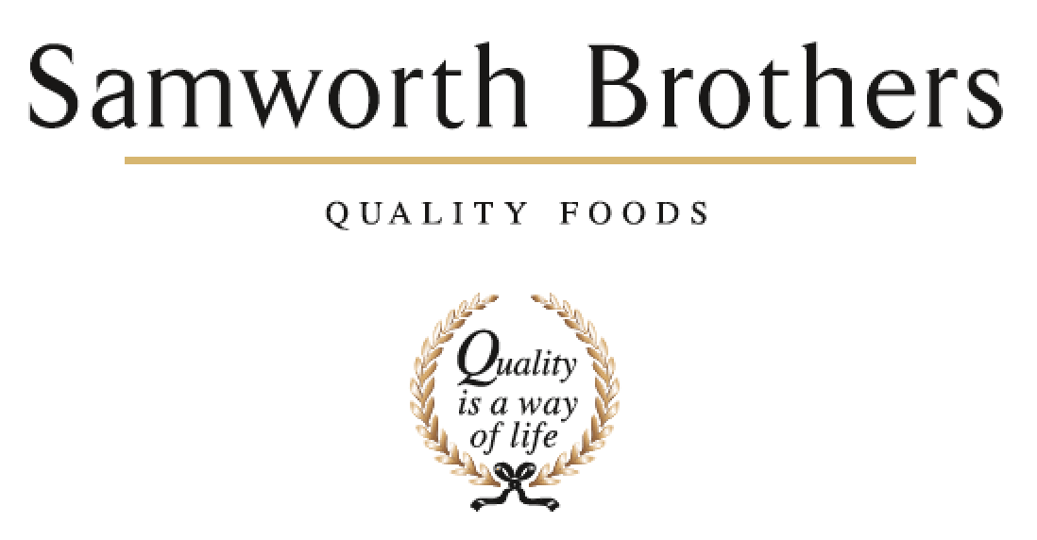

ROLE PROFILE
Job title | Area Manager | Date | 16.6.2021
Business | FTG - Bradgate Bakery
Department | Production
Location | Madeline Road / Ashton Green
ROLE SUMMARY
Reporting to the Production Manager you, will be instrumental in managing the day-to-day and longer-term activities of your department. This will involve accountability for attaining daily production plans whilst effectively managing your resources in line with the business’s KPIs and ensuring adherence to GMP standards.

REPORTING STRUCTURE
Reports to | Production Manager
Direct & indirect reports | Shift Team Leaders / Trainers / production operative
Key internal stakeholders | Hygiene Managers  Technical team  EngineeringTeam  Planning  C I Team
Key external stakeholders | Retail Customers – Tesco’s, Starbucks, Urban Eat Brand.

KEY ACCOUNTABILITIES AND RESPONSIBILITIES
- Ensure that all required Health & Safety checks and procedures are carried out in accordance with Health and Safety Toolkits and guidance.
- Lead our colleagues in the department or line to become a motivated and engaged teams, through organisation of job rotation, conducting personal reviews (PEM’s), ensure all appropriate colleague training is up to date, coaching, appropriate delegation, and regular communication of business and team performance.
- Coaches Team Leaders to be effective and lead the Samworth Way.
- Achievement of KPI’s in relation to production efficiencies, people, quality and profitability, through a continuous improvement approach and the manufacturing plan
- You will be able to plan, structure and organise work in order to set relevant objectives, key logical plans, prioritise critical tasks and monitor progress.
- Co-ordination of permanent and temporary labour during shift
- Ensuring the department has the appropriate number of skilled people to manage peak periods and a talent pipeline is in progress.
- You will have to liaise with all other areas of the business to ensure successful achievement of manufacturing targets
- Evaluate performance against targets on a regular basis throughout the day and take appropriate action on variances between planned and actual performance.
- Ensure that appropriate technical standards are maintained to the highest standards
- Ensure all Standard Operating Procedures (SOP’s) and Safe Systems of Work (SSOW’s) are correctly followed at all times.
- Drive colleague engagement and have a clear action plan in place to drive improve and retention
- Managing up to 16 lines during a shift with multiple changes overs and Allergen, Vegetarian, and species (AVS) cleans
- Engaging with customers during product panels, launches and audits

QUALIFICATIONS, EXPERIENCE, TECHNICAL SKILLS / KNOWLEDGE
- Experience in a supervisory / management capacity within a chilled food environment.
- Hands- on experience of running a department within food production
- Commercial awareness and a strong commitment towards quality and customer service
- A resilient, credible leadership style with the ability to inspire, coach and develop your team
- The ability to work, under pressure, on your own initiative and to ‘think outside the box’
- Good understanding of HACCP
- Knowledge and experience of managing absence, performance and conduct issues
- Level 3 or above Food Safety is desirable
- Level 2 and IOSH or above Health and Safety

CORE COMPETENCIES, ATTRIBUTES & BEHAVIOURS FOR SUCCESS
Competency | Descriptors
Values People | Demonstrates the belief that people are our most important asset and central to the success of the organisation. Everybody should be treated with dignity and respect at all times.
Customer Focus | Demonstrates the understanding that the satisfaction of our internal and external customers is the foundation of our success
Collaborative Team Working | The willingness to act as part of a team and work towards achieving shared objectives through adopting best practice in line with PQP and Federalism.
Flexibility & Adaptability | The ability to change and adapt own behaviour or work procedures when there is a change in the work environment, for example as a result of changing customer needs.
Initiative & taking ownership | Steps up to take on personal responsibility and accountability for tasks and actions in line with our values of Family, Pride and making things happen. .
People Management | The ability to understand people and their motivations, build good relationships with them and help them unlock their potential.
Empowering others | Creates an environment where people feel required and enabled to take ownership and responsibility.
Coaching for performance | The ability to help others achieve more through two-way feedback, clear direction and enabling.
Analysis & Planning | The ability to take a range of information, think things through logically and prioritise work to meet commitments aligned with organisational goals.
Drive for Excellence | Knows the most effective and efficient processes for getting things done, with a focus on continuous improvement.

