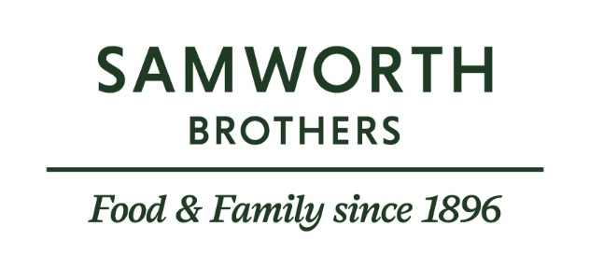

ROLE PROFILE
Job title | Pensions Administrator – Group Pensions | Date | 14 April 2025
Business | Group Functions
Department | Group Pensions
Working Hours | Monday – Friday 8.30am – 5.00pm – can be flexible/part time
Location | Oak Meadow, Scudamore Road, Leicester.  The role requires frequent travel to other sites which could include an overnight stay. Flexible working/working from home is also available.
ROLE SUMMARY
Reporting to the Pensions Specialist, you will provide an outstanding service and administrative support to the business and Pensions team’s stakeholders. You will be the first point of contact for pensions queries and perform administrative aspects of the Pensions teams responsibilities.
REPORTING STRUCTURE
Reports to | Pensions Specialist
Key internal stakeholders | People teams, Payroll team, Communications team & members.
Key external stakeholders

KEY ACCOUNTABILITIES AND RESPONSIBILITIES
- Monitor & triage incoming post & forward to the relevant Scheme Administrator, respond to straightforward queries.
- Monitor pensions email inbox & respond to straightforward member queries, providing accurate & timely responses. Refer more complex queries to Pensions Specialist.
- Organise and host pension surgeries and regular site visits to ensure colleagues have face to face access to a pensions team member as often as possible.
- Monitor Mercer Master Trust contribution submissions for weekly, monthly & executive payrolls.
- Log & code all Pensions invoices & pass for payment.
- Booking meeting venues & arranging refreshments for Trustee meetings.
- Supporting the People & Payroll teams within the Group with straightforward queries, refer complex queries to Pensions Specialist or Scheme Secretary.
- Archiving, scanning correspondence & filing member documents.
- Any other administrative tasks required by the Pensions Specialist.

QUALIFICATIONS, EXPERIENCE, TECHNICAL SKILLS / KNOWLEDGE
Experience - essential
- Experience of working in a customer facing role
- Experience in taking direct calls and receiving direct emails
- A good working knowledge or Microsoft Word, Excel, Outlook and to an extent PowerPoint
Experience - desirable
- A basic understanding of UK pension schemes
- A basic understanding of payroll practices
- A basic understanding of Life Assurance schemes
- A basic understanding of Group Income Protection schemes
- A basic understanding of Data Protection legislation
- Experience in dealing with sensitive cases (ill health and death)

Attributes – essential
- Excellent organisational skills,
- Excellent verbal and written communication skills,
- Excellent attention to detail,
- Ability to work using own initiative or as part of a wider team,
- Confident in making decisions quickly and efficiently,
- Confident in escalating queries to correct point of contact,
- Maintaining confidentiality and sensitivity at all times,
- Positive and professional attitude.

CORE COMPETENCIES, ATTRIBUTES & BEHAVIOURS FOR SUCCESS
Competency | Descriptors
Values People | Demonstrates the belief that people are our most important asset and central to the success of the organisation. Everybody should be treated with dignity and respect at all times.
Customer Focus | Demonstrates the understanding that the satisfaction of our internal and external customers is the foundation of our success
Collaborative Team Working | The willingness to act as part of a team and work towards achieving shared objectives through adopting best practice in line with our Purpose & Values.
Flexibility & Adaptability | The ability to change and adapt own behaviour or work procedures when there is a change in the work environment, for example as a result of changing customer needs.
Initiative & taking ownership | Steps up to take on personal responsibility and accountability for tasks and actions in line with our Purpose & Values.
Drive for Excellence | Knows the most effective and efficient processes for getting things done, with a focus on continuous improvement.
Resource Management | Effectively manages resources and cost drivers to achieve sustainable productivity and profitability.
Technical Expertise | Has the skills, knowledge and experience required to excel in own area of specialism and the willingness to further grow and develop.
Self-Management | Uses a combination of feedback and reflection to gain insight into personal strengths and weaknesses, so that own time, priorities and resources can be managed to achieve goals.

