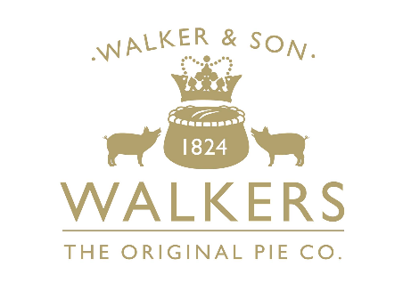

Process Administrator

Job Accountabilities
- To assist the Process team with the collection of Nutritional and Shelf-life samples for required testing via Westward labs and Eurofins.
- To be responsible for managing the Shelf life and Nutritional Critical Paths which involves tracking timelines and reviewing results of concern e.g. salt levels with Technical and Process; this is key to ensure any anomalies or out of spec results are assessed and, appropriate action taken prior to customer Gate Panels
- To support the Process and NPD teams on managing organoleptic reviews of trial products during various stages of life and, any quality concerns to be addressed ahead of customer Gate Panels.
- Further to clearly document all sensory results and ensure filed with the corresponding micro pack and passed to the Artwork Specifications team for upload to retailer online specifications.
- To manage product Re-heats as appropriate and other back of pack product information either at site or with external bodies such as Campden.
- Assist the Process team with trials where additional resource is required, which in turn will enhance their knowledge of key savoury pastry processes.
- To support the Senior Process Technologist with management of the trial Freezer bake programme and ensure returns are progressed within regular timelines and again progressed via relevant sensory panels.
- To assist the Process Team in the creation of QAS and input of key information and photos which are critical to the quality of new and existing retailer lines.
- Assist the Process team with trials where additional resource is required, which in turn will enhance their knowledge of key savoury pastry processes
- Participate in the organisation of customer visits to site and ensure all critical information e.g. line standards, PPR booklets and QAS are in place.
- Assist with the general collection of trial and launch samples and dispatch to customers as requested by the Process Team.

Qualifications, Experience, Technical Skills & Knowledge,
- Food Manufacturing or administrative background with an interest in the Process and wider technical function.
- Good organisational skills, attention to detail and managing timelines.
- Ability to take detailed photographs of products.
- A strong collaborator with the ability to multitask and work well with other staff across NPD, Technical, Purchasing and Operations.
- Good interpersonal skills.
- All relevant training to manage Nutritional, Sensory will be given thus a ‘positive work attitude’ and a keen desire to learn is key to this role.
- No formal qualifications needed, just a basic understanding of food safety and quality which will form part of the introductory role training.
- Basic IT Knowledge with emphasis on excel and word would be advantageous for report writing.
- Role will involve the use of a camera and/or IPAD for setting up QAS and line standards thus attention to detail will be required to emphasise key quality points.

In return you will receive a comprehensive benefits package including competitive salary, excellent pension plan, private healthcare (after qualifying period), 25 days holiday (plus 8 bank holidays), profit share and the chance to develop your career with Samworth Brothers.

