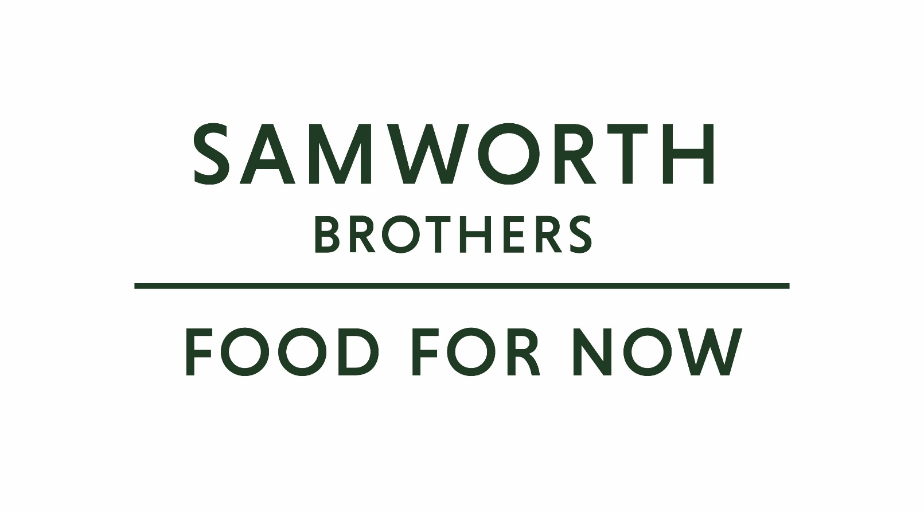

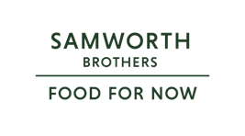

|  |  |  |  |
| --- | --- | --- | --- |
| ROLE PROFILE | | | |
| Job title | Senior Brand Manager – Urban Eat & West Cornwall Pasty Co | Date | June 2025 |
| Business | Food For Now | | |
| Department | Marketing Team | | |
| Location | Leicestershire | | |
| ROLE SUMMARY (main purpose) | | | |
| The Senior Brand Manager will be based within the Food for Now marketing Team, responsible for our company owned Urban Eat & West Cornwall Pasty Co brands. They will act as the brand guardian, lead the strategic direction for the brands and how this translates into innovation and communication plans. The role has a strong emphasis on driving the NPD agenda for both brands. | | | |
| REPORTING STRUCTURE | | | |
| Reports to | Head of Marketing | | |
| Direct & indirect reports | Brand Manager, Marketing Executive | | |
| Key internal stakeholders | Senior Leadership Team, Commercial Team, Finance Team, Bakery Teams, 3rd Party Manufacturers, Operations Teams | | |
| Key external stakeholders | Design / marketing agency / key customer accounts | | |
| KEY ACCOUNTABILITIES AND RESPONSIBILITIES | | | |
| **Brand Management**   * Responsible for the development and execution of annual brand plans across UE & WCP product launches and ensuring that they are aligned to our customer strategies. * Working alongside our category and NPD team in managing both EPD and NPD projects with the bakery & 3rd party suppliers. * Lead all agencies working on the brands to create a collaborative working environment that builds on the annual campaign and delivers a consistent approach across all channels. * Own the brand P&L, tracking performance against signed off annual budget and constantly looking at ways to optimise and improve our profit through cost re-engineering, innovation, and where appropriate CAPEX projects. * Give direction to the Trade & Shopper Manager for brand activation to produce the most effective creative content, across NPD launch campaigns, packaging, eCommerce and experiential projects. * Support the Marketing Executive to create marketing collateral for trade, consumer and online. * Work alongside Head of Marketing and trade PR agency to build brand equity across the trade and internally. * Work with Senior Customer Marketing Manager on potential range changes and insight driven range/ brand additions. * Work with colleagues and partners for the creation, execution and management of content for social media channels – communicating key brand messages and supporting website content. * Manage the brand guidelines, and where applicable campaign guidelines and toolkit. * Ensure all communication is clear and consistent with brand messaging and tone of voice. * Monitor brand performance, using sales, financial, marketing and consumer data. * Work with relevant internal teams to protect brand trademarks. | | | |
| QUALIFICATIONS, EXPERIENCE, SKILLS / KNOWLEDGE | | | |
| Qualifications | Degree level, ideally within the field of business and/ or marketing | | |
| Experience | Previous experience of working in a similar role managing and developing a brand and managing a budget. Experience of managing external agencies | | |
| Skills/ Knowledge | Solid project management skills, commercially aware, problem solving, influencing, passion for marketing and putting the customer at the heart of everything we do | | |
| PERSONAL ATTRIBUTES & BEHAVIOURS | | | |
| 1. Choose a positive attitude  2. Understand your impact  3. Take personal responsibility  4. Resilience  5. Achieve results  6. Customer service  7. Managing  8. Leading | | | |
| COMPETENCIES FOR SUCCESS | | | |
| Competency | Descriptors | | |
| Values People | Demonstrates the belief that people are the most important asset and central to the success of the organization. Everybody should be treated with dignity and respect at all times. | | |
| Customer Focus | Demonstrates the understanding that the satisfaction of our internal and external customers is the foundation of our success | | |
| Collaborative Team Working | The willingness to act as part of a team and work towards achieving shared objectives through adopting best practice in line with PQP and federalism | | |
| Flexibility and Adaptability | The ability to change and adapt our own behaviour or work procedures when there is a change in the work environment, for example, as a result of changing customer needs | | |
| Initiative and Taking Ownership | Steps up to take on personal responsibility and accountability for tasks and actions in line with PQP and Federalism. | | |