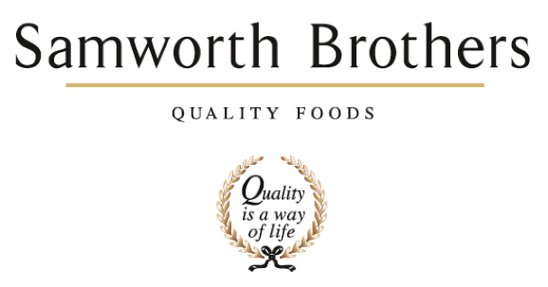

|  |  |  |  |
| --- | --- | --- | --- |
| ROLE PROFILE | | | |
| Job title | Process Technologist | Date | Jan ‘25 |
| Business | Samworth Brothers Walkers Deli | | |
| Department | Process Development – Technical | | |
| Location | Cobden Street, Leicester | | |
| ROLE SUMMARY | | | |
| Involvement in all stages of trial development from handover to launch for multiple premium supermarket brands of cooked meats and pate. Supporting with business projects linked to sustainability and efficiency improvement. Working with a wide range of teams across the whole business to deliver a consistent high quality and safe product in line with customer and site expectations. | | | |
| REPORTING STRUCTURE | | | |
| Reports to | Senior Process Technologist | | |
| Direct & indirect reports | N/A | | |
| Key internal stakeholders | Operations, NPD, Commercial, Specifications, Technical Systems, QA, Planning, Finance | | |
| Key external stakeholders | Retailers (project dependant), Suppliers (project dependant) | | |
| RESPONSIBILITIES, OBJECTIVES & EXPERIENCE GAINS | | | |
| The candidate, reporting into the Senior Process Technologist, and working within the team will be responsible for:   * Conducting factory trials in conjunction with customer codes of practice, including the capturing of traceability and trial data to populate the product folder. * Generating and updating product factory documents, including standards and specifications. * Organising post trial outputs to include; communicating approved recipes for BOM setup, organisation of samples for microbiological & chemical testing, customer samples and organoleptic testing * Supporting business projects and working collaboratively with the wider business to provide support in process matters.   Objectives & Experience Gains   * Understand the gate process from handover to launch, the key stakeholders involved and the steps required to deliver a successful launch to the required deadline. * Develop an understanding of the manufacturing processes involved in cooked meat and pate. The individual will gain exposure to meat butchery, curing, cooking and packing processes * Gain experience working across multiple teams in a fast passed environment, developing on organisation and communication skills * Gain technical knowledge and skills including validation process, shelf life determination and HACCP | | | |
| WHY PROCESS | | | |
| The Process team touch almost all areas of the business, it is a fantastic department to gain an appreciation for how all the roles interact in food manufacturing. There is massive scope for development and learning in this role whilst being part of a strong & supportive team. | | | |
| CORE COMPETENCIES, ATTRIBUTES & BEHAVIOURS FOR SUCCESS | | | |
| **Competency** | **Descriptors** | | |
| Values People | *Demonstrates the belief that people are our most important asset and central to the success of the organisation. Everybody should be treated with dignity and respect at all times.* | | |
| Customer Focus | *Demonstrates the understanding that the satisfaction of our internal and external customers is the foundation of our success* | | |
| Collaborative Team Working | *The willingness to act as part of a team and work towards achieving shared objectives through adopting best practice in line with PQP and Federalism.* | | |
| Flexibility & Adaptability | *The ability to change and adapt own behaviour or work procedures when there is a change in the work environment, for example as a result of changing customer needs.* | | |
| Initiative & taking ownership | *Steps up to take on personal responsibility and accountability for tasks and actions in line with PQP and Federalism.* | | |
| Drive for Excellence | *Knows the most effective and efficient processes for getting things done, with a focus on continuous improvement.* | | |
| Resource Management | *Effectively manages resources and cost drivers to achieve sustainable productivity and profitability.* | | |
| Technical Expertise | *Has the skills, knowledge and experience required to excel in own area of specialism and the willingness to further grow and develop.* | | |
| Self-Management | *Uses a combination of feedback and reflection to gain insight into personal strengths and weaknesses, so that own time, priorities and resources can be managed to achieve goals.* | | |