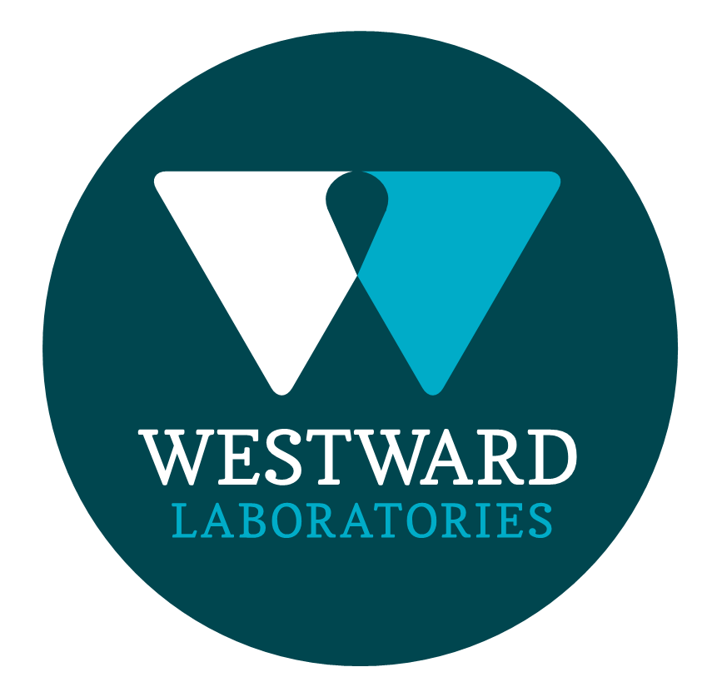

|  |  |
| --- | --- |
| **ROLE PROFILE** | |
| Job Title | Laboratory Analyst |
| Department | Laboratory |
| **ROLE SUMMARY** | |
| To carry out microbiological analysis of food and other materials, practicing aseptic technique and complying with the standards and principals set out in the Microbiology and Quality Manuals. Undertake tasks related to testing, promoting efficient work flow and a hygienic work environment.  To ensure that the accreditation requirements of ISO 17025 and the Campden BRI Retailer Supplementary Audit (RSA) Scheme are followed at all times. | |
| **REPORTING STRUCTURE** | |
| Reports to | Laboratory Supervisor |
| Direct & indirect reports | N/A |
| Key internal stakeholders | All departments within Westward and the wider Samworth Brothers Group |
| Key external stakeholders | External Customers, Accreditation Bodies |
| Deputy | N/A |
| KEY ACCOUNTABILITIES AND RESPONSIBILITIES | |
| * Microbiological testing of samples, which includes the sample preparation and plating, plate reading and interpretation and confirmation. The testing and related tasks must be carried out aseptically, following the methods described in the Microbiology Manual and the principles set out in the Quality Manual. The work is generally tackled as a team effort and analysts may undertake a variety of tasks within the day to provide optimum work flow. * Perform scheduled equipment checks and take appropriate action when equipment is not functioning correctly. Complete equipment monitoring records. * Undertake cleaning and hygiene operations during and at the end of the working day ensuring a high standard of personal cleanliness, maintaining clean equipment and workstations and proper disposal of laboratory waste. * Participate in internal and external quality control programmes. * Preparation of media when extra assistance or holiday/sick cover is required in this department. * Records results on LIMS and identify out of specification results and suspect Listeria and Salmonella detection to the appropriate Manager. * Report contamination, anomalous results or other internal anomalies to Manager. * Report any other internal anomalies to a Manager. * Demonstrate to other staff test of procedures in which you are fully trained and experience and supervise trainees work until you judge them to be proficient and aware of the critical points. * Observe the security procedures applicable to the results and data produced. * Answer telephone calls referring enquiries to the relevant person. * Maintain a professional approach at all times working alongside and supporting the team and management at all times. Set an example in your behaviour and work for other members of staff. * Good service is part of the company’s philosophy and as a customer focused industry all customers must be dealt with professionally as customer satisfaction depends on the whole of the team. * Ensure you act as part of the team and not just as an individual by good communication, cooperating and sharing skills. * Promote a posting and praising culture both vertically and horizontally within the team framework at the laboratory. * Communicate your ideas and problems and help the business achieve better solutions. * Be responsible for health and safety in the department and enforce safe practices of work and raise concerns with the Health and Safety Representative and or more Senior Management. | |
| QUALIFICATIONS, EXPERIENCE, TECHNICAL SKILLS / KNOWLEDGE | |
| * Two A level passes in science based subjects for five GCSE’s (Grade C or above) * Laboratory experience * Current Driving Licence * Evaluation skills * Knowledge of security requirements * Experience of equipment operation and check procedures * Effective team player | |
| **COMPETENCIES, ATTRIBUTES & BEHAVIOURS FOR SUCCESS** | |
| **CORE WAYS OF WORKING** | |
| **Competency** | **Descriptor** |
| Values People | Demonstrates the belief that people are our most important asset and central to the success of the organisation. Everybody should be treated with dignity and respect at all times. |
| Customer Focus | Demonstrates the understanding that the satisfaction of our internal and external customers is the foundation of our success |
| Collaborative Team Working | The willingness to act as part of a team and work towards achieving shared objectives through adopting best practice in line with PQP and Federalism. |
| Flexibility & Adaptability | The ability to change and adapt own behaviour or work procedures when there is a change in the work environment, for example as a result of changing customer needs. |
| Initiative & taking ownership | Steps up to take on personal responsibility and accountability for tasks and actions in line with PQP and Federalism. |