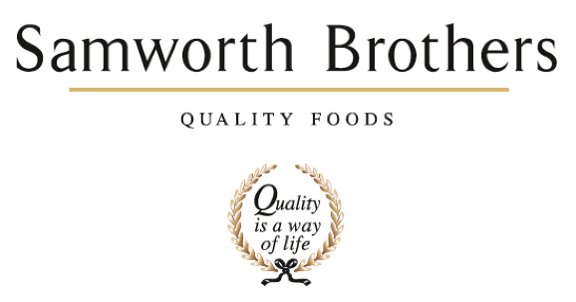

|  |  |  |  |
| --- | --- | --- | --- |
| ROLE PROFILE | | | |
| Job title | Senior Process Technologist | Date | 20.12.24 |
| Business | Samworth Brothers Ready Meals | | |
| Department | Process Development – Technical | | |
| Working Hours | Monday to Friday 08:30-17:00 | | |
| Location | Kettleby Foods, Melton Mowbray | | |
| ROLE SUMMARY | | | |
| Responsible for the generation and day to day management of customer critical paths in line with the Samworth Brothers Launch Process.  Management of customers’ expectations with delivery of concept to launch projects and other business lead initiatives within the process remit.  Assist in the coaching and development of a team of technologists, to deliver against the customer critical path.  Deputise for the Process Manager as required. | | | |
|  | | | |
| Reports to | Process Development Manager | | |
| Direct & indirect reports | Process Development Technologists | | |
| Key internal stakeholders | Production, Planning, Finance, Technical Services, QA and Commercial | | |
| Key external stakeholders | Retailers, Suppliers (project dependant) | | |
| KEY ACCOUNTABILITIES AND RESPONSIBILITIES | | | |
| * Management of customer critical paths in line with the Samworth Brothers Launch Process * Take ownership of customer visits that are process development lead. * Champion products from concept to launch and being the owner and contact for retailer projects * Manage post-trial outputs to include; initiation of BOM’s, completion of product specific documentation, organisation of samples for microbiological & chemical testing, customer samples and organoleptic testing * Manage post-trial meetings, capturing actions and ensuring close out of actions * Engage and build positive relationships with our customers both internally and externally * Create and manage pre-production agenda in conjunction with the Samworth Brothers Launch Process * Collaboratively work with manufacturing teams to identify process improvement opportunities with the business and lead initiatives * Be an active member of the site HACCP team to ensure robust controls are identified and changes communicated to the wider business. * Deputise for the Process Development Manager where necessary * Coach and develop a team of technologists both in role and in the Samworth Brothers Core Values * Working collaboratively with the wider business to provide support in process matters * Maintain high technical and quality standards in line with the businesses policies and procedures | | | |
| QUALIFICATIONS, EXPERIENCE, TECHNICAL SKILLS / KNOWLEDGE | | | |
| * Working knowledge of Food Manufacturing practices, ideally FMCG * Good working knowledge of customer concept to launch protocols * Collaborative team worker and able to work on own initiative * Experience of managing a small team, with demonstratable leadership skills * Strong attention to detail * Excellent written and verbal communication skills at all levels * Self-motivated, enthusiastic and able to work well under pressure * Good IT skills with experience of using MS Excel, Word, PP & Outlook * Strong organisational and planning skills * Flexible approach to working hours and business demands * Driving license * HND/BSc, preferably Food Science (desirable) * Minimum of 12 months working experience within chilled food manufacturing, ideally within a process or NPD function * Understanding of HACCP application and considerations * Understanding of allergen controls within a manufacturing area | | | |
| CORE COMPETENCIES, ATTRIBUTES & BEHAVIOURS FOR SUCCESS | | | |
| **Competency** | **Descriptors** | | |
| Customer Focus | Demonstrates the understanding that the satisfaction of our internal and external customers is the foundation of our success. | | |
| People Management | The ability to understand people and their motivations, build good relationships with them and help them unlock their potential | | |
| Drive for Excellence | Knows the most effective and efficient processes for getting things done, with a focus on continuous improvement. | | |
| Initiative & Taking Ownership | Steps up to take on personal responsibility and accountability for tasks and actions in line with PQP and Federalism. | | |
| Flexibility & Adaptability | The ability to change and adapt own behaviour or work procedures when there is a change in work environment, for example because of changing customer needs. | | |