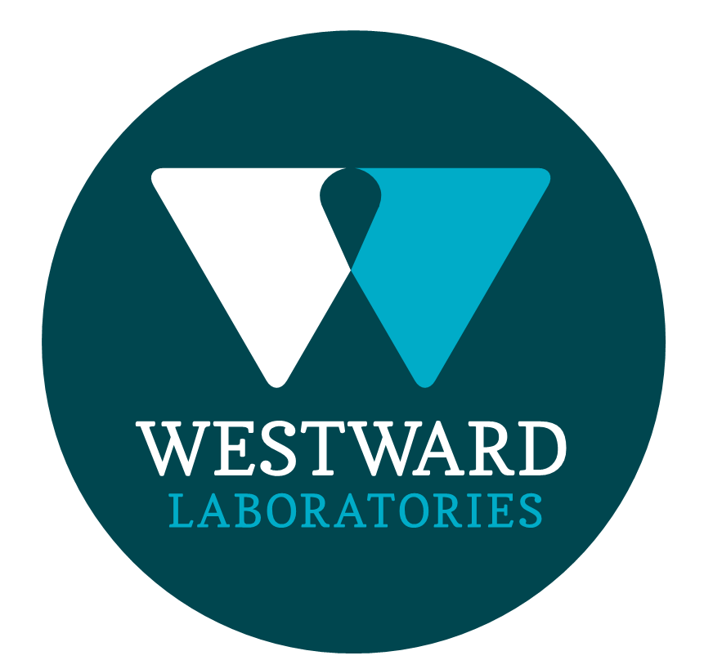

|  |  |
| --- | --- |
| **ROLE PROFILE** | |
| Job Title | Laboratory Hygiene Steward |
| Department | Laboratory |
| **ROLE SUMMARY** | |
| To undertake cleaning of Westward Laboratories Microbiology, Pathogen and Media Preparation departments.  To ensure that the accreditation requirements of ISO 17025, and the Campden BRI Retailer Supplementary Audit (RSA) Scheme are followed at all times. | |
| **REPORTING STRUCTURE** | |
| Reports to | Laboratory Supervisor |
| Direct & indirect reports | N/A |
| Key internal stakeholders | All departments within Westward, Samworth Brothers Group |
| Key external stakeholders | Consumable Suppliers, Accreditation Bodies |
| Deputy | N/A |
| KEY ACCOUNTABILITIES AND RESPONSIBILITIES | |
| * Clean laboratory environment in accordance with Hygiene Schedule for those departments following the requirements and procedures set out in the Hygiene Manual. Ensure all Hygiene paperwork is completed. * Clean laboratory areas in liaison with analytical staff in accordance with Hygiene Schedule and Hygiene Manual. * Communicate stock levels of cleaning supplies and equipment to the Customer Service Manager. * Perform weekly deep clean duties in laboratory departments. * Transfer waste from laboratory areas to the wheelie bin and assist laboratory staff in the disposal of non-infected waste. * Assist laboratory staff in disposing of infected waste, operating the waste disposal unit and autoclaves. Check sterilisation cycle and transfer processed waste to the wheelie bin. * Assist laboratory staff in loading and unloading the glass washer, maintaining a constant supply of clean, dry apparatus to the laboratory. * Assist the media preparation staff where necessary. * Maintain an efficient flow of stock from storage shed to relevant laboratory departments when required. Manage and maintain good stock rotation practices. * Carry out duties without compromising quality or efficiency of laboratory output. * Be responsible for health and safety in the department and enforce safe practices of work and raise concerns with the Health and Safety Representative and or more Senior Management. * Observe the security procedures applicable to the results and data produced and security of the building and laboratories. * Maintain a professional approach at all times working alongside and supporting the team at all times. * Ensure you act as part of the team and not as an individual by good communication, cooperation and sharing skills. * Promote a positive and praising culture both vertically and horizontally within the team framework. * Communicate your ideas and problems and help the business achieve better solutions. * Good service is part of the company’s philosophy and as a customer focused industry all customer must be dealt with professionally as a customer satisfaction depends on the whole team. | |
| QUALIFICATIONS, EXPERIENCE, TECHNICAL SKILLS / KNOWLEDGE | |
| * Good General Education * Good Knowledge of cleaning and hygiene * Use of chemicals for cleaning tasks. * Basic understanding of laboratory operation * Manual handling techniques * Basic knowledge of media prep procedures * Knowledge of equipment operation and check procedures | |
| **COMPETENCIES, ATTRIBUTES & BEHAVIOURS FOR SUCCESS** | |
| **CORE WAYS OF WORKING** | |
| **Competency** | **Descriptor** |
| Values People | Demonstrates the belief that people are our most important asset and central to the success of the organisation. Everybody should be treated with dignity and respect at all times. |
| Customer Focus | Demonstrates the understanding that the satisfaction of our internal and external customers is the foundation of our success |
| Collaborative Team Working | The willingness to act as part of a team and work towards achieving shared objectives through adopting best practice in line with PQP and Federalism. |
| Flexibility & Adaptability | The ability to change and adapt own behaviour or work procedures when there is a change in the work environment, for example as a result of changing customer needs. |
| Initiative & taking ownership | Steps up to take on personal responsibility and accountability for tasks and actions in line with PQP and Federalism. |