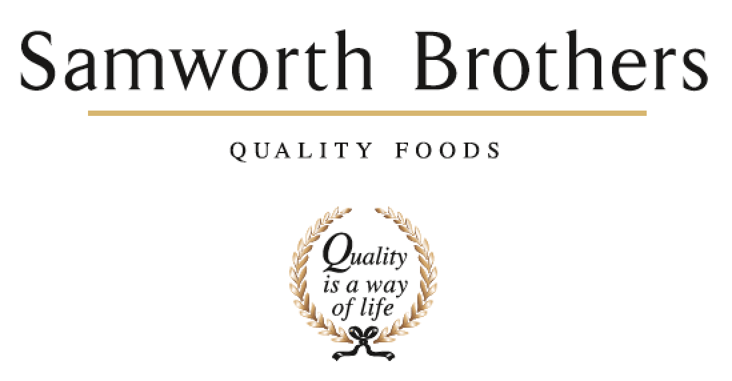

|  |  |  |  |
| --- | --- | --- | --- |
| ROLE PROFILE | | | |
| Job title | QA | Date | October 2020 |
| Business | As applicable | | |
| Department | Technical | | |
| Location | As applicable | | |
| ROLE SUMMARY | | | |
| To ensure that all aspects of food safety, quality and legality for the products manufactured are complied with ensuring that the technical integrity of the site is maintained. | | | |
| REPORTING STRUCTURE | | | |
| Reports to | QA Team Leader | | |
| Direct & indirect reports | None | | |
| Key internal stakeholders | Operations team, Process team, Supply chain, Technical systems team, Hygiene team | | |
| Key external stakeholders | Suppliers and Customers (Various depending on business) | | |
| KEY ACCOUNTABILITIES AND RESPONSIBILITIES | | | |
| 1. Audit compliance against Quality Management Systems and GMP, hygiene and fabrication standards raising all non-conformances against relevant standards with objective evidence enabling the operational teams to take the appropriate and necessary corrective action, to follow up and monitor completion of actions. 2. Understand and apply the business quality standards ensuring company, customer and legislative requirements are met and maintained by monitoring and evaluating good manufacturing practices applying HACCP principles. 3. Organizing and undertake taste panels, relevant paperwork and ensuring corrective actions are put into place to prevent recurrence 4. To carry out quality checks across the site against documented standards- e.g. Goods in, stored wip, online assembly. 5. Accurately complete micro testing submissions, nutritional, speciation and allergen against schedules, support investigations including traceability and root cause analysis. 6. Support NPD trials and product launches, managing micro testing and product life assessment to ensure product is manufactured to correct standard. 7. Work with the production teams on continuous improvement of operation compliance. 8. Provide initial expertise/guidance for any technical challenges raised by the operations team. 9. To audit the adherence of site segregation- e.g. Allergen, species, claims 10. Ability to work flexibly as required to meet business needs. 11. Ability to work under pressure to deadlines and on own initiative 12. Represent both themselves and the Company in a positive, open and professional manner at all times 13. Strong commitment to living and promoting the company values | | | |
| QUALIFICATIONS, EXPERIENCE, TECHNICAL SKILLS / KNOWLEDGE | | | |
| * Technical knowledge and expertise within chilled food. * Experience of customer and industry audits * HACCP Level 2 * Food Safety Level 2 * Internal audit trained * Strong influencing skills * Proactive person who is not only able work as part of a close-knit team, but also on their own initiative with the confidence in decision making * Good attention to detail * Have a sound understanding of microbiological aspects present in a food manufacturing factory. * Excellent knowledge of MS Office – Word / Excel / PowerPoint. * Strong communication and interpersonal skills including both written and verbal communication * Flexible approach | | | |
| CORE COMPETENCIES, ATTRIBUTES & BEHAVIOURS FOR SUCCESS | | | |
| **Competency** | **Descriptors** | | |
| Values People | *Demonstrates the belief that people are our most important asset and central to the success of the organisation. Everybody should be treated with dignity and respect at all times.* | | |
| Customer Focus | *Demonstrates the understanding that the satisfaction of our internal and external customers is the foundation of our success* | | |
| Collaborative Team Working | *The willingness to act as part of a team and work towards achieving shared objectives through adopting best practice in line with our values* | | |
| Flexibility & Adaptability | *The ability to change and adapt own behaviour or work procedures when there is a change in the work environment, for example as a result of changing customer needs.* | | |
| Initiative & taking ownership | *Steps up to take on personal responsibility and accountability for tasks and actions in line with PQP and Federalism.* | | |
| People Management | *The ability to understand people and their motivations, build good relationships with them and help them unlock their potential.* | | |
| Empowering others | *Creates an environment where people feel required and enabled to take ownership and responsibility.* | | |
| Coaching for performance | *The ability to help others achieve more through two-way feedback, clear direction and enabling.* | | |
| Analysis & Planning | *The ability to take a range of information, think things through logically and prioritise work to meet commitments aligned with organisational goals.* | | |
| Drive for Excellence | *Knows the most effective and efficient processes for getting things done, with a focus on continuous improvement.* | | |