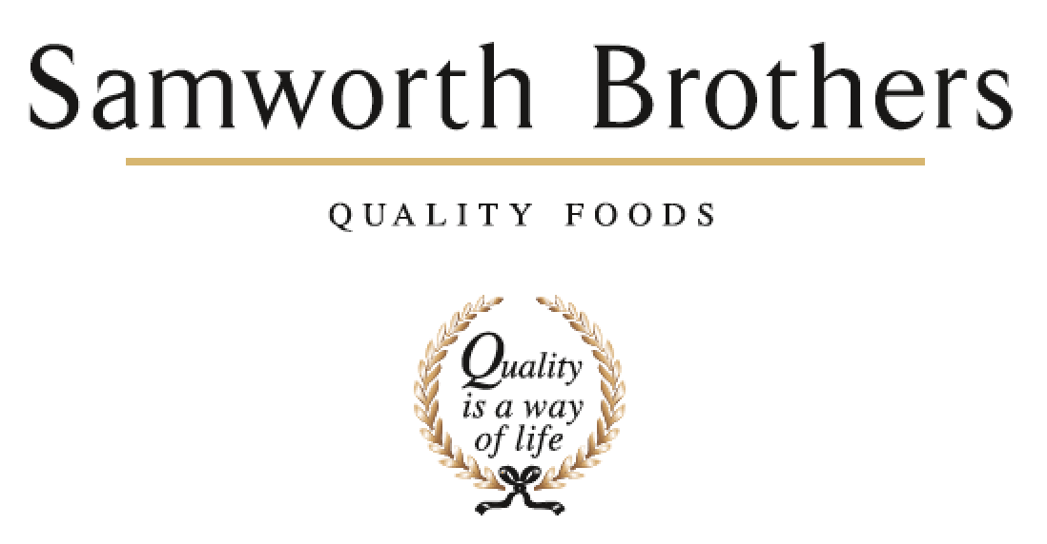

|  |  |  |  |
| --- | --- | --- | --- |
| ROLE PROFILE | | | |
| Job title | Site Services Engineer | Date |  |
| Business |  | | |
| Department | Engineering | | |
| Location |  | | |
| ROLE SUMMARY | | | |
| Reporting directly to the Site Services team leader. The Site Services engineers role will be a direct support for Operations Samworth Brothers strategy for Manufacturing Excellence & Engineering, including – Asset Care and Maintenance, Reliability, Maintenance Cost through continuous improvement initiatives, a “First time Fix” approach to breakdwowns and Health, Safety & Environmental compliance.  Work in collaboration with broader business teams and stakeholders to improve operational performance and contribute to sustainable business success.  The position is based on (*08:00 – 16:00)* with a starting salary (*TBC)*  The Site Services team are a crucial part of the engineering team and operational process. Failure of equipment within the site services area could have a detrimental impact to the business and our customers.  Your role is to ensure key equipment such as *(Refrigeration systems, Air Handling, Compressed air systems, Steam systems, Electrical systems, Effluent systems, water systems and legionella control etc…)* are maintained to the highest standards and quickly rectified should an issue arise. Whilst ensuring food safety and health & safety compliance is maintained.  A breakdown in these areas which cannot be rectified in time would need escalating to the Engineering Team Leader/ Engineering Management and supported through following site processes to ensure plant availability and compliance are returned in a timely manner.  This role will require an individual who is driven, motivated, can work under pressure, prioritise own workload and has a keen attention to detail.  Your duties as a Site Services Engineer are as follows:   * Support legislative compliance. * Preventative maintenance on plant and equipment. * Responding to emergency plant and equipment breakdowns. * Managing contractors on site. * Support design, installation, and movement of machines and equipment. * Overhaul and repair equipment and machinery. * Carrying out plant checks forming part of compliance and plant availability. * Electrical fault finding. * Ensuring site services plant and equipment is compliant, safe and fit for purpose. * Carry out continuous improvement projects. * Support engineering daily, weekly & monthly plans. * Attend meetings as required. * Perform RCA on failed equipment and offer solutions to prevent re-occurrence. * Effective communication – keeping management and relevant parties aware and seeking advice and assistance when required. * Work with and coordinate contractors as and when required. * Risk assesses activities to ensure your safety and others around you.   The above list offers an insight to key duties and what is required as a Site Services Engineer.  There might be other duties to help maintain and support the bakery that is within the engineering teams capabilities and skill set.  You might be asked to deputise for the Engineering Team Leader to cover holiday and absence. This is to support engineering and operational continuity between shifts and ensure communication is maintained throughout the operational process and tiered management.  There will be other duties as deputy to the Team Leader such as:   * Engineering & maintenance planning. * Ensure parts availability to achieve planned maintenance tasks. * Attend tier 1 and management meetings. * Arrange contractors to attend site. * Delegate work requests to peers.   There are opportunities to further develop as a Site Services Engineer through the Samworth Brothers Engineering Career Path. Which is fully supported with training and mentorship. | | | |
| REPORTING STRUCTURE | | | |
| Reports to | Site Services Team Leader | | |
| Deputy |  | | |
| Direct & indirect reports |  | | |
| Key internal stakeholders | Health & Safety, Engineering, Operations, Hygiene, Technical teams & Hayley Stores | | |
| Key external stakeholders | Engineering contractors | | |
| SKILLS & ABILITIES | | | |
| Leadership & Management   * Act as a role model for the Samworth Brothers Values and Ways of Working and encourages teams to share in our Purpose of “We do GOOD things with GREAT food”. * Work collaboratively with the leaders and managers of the business to build a values-based culture, delivering on the Culture Framework and ensuring that results are achieved with people at the heart of every decision, and consistent focus is given to providing a positive experience for Colleagues. * Take a long-term view of all business relationships and pro-actively builds relationships at all levels. Role model and develop relationships which inspire trust between colleagues, teams, and departments, and with external stakeholders. * Supports the impact of organisational change within the operation, to maximise benefit and minimise any negative impact. Encourages the view that change is a necessary and valuable part of business progress. * Pro-actively take personal responsibility and accountability to fully understand challenges, seek solutions, and facilitate collaborative working. Look to senior peers for guidance as appropriate. * Continually look to improve own performance and capability by linking personal objectives to support the business and seeks learning and development opportunities. Take ownership for own Continuing Professional Development (CPD)   Health & Safety, Responsible Business   * Has a strong understanding and actively supports the culture of behavioural safety, encouraging shared ownership of safe working practices and risk mitigation. * Actively seeks and reports any hazards found to peers & engineering management. * Has a strong understanding and can demonstrate safe isolation. * Supports and understands the importance of SOP’s, challenges those who don’t follow the correct standard and actively coaches to the right standard. * Takes time to Risk assess their own work prior to commencing and is able to put controls in place to reduce risk. Highlights and reports any residual risks which cannot be mitigated. * Proactively seeks to improve their own safety and safety of others by feeding back to leaders that can impact and improve safe systems of work, Risk assessments & reports Hazards. * Act as a role model of responsible behaviour. Challenge any unsafe behaviours and lead the teams to improve standards.   Food Safety & Quality   * Takes accountability for food safety, ensuring any corrective work carried out, has been completed to a high quality and standard. Ensuring maintenance carried out on processes which can impact CCP’s have been communicated to key stakeholders for validation. * Work closely with the Technical and Operations teams to ensure all Engineering work is carried out in accordance with food safety best practice, and to highlight, resolve and/or advise on any food safety issues or concerns in which machinery, facilities or engineering practice is a factor.   Engineering Operations & Performance   * Understands the importance of Engineering plans which are in place to meet the needs of the business and the manufacturing operation. Actively communicates with engineering stakeholders should plans need changing, allowing Engineering management time to make required amends & communicate accordingly. * Drive collaboration between departments and cross functional teams to pro-actively manage own workload and prioritises with Engineering team leader. * Strives for high standards in their own Engineering, quality of work and internal customer satisfaction, monitoring, and following up to management with corrective actions as required through Mainsaver. * Ensure continuous preparedness for internal and 3rd party audits and achievement of the highest grade against external standards, and to demonstrate this at audit. * Takes responsibility of contractors when issuing permits. Ensuring site contractor management protocols are met and adhered to. Reports contractors to engineering management who do not follow site standards. * Identify areas for improvement of Engineering practice to support overall efficiency and quality, and food safety. Offers ideas on Continuous Improvement (CI) projects and Profit Improvement Plan (PIP) through improvement teams & engineering management. * Has a strong understanding the impact site service equipment can have on the business and the importance to ensure all assets are effectively maintained to a high standard.   People Management   * Facilitate effective communication between teams, other departments, and other sites. * Is fair and ethical in line with Company rules and Working Time Directive, constructively challenges peers and reports to engineering management if these rules and directives are being broken. * Be accountable for their overall attendance and wellbeing. * Actively seeks for a development and succession plan with their manager - monitor skills and capabilities against business requirements and put in place action plans which continually enhance business performance and support internal career progression. Ensure that line managers and colleagues fully utilise the development tools and resources. * Be supportive of peers; coach, empower, and motivate people to achieve goals.   Communication   * Communicate in a clear and confident manner that involves and engages others, flexing between different styles to suit the audience and situation. Influence and engage across various levels of the business. Manage confidentiality and sensitive information appropriately. * Deliver and lead meetings as required (If made deputy), ensuring that information is effectively shared and cascaded, and solutions and actions are agreed. | | | |
| KNOWLEDGE & UNDERSTANDING | | | |
| Leadership & Management   * Demonstrate a clear understanding of your role and how as a Site Services Engineer, you are a role model for the Samworth Brothers Values and Ways of Working. * Have solid business acumen - understands the way business operates and how the moving parts work together to make it successful. Know how to read the progress of the business through its financial metrics and has awareness of the levers, risks and opportunities which impact profitable growth. * Demonstrate understanding of the business’ overall strategic objectives and the goals of other functions and departments and can drive active support for these. * Actively supports change, including communication and consultation with peers and stakeholders. * Understands the importance of continued personal and professional development (CPD).   Health & Safety, Responsible Business   * Has an awareness and understanding of the Health & Safety and Environmental management procedures: - Safe Systems of Work, Risk Assessment, Accident Investigation & Reporting, Auditing Skills, Near Miss System, COSHH, Emergency procedures and behavioural safety approach. * Demonstrate a sound knowledge of environmental sustainability and how to manage relevant factors in the operation. * Knows how to use the H&S and environmental management IT system. * Recognise own responsibilities as a Site Services engineer of health, safety, and environment as per Company policy and has the knowledge to carry out and uphold the SSOW's, SOP's and procedures. * Knows the Occupational Health control measures and routine surveillance programme.   Food Safety & Quality   * Demonstrate clear understanding of the Food Safety and Quality Management Systems, Process Control documentation, Hygiene schedules and processes, HACCP, Audit standards, Personal Hygiene. * Has an understanding of the manufacturing processes and key quality aspects to be observed, with particular focus on Critical Control Points and known key areas of challenge. * Demonstrate clear understanding of all the Standard Operating Procedures (SOP's) and Key Performance Indicators (KPI's) for the operation. * Demonstrate an appreciation of product knowledge, from understanding the ingredients involved to the customer specifications and process flow.   Engineering Operations & Performance   * Knows how to analyse and interpret engineering day plans and information to make short and long-term Engineering plans, and how to identify and mitigate any risk to required results using critical thinking and contingency planning approach with their line manager. * Understands best practice Engineering in the context of food manufacturing, and knows how to deliver consistent standards of all key components – safety, legal and regulatory compliance, asset care and maintenance, quality work, internal customer service, etc * Understands the principles and methodologies of Continuous Improvement (CI), how and when to select and apply these tools and techniques until best practice is sustained, and can guide others to do the same. * Understands the principles of RCA. * Understands the principles and methodologies of PPS. (Practical Problem Solving) * Knows how to manage their own time to achieve business objectives. * Can demonstrate knowledge of all relevant legal, regulatory, audit standards and customer Codes of Practice. * Understand the importance of own role on delivering internal customer satisfaction and attaining and maintaining critical standards in partnership with other business functions. * Has clear understanding of the financial implications of decisions / actions. * Knows how to use all relevant IT software programmes and tools. * Has a good knowledge of KPI's and measures are used to drive results in Engineering and manufacturing processes.   People Management   * Knows how to work people in a respectful, fair, and inclusive way in line with our Values and acts as a role model of good people management practice. * Has a good knowledge of the Samworth Brothers People Policies and Processes, job roles and structure, and People Portal system. * Knows how to manage in line with the Working Time Directive, Company policy, as well as the Ethical Trade Initiative (ETI) Base Code. * Understands the factors which impact colleague wellbeing and knows how to support colleagues in ways which balance with business needs, and how to signpost to additional support when needed. * Knows how to effectively utilise the Samworth Brothers tools - Talent & Succession toolkit, Performance Enhancement process, including Ways of Working, Learning Toolkit and the training and development opportunities. * Understands how to use a coaching style, empowering others to deliver results and develop understanding through personal accountability. Can clearly articulate the methodology and models behind this approach.   Communication   * Knows how to communicate effectively, to engage and motivate, adjusting the approach according to context and audience, and acts as a role model for effective communication, active listening, and feedback. * Has good levels of literacy; is able to write and produce reports and documentation relevant for the role. * Understands how to produce presentations to share ideas, engage the audience and garner support from key stakeholders. | | | |
| QUALIFICATIONS, EXPERIENCE, TECHNICAL SKILLS | | | |
| * NVQ3 / HND or equivalent in Mechanical / Electrical Engineering. * IOSH essential * 18th Edition Electrical Regs BS7671 * Electrical and mechanical fault-finding skills. * A strong understanding of Route Cause Analysis * Legionella Awareness essential * Boiler Awareness essential * Ammonia Awareness essential * Understanding of refrigeration systems | | | |
| CORE COMPETENCIES, ATTRIBUTES & BEHAVIOURS FOR SUCCESS | | | |
| Values People | *Demonstrates the belief that people are our most important asset and central to the success of the organisation. Everybody should be treated with dignity and respect at all times.* | | |
| Customer Focus | *Demonstrates the understanding that the satisfaction of our internal and external customers is the foundation of our success* | | |
| Collaborative Team Working | *The willingness to act as part of a team and work towards achieving shared objectives through adopting best practice in line with PQP and Federalism.* | | |
| Flexibility & Adaptability | *The ability to change and adapt own behaviour or work procedures when there is a change in the work environment, for example as a result of changing customer needs.* | | |
| Initiative & taking ownership | *Steps up to take on personal responsibility and accountability for tasks and actions in line with PQP and Federalism.* | | |
| People Management | *The ability to understand people and their motivations, build good relationships with them and help them unlock their potential.* | | |
| Decision making and judgement | *In line with our guiding principles of PQP & Federalism, makes timely and informed decisions that take into account the facts, goals, constraints and risks that keep the organisation moving forward.* | | |
| Commercial awareness | *Demonstrates an understanding of the impact decisions and actions have on the organisation in line with PQP and Federalism.* | | |
| Developing partnerships | *The ability to establish formal and informal relationships inside and outside the organisation, and to anticipate and balance the needs of those whose cooperation is needed for the long-term success of the business.* | | |
| Engaging others through change | *The ability to communicate a compelling vision throughout the organisation, generating genuine motivation and commitment and to act as a sponsor of change.* | | |
| Focussing on the future | *Demonstrates enthusiasm about our future by identifying strategic issues, opportunities to drive sustainable, profitable growth, and managing risk.* | | |
|  |  | | |