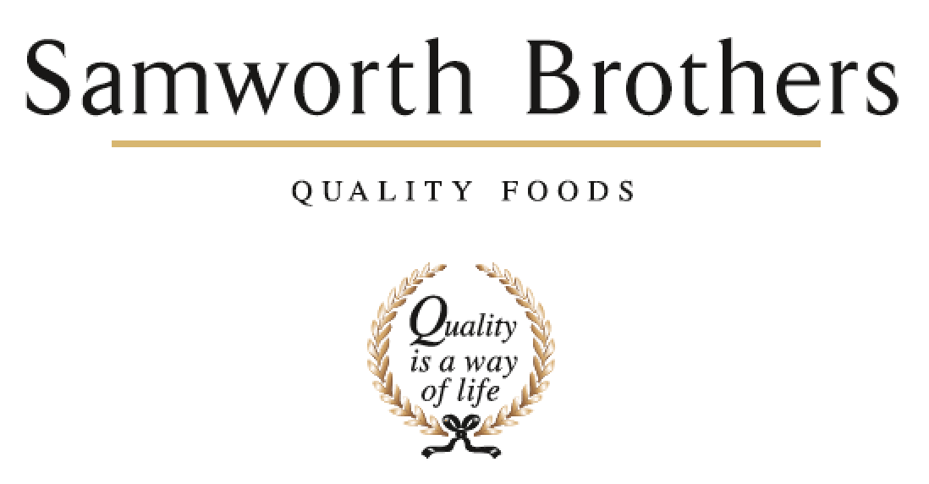

|  |  |  |  |
| --- | --- | --- | --- |
| ROLE PROFILE | | | |
| Job title | Senior Compliance Technologist | Date | 27th August 2025 |
| Business | Food to go | | |
| Department | Technical | | |
| Location | Manton Wood | | |
| ROLE SUMMARY | | | |
| As a **Compliance Officer**, you will play a key role in supporting the technical team in maintaining food safety, legality, and quality across site operations. You will deputise for the Compliance Manager when required, lead traceability activities, manage technical documentation, and help ensure alignment with BRC and major retailer standards | | | |
| REPORTING STRUCTURE | | | |
| Reports to | Compliance Manager | | |
| Direct & indirect reports | None | | |
| Key internal stakeholders | Compliance Team  Raw Materials Team  QA Team  Operations Team | | |
| Key external stakeholders | Technical team on other FTG sites | | |
| KEY ACCOUNTABILITIES AND RESPONSIBILITIES | | | |
| 1. Deputise for the Compliance Manager as needed 2. Lead traceability exercises and mass balance reporting, ensuring all processes are accurately documented and in line with site and customer expectations. 3. Conduct traceability challenge tests within a four-hour timeframe, in accordance with the designated rota. Document any issues as non-conformances, ensuring all results are scored, recorded, and trended for continuous improvement. 4. Prepare and present traceability exercises as required for third-party or internal audits, ensuring full compliance with relevant standards and audit readiness at all times. 5. Monitor and manage the site's traceability non-conformance system, working collaboratively across departments to ensure timely investigation and closure of non-conformances with robust root cause analysis and effective corrective actions 6. Prepare and maintain launch documentation for new products and processes 7. Perform GAP analyses against customer standards and internal procedures 8. Write, review, and update site procedures and technical documentation 9. Collate, analyse, and report on KPI data; identify and communicate trends 10. Support closure of non-conformances through effective root cause analysis and corrective action 11. Collaborate with cross-functional teams to drive site-wide compliance improvements 12. Maintain the QMS and support site readiness for BRC and customer audits 13. Assist in delivering technical training and briefings where appropriate 14. Chair meetings and drive actions to ensure full closure 15. Cover other roles within the department, including deputising for the Compliance Manager 16. Carry out internal audits | | | |
| QUALIFICATIONS, EXPERIENCE, TECHNICAL SKILLS / KNOWLEDGE | | | |
| * Practical experience in a technical or compliance role within food manufacturing * Working knowledge of BRCGS standards and major UK retailer codes of practice * HACCP understanding and application (ideally Level 3) * Proven ability to conduct GAP analyses and implement compliance actions * Experience with QMS systems and technical documentation management * Competent in collecting and analysing KPI data for trend reporting * Strong time management and organisational skills * Confident in cross-functional collaboration * Skilled in non-conformance management and root cause analysis * Strong factory traceability programme skills and experience * Internal audit trained * Excellent Excel skills * Forward thinking and ability to use own initiative * Good attention to detail * Proactive approach to daily tasks * Microbiological knowledge would be an advantage   **What sort of person are we looking for?**  Someone who lives the Samworth Brothers Values: 1) We are a Family; 2) We take Pride; 3) We Make Things Happen. | | | |
| CORE COMPETENCIES, ATTRIBUTES & BEHAVIOURS FOR SUCCESS | | | |
| **Competency** | **Descriptors** | | |
| Values People | Demonstrates the belief that people are our most important asset and central to the success of the Organisation. Creates a culture where everybody is treated with dignity and respect at all times and diversity of thought is encouraged. | | |
| Customer Focus | Is a visionary in the area of Customer Experience and can structure a business to create the right offer for our existing and future customers and consumers through insight and innovation. | | |
| Collaborative Team working | Demonstrates the ability to influence, persuade and collaborate across the Samworth Brothers Business and Group Functions to sustainable profitable growth for the Group | | |
| Flexibility & adaptability | Demonstrates the ability to create an agile organisation that can respond quickly and efficiently to the changing environment | | |
| People Management | Demonstrates good emotional intelligence with the ability to build, develop and lead a great team and to understand people and their motivations, build good relationships with them and help them unlock their potential | | |
| Commercial Awareness | Demonstrates an understanding of the Commercial impact decisions and actions have on the Organisation. | | |
| Engaging others through change | Outstanding communicator with the ability to communicate a compelling vision throughout the organisation, generating genuine motivation and commitment to deliver the change. | | |
| Focusing on the future | Demonstrates enthusiasm about our future by identifying strategic issues, opportunities to drive sustainable, profitable growth, and managing risk. | | |
| Developing Partnerships | The ability to establish formal and informal relationships inside and outside the organisation, and to anticipate and balance the needs of all stakeholders whose cooperation is needed for the long-term success of the business. | | |
| Decision making & Judgement | Demonstrates the ability to deal with complexity and make timely and informed decisions that take into account the facts, goals, constraints and risks that keep the Organisation moving forward. | | |