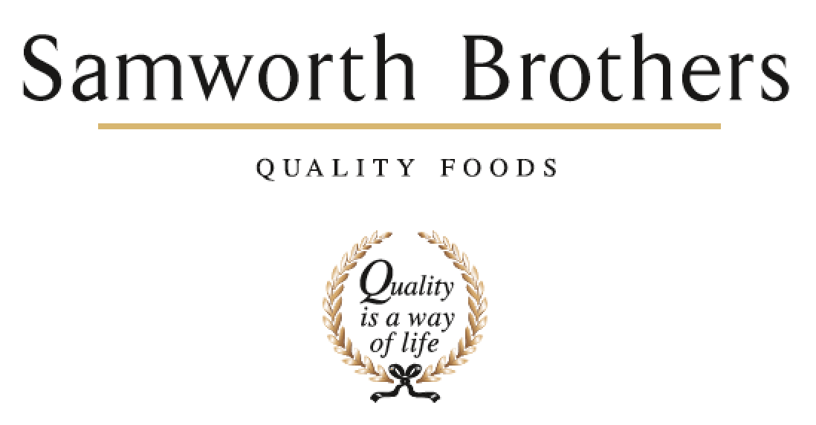

|  |  |  |  |
| --- | --- | --- | --- |
| ROLE PROFILE | | | |
| Job title | Compliance Manager: Specifications | Date | Aug 2025 |
| Business | Meals Division | | |
| Department | Technical | | |
| Location | Leicester | | |
| ROLE SUMMARY | | | |
| Drive product Quality and safety on site through specifications. Build customer confidence and engagement as the main contact with customers for specification and artwork critical paths, project challenges and KPI data. The role will involve working closely with internal NPD, Process Development and Commercial departments.  Responsible for the internal systems in place for the creation and maintenance of customer specifications.  Responsible for artwork approval process and the main coordinator for private brand artwork file creation and approval.  To be responsible for all activity, mentorship and training within the team to ensure project activity is completed accurately. Project management of the critical path post scale up trials is to be set, managed and completed on time. To ensure workplans maintain audit ready status for customer specifications and the additional documents linked to internal, customer and audit criteria. | | | |
| REPORTING STRUCTURE | | | |
| Reports to | Technical Services Manager | | |
| Direct & indirect reports | Senior Spec Techs, Spec Techs | | |
| Key internal stakeholders | Technical Services, Operations, Hygiene, Commercial, Process, Planning, Health, Safety and Environment, Engineering, People Team, Supply Chain | | |
| Key external stakeholders | All external customers, audit bodies and suppliers | | |
| KEY ACCOUNTABILITIES AND RESPONSIBILITIES | | | |
| To have overall responsibility of compliance of the Specification Management System ensuring that delivering needs and fit for purpose, complaint with food safety, quality and legal requirements.  **Responsibilities**   * Help deliver group, customer and category strategy within the site. Adopt and embed Samworth Way best practice. * To actively engage and lead the cross functional site teams to maintain a top-level audit ready standard at all times through compliance. * Seek best practice from other sites in group when implementing or upgrading site policies and procedures. * Seek industry updates to ensure full compliance. * Active engagement and implementation of change management across the site’s. * To manage teams workload and key responsibilities to deliver Customer and category requirements including Audits, Artwork and Specifications. * Develop team * Drive standards using set KPIs and a continuous improvement culture * Deputise for the Technical Services Manager for specification and artwork duties. * Manage the compliance and deliver customer requirements via the Technical Services Department ensuring the criteria and customer rules set in customer codes of practice are met. * Project Management and critical path delivery. * Support NPD process any queries relating to customer codes of practice or labelling queries, reviews at feasibility stage to ensure data at customer feasibility sessions is accurate. * Customer Specifications **–** Ensure all customer specifications and artwork are accurate and delivered in a timely manner**.** | | | |
| QUALIFICATIONS, EXPERIENCE, TECHNICAL SKILLS / KNOWLEDGE | | | |
| **Qualification**   * Minimum HND/Degree in a food related subject, or relevant experience.   **Experience**   * Experience in delivering and managing third party and customer standards * Minimum 2 years’ experience in a Technical specification systems in a food manufacturing environment * Ability to demonstrate a high degree of planning organisational and detailed analytical skills * Confident decision-making skills * Effective communication skills * A strong leader of people with previous experience and proven track record of developing people * Focussed on achieving results * A self-starter able to use own initiative with a pro-active approach * Problem solving & organisation skills * Ability to work well under pressure * Computer Literacy (Word, Excel, Powerpoint, databases, Power BI) * Driving License is required * Experience of completing launches with a large number of retail and branded products * Experience using product retails specifications and artwork systems for multiple retailers * Understanding of labelling regulationsand an understanding of each retailers labelling guidelines | | | |
| CORE COMPETENCIES, ATTRIBUTES & BEHAVIOURS FOR SUCCESS | | | |
| **Competency** | **Descriptors** | | |
| Values People | *Demonstrates the belief that people are our most important asset and central to the success of the organisation. Everybody should be treated with dignity and respect at all times.* | | |
| Customer Focus | *Demonstrates the understanding that the satisfaction of our internal and external customers is the foundation of our success* | | |
| Collaborative Team Working | *The willingness to act as part of a team and work towards achieving shared objectives through adopting best practice in line with PQP and Federalism.* | | |
| Flexibility & Adaptability | *The ability to change and adapt own behaviour or work procedures when there is a change in the work environment, for example as a result of changing customer needs.* | | |
| Initiative & taking ownership | *Steps up to take on personal responsibility and accountability for tasks and actions in line with PQP and Federalism.* | | |
| Drive for Excellence | *Knows the most effective and efficient processes for getting things done, with a focus on continuous improvement.* | | |
| Resource Management | *Effectively manages resources and cost drivers to achieve sustainable productivity and profitability.* | | |
| Technical Expertise | *Has the skills, knowledge and experience required to excel in own area of specialism and the willingness to further grow and develop.* | | |
| Self-Management | *Uses a combination of feedback and reflection to gain insight into personal strengths and weaknesses, so that own time, priorities and resources can be managed to achieve goals.* | | |