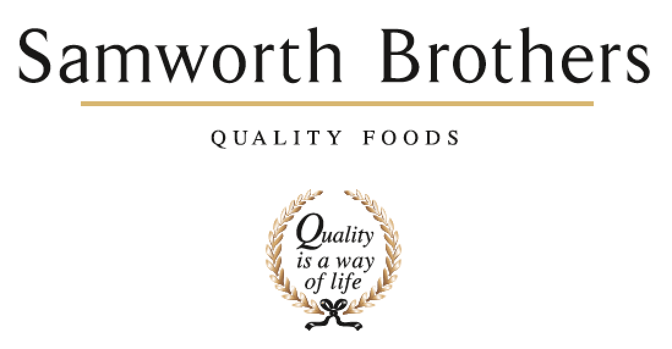

|  |  |  |  |
| --- | --- | --- | --- |
| ROLE PROFILE | | | |
| Job title | Technical Analyst | Date | July 2024 |
| Business | Bradgate Bakery | | |
| Department | Technical | | |
| Location | Madeline Road / Ashton Green | | |
| ROLE SUMMARY | | | |
| To ensure that all aspects of food safety, quality and legality for the products manufactured are complied with ensuring that the technical integrity of the site is maintained. | | | |
| REPORTING STRUCTURE | | | |
| Reports to | Senior Quality Systems Technologist / Compliance Manager | | |
| Direct & indirect reports | None | | |
| Key internal stakeholders | QA Departments, Technical Managers, Process Team, Specifications team, Production, Commercial | | |
| Key external stakeholders | All customers – quality of data | | |
| KEY ACCOUNTABILITIES AND RESPONSIBILITIES | | | |
| * + Prioritise and multitask work set on daily basis.   + To update Technical Systems to allow the production of safe, legal and high-quality products.   + Weekly and monthly Technical and customer KPI data collation, including trending of data, to be accurately completed and issued when required.   + To keep trending systems up to date and in working order.   + To ensure the coding schedule is correct and issued on time.   + To ensure complaints are logged and shared with the site QA teams, and all responses are typed and communicated back to customers.   + Monitoring of Customer Retail Systems – monitor all alerts and customers testing results, ensuring any surveillance fails are communicated to the appropriate teams.   + To provide support to the specification’s teams for ad-hoc spec updates and artwork checks.   + Maintenance of internal audits and fabric audits schedules ensuring any non-conformances raised are logged.   + Data input into various technical trackers to include micro results, nutritional and corrective actions.   + To ensure the nutritional trackers remain up to date and inform the QA teams of adverse results.   + Update, amend and issue Technical Paperwork as and when required.   + To prepare presentations for Technical KPI meetings when required.   + Generation of ad hoc presentation packs, trending reports, summary reports as required   + To ensure document control is completed effectively and in a timely manner. | | | |
| QUALIFICATIONS, EXPERIENCE, TECHNICAL SKILLS / KNOWLEDGE | | | |
| * Excellent knowledge of MS Office – Word / Excel / PowerPoint * Excellent knowledge of Power Bi * Excellent verbal and written communication skills * Effective planning and organization skills * Works in an accurate / logical / methodical manner * Continually challenges / drives standards forward * Good working knowledge of IT systems and on-line retailer portals * General technical knowledge * Experience in a Technical System role in chilled food manufacture - preferred | | | |
| CORE COMPETENCIES, ATTRIBUTES & BEHAVIOURS FOR SUCCESS | | | |
| **Competency** | **Descriptors** | | |
| Values People | *Demonstrates the belief that people are our most important asset and central to the success of the organisation. Everybody should be treated with dignity and respect at all times.* | | |
| Customer Focus | *Demonstrates the understanding that the satisfaction of our internal and external customers is the foundation of our success* | | |
| Collaborative Team Working | *The willingness to act as part of a team and work towards achieving shared objectives through adopting best practice in line with PQP and Federalism.* | | |
| Flexibility & Adaptability | *The ability to change and adapt own behaviour or work procedures when there is a change in the work environment, for example as a result of changing customer needs.* | | |
| Initiative & taking ownership | *Steps up to take on personal responsibility and accountability for tasks and actions in line with PQP and Federalism.* | | |
| Empowering others | *Creates an environment where people feel required and enabled to take ownership and responsibility.* | | |
| Analysis & Planning | *The ability to take a range of information, think things through logically and prioritise work to meet commitments aligned with organisational goals.* | | |
| Drive for Excellence | *Knows the most effective and efficient processes for getting things done, with a focus on continuous improvement.* | | |