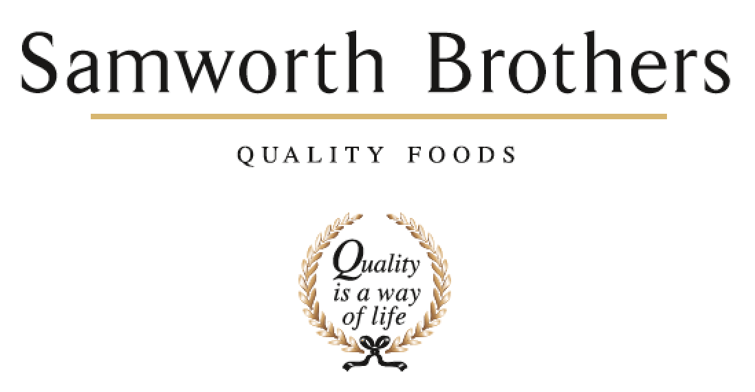

|  |  |  |  |
| --- | --- | --- | --- |
| ROLE PROFILE | | | |
| Job title | People Advisor | Date | Jan 2022 |
| Business |  | | |
| Department | People Team | | |
| Location |  | | |
| ROLE SUMMARY | | | |
| The People Advisor delivers proactive and flexible generalist People support to improve business performance and to contribute to the delivery of value-add People plans in line with the Samworth Brothers Purpose, Culture & Values.  As first port of call for People related matters you will act as an advisor to line managers as they lead their teams through change and enhance colleague engagement and performance. You will support with recruitment, talent management, succession planning, employee relations, performance management, absence management, recognition, reward, and benefits.  You will be able to produce and interpret key People metrics, data, insight and explain what they mean for business performance.  Your business area looks to you as a skilled advisor in People matters, and you will offer coaching and guidance on policies, procedures, and best practice across all areas of people management, ranging from transactional to relatively complex.  You’ll be instrumental in ensuring that managers deliver results with People at the heart of the agenda, and that every decision and action is taken with the Colleague experience as a key consideration. | | | |
| REPORTING STRUCTURE | | | |
| Reports to |  | | |
| Deputy |  | | |
| Direct & indirect reports |  | | |
| Key internal stakeholders |  | | |
| Key external stakeholders |  | | |
| SKILLS & ABILITIES | | | |
| * Work and collaborate with the People team to collectively deliver our purpose of ‘Doing GOOD things with GREAT food’ for all of our colleagues; ensuring we welcome all colleagues into our family and providing opportunities for all of our people to grow, improve their prospects and achieve their full potential. * Work in partnership with the line managers of the business to build a values-based culture, delivering on the Culture Framework and ensuring that results are achieved with people at the heart of every decision, and consistent focus is given to providing a positive experience for Colleagues. * Provide constructive commercially driven advice and guidance to all line managers on policies, procedures, and employment matters, taking time to identify any opportunities and risks to ensure great solutions for the business that are aligned with group values and ways of working. * At all times, represent the People Team, seeking to fully engage line managers in identifying, supporting, and delivering plans in alignment with the People strategy and business’ People plans. Look for ways to drive momentum on colleague engagement and development, influencing when key decisions are being made that impact our Colleagues. * Support the delivery of the People strategy in the business, ensuring that all people activities across the employment lifecycle are executed in ways which add value to both the business and the Colleague experience, with the People vision in mind. Pro-actively support projects to fully embed our strategic ‘enabler’ ways of working in the business. * As required, be responsible for any other tasks, projects, duties, and work streams which contribute to the success of the People team in supporting the business in day-to-day people management activity and in delivering on the objectives of the agreed annual strategic People plan. * Play an active role in supporting change to assist the business in achieving its goals whilst upholding our values and maintaining a positive experience for colleagues. Support the consultation process, and provide guidance and insight on the People aspects – capabilities and skills, labour patterns and pay, ways of working, engagement, and sentiment, and work with managers to deliver positive and effective change plans. * Play an active part in encouraging diversity and respectful inclusive behaviours, identifying and removing barriers to equality. Act as a role model by ensuring own knowledge is current, managing own biases and behaviours and providing guidance to others. * Promote colleague wellbeing, both as an ethical priority and as a key factor in colleague performance, satisfaction, and retention. * Where required, assist in delivering the internal communications plan for the business, helping to create a strong sense of belonging and identity for Colleagues, and ensuring key information is effectively shared. * Support the annual Colleague Engagement Survey process to ensure a high response rate. * As required, assist with the assembly and ongoing activities of the Consultative Committee, in a way which supports meaningful two-way discussion and builds trust, in line with group procedures and ways of working. * Support with Performance Enhancement practice, coaching line managers and colleagues in the use of these tools to unlock potential, enhance engagement and develop behaviours in line with the Samworth Ways of Working. * Work collaboratively with the L&D team to partner with line managers, coaching them to develop high performing teams and support individual colleague progression. Promote our L&D tools and opportunities, and seek to remove any barriers to learning and development. * Support line managers to effectively manage individual cases of underperformance in a timely manner, with clarity, taking a constructive approach. * Support recruitment for Monthly and Weekly paid roles, encouraging recruiting managers to effectively liaise with the central Resourcing team adhering to agreed processes, and ensuring that candidates experience our business positively. Support with interview and onboarding as required. Connect with all outgoing colleagues for an exit interview, analysing trends and providing feedback where appropriate to management. * Liaise with temporary worker agency and off-payroll worker agency as required, playing an active part in ensuring that workers have a positive onboarding and working experience. * Manage and support with the delivery of colleague relations casework including absence management, disciplinary and grievance cases as required. Promptly provide updates and information in line with agreed escalation points. Coach and provide guidance to line managers to improve capability and to ensure cases are managed effectively and constructively, and with sensitivity to the colleague experience. * Record, maintain and report accurate data and information to inform People related decisions and activity, enhance stakeholder engagement and evidence business progress and ROI. * Support on the preparation for and delivery of internal and external audits including Ethical audit and routine customer and governing body audits and assist in close out of any People-related non-conformances in a timely manner. Follow required ways of working to ensure People team activities are compliant and to ‘audit ready’ standards. * Ensure that People systems, information and data are accurate, up to date, and managed and held in a format which follows current legislation (e.g., GDPR) and customer standards / codes of practice. * Work collaboratively with People Team colleagues, sharing knowledge and supporting others, to provide effective and efficient People partnering support to the business, it’s line managers and colleagues, working in alignment with the group Purpose & Values, People strategy and business’ People plans. * Actively engage with reliable sources to update and enhance own knowledge and understanding of new developments, best practice and fresh perspectives in the marketplace, industry, and the People profession. | | | |
| KNOWLEDGE & UNDERSTANDING | | | |
| * Understands the principles of how values-based business leadership with clear purpose develops a positive culture and underpins strong business performance. * Knows the Samworth Brothers Purpose & Values, how these were conceived and have evolved as the group has grown and developed over the years. * Is fully conversant with the Culture Framework, it's function as an enabler of the Purpose & Values, and how it is delivered in the business. * Understands how to effectively deliver training, facilitate learning, and lead a group session to upskill, inform and inspire. * Has business acumen - understands the way business operates and how the moving parts, including people aspects, work together to make it successful. * Understands the dynamics of the management teams and how the People Advisor role in this context contributes to broader business strategy and influences decisions beyond the People agenda. * Knows how to effectively communicate, influence, and work collaboratively with colleagues and stakeholders, including how to provide feedback and positively challenge when necessary. * Takes a coaching approach with colleagues and internal stakeholders, empowering others to deliver results and develop understanding through personal accountability. Can clearly articulate the methodology and models behind this approach. * Maintains an up-to-date knowledge of key legislation, precedents, and best practice (employment, ETI Base Code, GDPR, SB policies & procedures, etc) and has a good awareness of other areas relevant to SB business operations (food safety, H&S, finance, etc). * Is fully conversant with the Samworth Brothers People Toolkit - policies, processes, learning & development programmes, etc and their relevance to business operations and objectives. * Understands how change processes are structured to take into account business objectives, legislative and procedural requirements, and colleague experience / engagement. * Understands how to deliver business change plans, including the process of communication and consultation with individuals and collective groups, ensuring that a planned and co-ordinated approach results in effective and timely outcomes. * Understand drivers of, and barriers to diversity & inclusion, and mechanisms of individual bias and how to mitigate and positively challenge. * Is aware of the importance of colleague wellbeing in overall engagement and performance, and the positive impact on wider business results. Is aware of the various physical, mental, and emotional factors contributing to resilience and wellbeing, and how these are supported / impacted in the business operation. * Has an appreciation of the Samworth Brothers Wellbeing strategy, it's function as an enabler of the Purpose & Values and overall business performance, and how it is delivered in the business. * Has an appreciation of the internal communications strategy for the business area. Understands key factors such as the audience segmentation, available channels, and main themes and messages. * Understands the purpose of colleague forums and how these are delivered across Samworth Brothers. * Understands the Samworth Brothers organisation design as set out in the Career Pathways, L&D Pathways and Ways of Working, and knows how these structures, roles and capabilities are applied within own business area. * Is fully conversant with the Samworth Brothers Performance Enhancement toolkit, its function as an enabler of colleague development and engagement in line with the People Vision and overall business performance, and how this is delivered in the business. * Appreciates the differences between intrinsic vs extrinsic motivation, the factors which drive and sustain these, and can recognise how these are embedded in the People policies and practices. * Is aware of the content of L&D Pathways for each Job Family, and the strategic L&D plan in place for own business area. * Understands the role of L&D Advisor and L&D Partner, and knows the induction and compliance training requirements for the business area. * Can articulate the principles of a fair, effective, and equitable recruitment and selection process from job role planning through to screening, interviewing, and profiling candidates and has the knowledge to support and guide managers through these steps. * Has appropriate knowledge and understanding of auditing procedures to carry out audits of internal process and of agency labour providers. * Has full knowledge of the Samworth Brothers pay and benefits, contract of employment terms & conditions (e.g. shift patterns) as well as relevant legislation (e.g. Working Time Directive) and how these are applied and managed in the business. * Understands the importance of taking a 'mediation and resolution' approach to employee relations, has the knowledge to manage cases this way in practice and to role model / coach this approach to others. * Demonstrates solid knowledge of critical thinking and objective decision-making methodology. * Understands the importance of accurate, up-to-date information and data in the People and business context. Knows how to select, analyse, and interpret data and ways in which results can be effectively presented to others. * Knows the SB business processes and procedures relevant to their role which must be adhered to for safety, quality, and legal compliance e.g., Health & Safety procedures. * Has full working knowledge of the key information systems used by the People Team - People Portal, clocking & attendance, AX, Sharepoint, etc. * Understands how the people function operates within the wider business context, including the factors which build positive reputation and influence. * Knows how to select and evaluate different sources of information to ascertain reliability and relevance, and understands how to introduce new learnings into the Samworth Brothers context in ways which best add value. * Understands the importance of continued personal and professional development (CPD). | | | |
| QUALIFICATIONS & EXPERIENCE | | | |
| CIPD L3 People Management   * Advising and coaching line managers * Managing ER caseload * Mediation * Coaching * Train the Trainer | | | |
| CORE COMPETENCIES, ATTRIBUTES & BEHAVIOURS FOR SUCCESS | | | |
| **Competency** | **Descriptors** | | |
| Core |  | | |
| Values People | *Demonstrates the belief that people are our most important asset and central to the success of the organisation. Everybody should be treated with dignity and respect at all times.* | | |
| Customer Focus | *Demonstrates the understanding that the satisfaction of our internal and external customers is the foundation of our success* | | |
| Collaborative Team Working | *The willingness to act as part of a team and work towards achieving shared objectives through adopting best practice in line with PQP and Federalism.* | | |
| Flexibility & Adaptability | *The ability to change and adapt own behaviour or work procedures when there is a change in the work environment, for example as a result of changing customer needs.* | | |
| Initiative & taking ownership | *Steps up to take on personal responsibility and accountability for tasks and actions in line with PQP and Federalism.* | | |
| Individual Contributor |  | | |
| Drive for Excellence | *Knows the most effective and efficient processes for getting things done, with a focus on continuous improvement.* | | |
| Resource Management | *Effectively manages resources and cost drivers to achieve sustainable productivity and profitability.* | | |
| Technical Expertise | *Has the skills, knowledge and experience required to excel in own area of specialism and the willingness to further grow and develop.* | | |
| Self-Management | *Uses a combination of feedback and reflection to gain insight into personal strengths and weaknesses, so that own time, priorities, and resources can be managed to achieve goals.* | | |