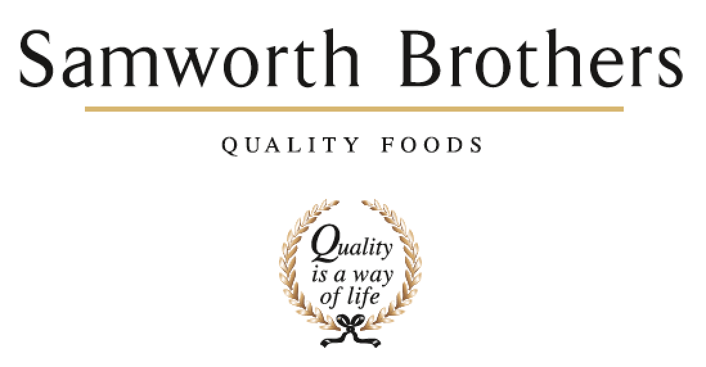

|  |  |  |  |
| --- | --- | --- | --- |
| ROLE PROFILE | | | |
| Job title | Trainer | Date | January 2025 |
| Business | Samworth Brothers Manton Wood | | |
| Department | Operations | | |
| Location | Manton Wood | | |
| ROLE SUMMARY | | | |
| Responsible for supporting the training function within the bakery and across all other departments as advised. Setting standards and providing instructions on GMP, Quality, H&S, training of SOP’s and SSOW’s for new and existing colleagues. | | | |
| REPORTING STRUCTURE | | | |
| Reports to | L&D Advisor | | |
| Working With | All colleagues | | |
| Key internal stakeholders | Department Managers, People Team, Team Leader, L&D Advisor | | |
| KEY ACCOUNTABILITIES AND RESPONSIBILITIES | | | |
| * Conducting Company inductions to new starters, including Health and Safety and Food Safety. * Ensuring core skills are trained in a timely manner to new starters and assessed at appropriate intervals, including Manual Handling, relevant SOP’s, etc. * Maintaining high standards of communication with Managers, Team Leaders and colleagues, supporting the gap analysis. * Ensure all necessary paperwork is completed in an accurate and timely manner and is uploaded on to department training matrices/Learning Management system. Supporting with tracking and driving training KPI’s as well as ensuring all training refreshers are planned ahead to ensure compliance. * Develop and promote an excellent Health & Safety culture. * Develop and promote an excellent Food Safety culture. * Work closely with stakeholders to ensure SOP / SSOW training is created/updated as and when required. * Ensure all colleagues understand and are signed off on all procedures to ensure compliance with Health & Safety, Food Safety and operational ways of working. * Provide training and sign off support for all CCP operatives and update CCP matrices. * Liaise with the L&D Advisor on the timing and delivery of programmes over and above bakery compliance. * Where appropriate train and assess competency on equipment within the bakery. * Any other reasonable request, including on-line work/training. | | | |
|  | | | |
| **Required**  Good basic IT skills & ideally experience of systems such as MS Excel and PowerPoint.  Accurate and organised in administration.  Able to prioritise a busy and varied workload.  Ability to work with internal stakeholders to achieve objectives.  Excellent communication skills both verbal and written.  Flexibility around meeting the requirements of the role.  **Advantage**  Food Safety / Health & Safety qualifications up to level 3  Food & Drink industry experience | | | |
| CORE COMPETENCIES, ATTRIBUTES & BEHAVIOURS FOR SUCCESS | | | |
| **Competency** | **Descriptors** | | |
| Values People | *Demonstrates the belief that people are our most important asset and central to the success of the organisation. Everybody should be treated with dignity and respect at all times.* | | |
| Customer Focus | *Demonstrates the understanding that the satisfaction of our internal and external customers is the foundation of our success* | | |
| Collaborative Team Working | *The willingness to act as part of a team and work towards achieving shared objectives through adopting best practice in line with PQP and Federalism.* | | |
| Flexibility & Adaptability | *The ability to change and adapt own behaviour or work procedures when there is a change in the work environment, for example as a result of changing customer needs.* | | |
| Initiative & taking ownership | *Steps up to take on personal responsibility and accountability for tasks and actions in line with PQP and Federalism.* | | |