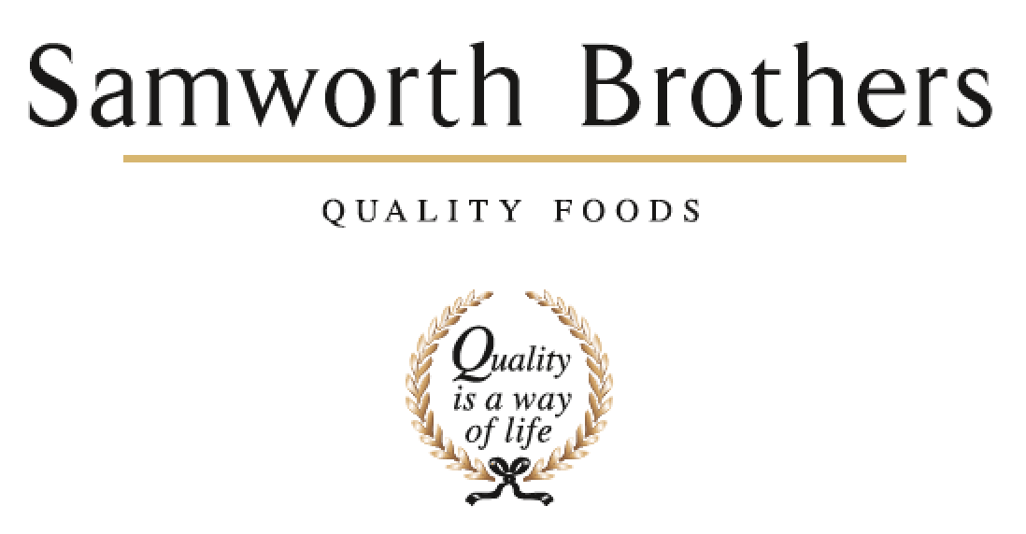

|  |  |  |  |
| --- | --- | --- | --- |
| ROLE PROFILE | | | |
| Job title | L&D Partner | Date | 2022 |
| Business | Samworth Brothers | | |
| Department | Group People | | |
| Location | Oak Meadow, Scudamore Rd, Leicester | | |
| ROLE SUMMARY | | | |
| The L&D Partner works closely with People teams, leaders and managers at all levels, delivering the Group L&D strategy in support of the overall Group People Strategy.  In this role you will act as a strategic partner to a portfolio of businesses and job families across Samworth Brothers, improving overall business performance through value-add learning & development. Working with senior stakeholders, you will shape People development plans which enable the business to align to opportunities, support change and further the talent agenda to build high performing teams and develop excellent leaders and managers in line with the Samworth Brothers Purpose, Culture & Values.  You will take a keen interest in the key business performance measures, understanding how you can support, influence, and drive these areas. You’ll be able to deploy and interpret key People metrics, data, insight and explain what they mean for business performance.  Your business areas look to you as the professional expert in L&D matters, and you will offer coaching and guidance as well as clear direction. You’ll be instrumental in ensuring that the business delivers results with People at the heart of the agenda, and that every decision and action is taken with the Colleague experience as a key consideration. | | | |
| REPORTING STRUCTURE | | | |
| Reports to | Head of L & D | | |
| Direct & indirect reports | n/a | | |
| Key internal stakeholders | Group People Director, Directors, People Teams and Group Resourcing, Line Managers, Scheme Participants | | |
| Key external stakeholders | Recruitment Partners, Learning Providers, Industry network | | |
| SKILLS & ABILITIES | | | |
| * Collaborate with the L&D and People Team community on projects to collectively deliver our purpose of ‘Doing GOOD things with GREAT food’ for all our colleagues; ensuring we welcome all colleagues into our family and providing opportunities for all our people to grow, improve their prospects and achieve their full potential. * Work in partnership with the leaders and managers of the business to build a values-based culture, delivering the Culture Framework and ensuring that learning, growth, development, and a positive experience for colleagues is at the heart of how business results are achieved. * Partner with senior teams and line managers to develop and support high performing teams, and to shape and deliver strategic plans for enhancing capability in ways which are commercially focused and aligned with group values and ways of working. * Deliver the Group L&D strategy, and support the delivery of the wider People strategy, ensuring that all learning & development across the employment lifecycle is executed in ways which add value to both the business and the Colleague experience, with the People vision in mind. * Work collaboratively with People Teams, supporting them to partner leaders and senior managers around colleague development, and keeping them in step with delivery of the L&D strategy and plans. Together, promote our L&D tools and opportunities, and seek to remove any barriers to learning and development. * Scope, design and develop content, resources and materials for training and development programmes to address clearly identified business requirements, putting in place measures to assess impact and return on investment. Work collaboratively with L&D colleagues to share good practice and learnings, and to develop programmes which are relevant and aligned across the Samworth Brothers group. * Deliver training, facilitate workshops and co-ordinate learning events and programmes using an approach which conveys content with clarity, in an environment which is inclusive and engaging for colleagues and participants. * Play a pro-active role in supporting change to assist in delivery of business goals whilst upholding our values and maintaining a positive experience for colleagues. Provide guidance and insight on the People development aspects – capabilities and skills, progression and development opportunities, engagement and sentiment, and work with change management teams to shape and deliver positive and effective change plans. * Work in partnership with the People Team to analyse and follow up response data from the annual Colleague Engagement Survey to shape and drive L&D action plans which increase overall colleague development and progression, engagement, wellbeing, and satisfaction. * Utilise and analyse MI and data to inform L&D related decisions and activity, enhance stakeholder engagement and evidence business progress and ROI.  Conduct external benchmarking where relevant. * Support and promote the Performance Enhancement process as a key foundation of colleague development and engagement, encouraging managers to coach towards high performance and progression, and colleagues to fully engage and take ownership of their own development journey. * Support senior and line managers, where required, with preparing for talent mapping and succession planning activities and work with them to create appropriate action plans based on the outputs of these. * Fully utilise the People Portal, including LMS and Talent, as tools to enable an accessible, consistent, and effective L&D provision for the business and our colleagues. Encourage managers and colleagues to engage with L&D through the People Portal, supporting the business to entirely adopt and embed the system. * Work closely with the People Leads and Comms Specialists to ensure that there is synergy in the key themes and messages across internal communications and L&D content. Where required, assist in delivering the internal communications strategy for the business, helping to create a strong sense of belonging and identity for Colleagues, and ensuring key information is effectively shared. * Apply key learning principals, and embed these into all L&D content and materials to underpin an overall learning culture i.e., 70:20:10, growth mindset, manager as coach. * Design and manage delivery of onboarding and induction learning activity which is effective in communicating required elements, and in offering new colleagues an interesting and impactful experience and a warm introduction to the business. * Work closely with senior managers to ensure compliance training meets the requirements of the business, the delivery approach is a good fit and any barriers to attendance are promptly resolved. Ensure routine, accurate tracking is in place and is used by line managers to drive full compliance. * Ensure colleagues undertaking training, and their line managers and mentors, receive robust support throughout their learning journey, from initial understanding of requirements through to ongoing routine touchpoints and early intervention on any significant challenges. * Manage the L&D team to provide effective and efficient L&D partnering support to the business, it’s line managers and colleagues, working in alignment with the group Purpose & Values, People strategy and business’ L&D and People plans. Coach and develop your direct reports, delegating work as appropriate to provide stretch and challenge whilst fully managing any potential risk to the business and individual. * Promote colleague wellbeing, both as an ethical priority and as a key factor in colleague performance, satisfaction, and retention. * Play a key part in encouraging diversity and respectful inclusive behaviours, identifying and removing barriers to equality. Act as a role model by ensuring own knowledge is current, managing own biases and behaviours and providing guidance to others. * Build strong, effective partnerships with providers, using ongoing measures and two-way feedback to manage quality. Select external learning/service providers, where required, based on objective criteria including credibility and relevant expertise. * Partner with the People Leads and senior team to shape and manage annual L&D budget plans, and work collaboratively to ensure maximum return on investment for the group from both direct and apprenticeship levy spend. * Support on preparation for and delivery of internal and external audits, including Ethical audit and routine customer and governing body audits, and close out any training related non-conformances in a timely manner. Ensure that L&D and training activities are compliant and run to ‘audit ready’ standards including maintenance of accurate records and information. * Ensure that L&D systems, information, and data are accurate, up to date, and managed and held in a format which follows current legislation (e.g., GDPR) and customer standards / codes of practice. * As required, be responsible for identifying any other tasks, projects and/or work streams which contribute to the success of the L&D and People Team in supporting the business in day-to-day people development and engagement activity, and/or in delivering the objectives of the strategic People plan. * Actively engage with reliable sources to update and enhance own knowledge and understanding of new developments, best practice and fresh perspectives in the marketplace, industry, and the People profession. | | | |
| KNOWLEDGE & UNDERSTANDING | | | |
| * Understands how values-based business leadership with clear purpose develops a positive culture and underpins strong business performance. * Knows the Samworth Brothers Purpose & Values, how these were conceived and have evolved as the group has grown and developed over the years. * Is fully conversant with the Culture Framework, it's function as an enabler of the Purpose & Values, and how it is delivered in the business. * Has solid business acumen - understands the way business operates and how the moving parts, including people aspects, work together to make it successful. Knows how to read the progress of the business through its financial metrics and has awareness of the levers, risks and opportunities which impact profitable growth. * Knows how to effectively communicate, influence, and work collaboratively with colleagues and stakeholders at all levels of the organisation, including how to provide feedback and positively challenge when necessary. * Takes a coaching approach with colleagues and internal stakeholders, empowering others to deliver results and develop understanding through personal accountability. Can clearly articulate the methodology and models behind this approach and apply appropriately according to the individual person and circumstance. * Is fully conversant with the Samworth Brothers People Toolkit - policies, processes, learning & development programmes, etc and their relevance to business operations and objectives. * Understands the methodology for identifying capability levels and skills gaps in a given business area against the L&D Pathways and Role Profiles for each Job Family, in order to agree areas for strategic L&D focus and programmes to support business objectives. Can contribute and give feedback as these Role Profiles and L&D Pathways are reviewed and updated. * Understands how to effectively deliver training, facilitate learning, and lead a group session to upskill, inform and inspire. * Has a good working knowledge of up-to-date neuroscience principals relevant to L&D practice. * Can structure, build, and deliver a presentation in a way which effectively conveys the message, engages the audience, and garners support for the proposal. * Understands how change processes are structured to take into account business objectives, legislative and procedural requirements, and colleague experience / engagement, and how they are delivered, including communication and consultation with individuals, larger audiences, and key stakeholders, in with a planned and co-ordinated approach to ensure effective and timely outcomes. * Understands the key factors which affect employee engagement, and the ways in which business can create the conditions in which colleagues will offer more commitment and enhances capability. * Knows how to select, analyse, and interpret data and ways in which results can be effectively presented to others. Understands how to set measurables (KPI's, objectives, etc) in a way which drives performance and demonstrates progress. * Fully comprehends the SB organisation design as set out in the Career Pathways, L&D Pathways and Ways of Working, and is fully conversant with how these structures, roles and capabilities are applied within own business area ensuring that all L&D programmes and content is fully aligned with them. * Is fully conversant with the SB Performance Enhancement and Talent & Succession toolkits, their function as an enabler of colleague development and engagement in line with the People Vision and overall business performance, and how these are delivered in the business. * Has full working knowledge of the key information systems used by the People Team - People Portal, AX, SharePoint, etc. * Has a basic understanding of how an effective internal communications strategy is structured, including key factors such as audience segmentation, available channels, and basic marketing principles. * Knows the SB business processes and procedures which must be adhered to for safety, quality, and legal compliance e.g., Health & Safety procedures, Group Authorities Manual. * Has a full understanding of apprenticeships - how the apprenticeship levy is paid, and funding rules applied, and how apprenticeship standards are developed, delivered, and assessed. * Understands how to manage an L&D function within the wider business context, including the factors which build positive reputation and influence. * Has the knowledge to underpin strong people management skills e.g., how, and why to lead with vision and empathy, delegation, and time management, developing others. * Understands the importance of colleague wellbeing in overall engagement and performance, and the positive impact on wider business results. Is fully conversant with the various physical, mental, and emotional factors contributing to resilience and wellbeing, and how these are supported / impacted in the business operation. * Is fully conversant with the SB Wellbeing strategy, it's function as an enabler of the Purpose & Values and overall business performance, and how it is delivered in the business. * Understand drivers of, and barriers to diversity & inclusion, and mechanisms of individual bias and how to mitigate and positively challenge * Is conversant with the language, terminology and structure of legal contracts, service level agreements, etc., and understands where it is appropriate to seek specialist advice in developing, negotiating, or agreeing these. * Understand the annual budget process, how to build and structure an L&D budget and how to manage, reconcile and report on spends, keeping a close control on costs. * Has a good working knowledge of the relevant sections of Customer codes of practice and other audit standards which are applicable to people management and People Team operations. * Understands how to effectively manage external stakeholders and auditors, in line with our Values. * Maintains an up-to-date knowledge of key legislation, precedents, and best practice (employment, ETI Base Code, GDPR, SB policies & procedures, etc) and has a good awareness of other areas relevant to SB business operations (food safety, H&S, finance, etc). * Knows how to select and evaluate different sources of information to ascertain reliability and relevance, and understands how to introduce new learnings into the Samworth Brothers context in ways which best add value. * Understands the importance of continued personal and professional development (CPD). | | | |
| QUALIFICATIONS, EXPERIENCE, TECHNICAL SKILLS / KNOWLEDGE | | | |
| CIPD L5 Learning & Development   * L&D Business Partner at a senior management team level * Strong and engaging training delivery / facilitation / presentation skills * Developing and designing training events, courses, programmes * People management & development   **Advantage**  Coaching qualification  Insights Discovery Certified Practitioner  Food Safety / Health & Safety qualifications | | | |
| CORE COMPETENCIES, ATTRIBUTES & BEHAVIOURS FOR SUCCESS | | | |
| **Competency** | **Descriptors** | | |
| Values People | *Demonstrates the belief that people are our most important asset and central to the success of the organisation. Everybody should be treated with dignity and respect at all times.* | | |
| Customer Focus | *Is passionate about quality, striving to continuously make a positive difference for our customers and our consumers.* | | |
| Collaborative Team Working | *The willingness to act as part of a team and work towards achieving shared objectives through adopting best practice in line with our Purpose Statement and Company Values.* | | |
| Flexibility & Adaptability | *The ability to change and adapt own behaviour or work procedures when there is a change in the work environment, for example as a result of changing customer needs.* | | |
| Initiative & taking ownership | *Steps up to take on personal responsibility and accountability for tasks and actions in line with our Purpose Statement and Company Values.* | | |
| People Management | *The ability to understand people and their motivations, build good relationships with them and help them unlock their full potential.* | | |
| Empowering Others | *Creates an environment where people feel required and enabled to take ownership and responsibility.* | | |
| Coaching for Performance | *The ability to help others achieve more through two-way feedback, clear direction and enabling.* | | |
| Analysis & Planning | *The ability to take a range of information, think things through logically and prioritise work to meet commitments aligned with organisational goals.* | | |
| Drive for Excellence | *Knows the most effective and efficient processes for getting things done, with a focus on continuous improvement.* | | |