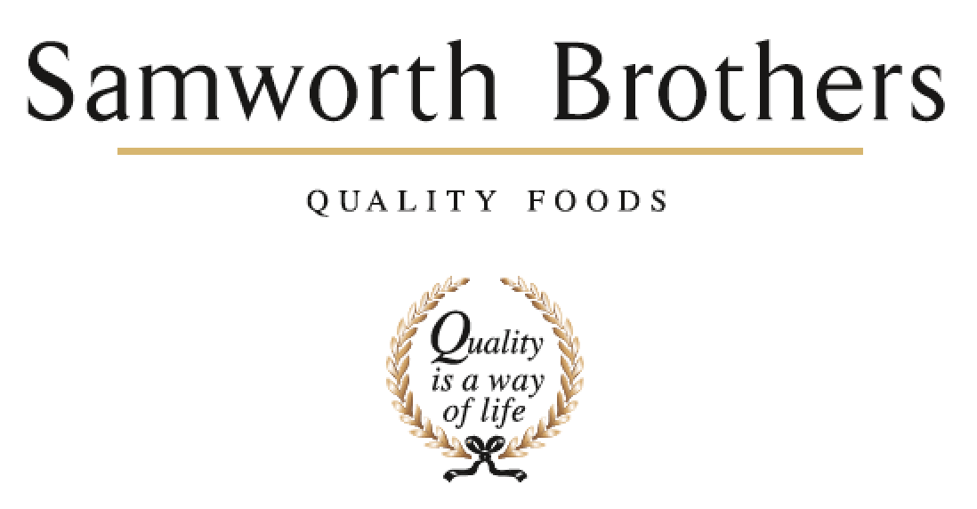

|  |  |  |  |
| --- | --- | --- | --- |
| ROLE PROFILE | | | |
| Job title | Development Technologist | Date | May 24 |
| Business | Samworth Brothers Meals | | |
| Department | Commercial | | |
| Location | Saladworks | | |
| ROLE SUMMARY | | | |
| Support the Senior Technologist in the delivery of projects from initial concept idea to handover.  The purpose of this role is to ensure the NPD function develops and deliver commercially viable products in line with our growth strategy.  Along with supporting the development of new concepts you will get involved with refreshing and optimising existing products following a development gate process.  You will work cross functionally in partnership with the Commercial, Category, Sourcing and Procurement functions, Production and Technical/Process teams in the development of new products from concept through to factory handover. | | | |
| REPORTING STRUCTURE | | | |
| Reports to | Senior Development Technologist | | |
| Direct & indirect reports |  | | |
| Key internal stakeholders | NPD Managers, Development Chef, Commercial & Category Teams, Costing Teams, Technical and Process, NPD Sourcing Specialists & Procurement | | |
| Key external stakeholders | Retailer Colleagues | | |
| KEY ACCOUNTABILITIES AND RESPONSIBILITIES | | | |
| * Assist the Senior Technologist in the daily project management of strategic and customer led projects. * Ensure deadlines are met in line with the launch process and critical paths, supporting the company objectives on cost. * Ensure product files are maintained through the launch process. * Use Point 74 to create accurate recipes and nutritional summaries. * Briefing new raw materials and packaging to the sourcing log. * Ensuring recipes are sent for costing in a timely manner and returned in line with Customer meetings/presentations. * Preparation of accurate paperwork for feasibilities/handovers and all customer meetings. * Arranging competitor samples availability for internal and customer meetings. * Amendment of paperwork through internal and external submissions and assurance of accuracy and compatibility with recipe versions. * Ensure recipe changes still meet customer brand values for each category. * Ensure recipe changes still meet QUID targets. * Accountable for the accurate and timely availability of submission paperwork. * Liaise with Ingredient Sourcing Specialist and Packaging Executive to ensure all raw materials and packaging are available for product development and submissions. * Working cross functionally with Technical, Process and operations to ensure alignment through the stage & gate process. * Responsible for courier arrangement for delivery of samples to meetings/photography. | | | |
| QUALIFICATIONS, EXPERIENCE, TECHNICAL SKILLS / KNOWLEDGE | | | |
| * Min 1 years' experience in food manufacturing environment is desirable. * BSc or equivalent in a Food related discipline. * Project Management experience. * Competent with NPD software packages. * Strong organisational, and project management skills to assist with critical path deadlines and project priorities. * Knowledge of food production. * Can effectively time manage prioritise work. * Hardworking and accurate with an eye for detail. * Ability to problem solve | | | |
| CORE COMPETENCIES, ATTRIBUTES & BEHAVIOURS FOR SUCCESS | | | |
| **Competency** | **Descriptors** | | |
| Values People | *Demonstrates the belief that people are our most important asset and central to the success of the organisation. Everybody should be treated with dignity and respect at all times.* | | |
| Customer Focus | *Demonstrates the understanding that the satisfaction of our internal and external customers is the foundation of our success* | | |
| Collaborative Team Working | *The willingness to act as part of a team and work towards achieving shared objectives through adopting best practice in line with PQP and Federalism.* | | |
| Flexibility & Adaptability | *The ability to change and adapt own behaviour or work procedures when there is a change in the work environment, for example as a result of changing customer needs.* | | |
| Initiative & taking ownership | *Steps up to take on personal responsibility and accountability for tasks and actions in line with PQP and Federalism.* | | |
| Drive for Excellence | *Knows the most effective and efficient processes for getting things done, with a focus on continuous improvement.* | | |
| Resource Management | *Effectively manages resources and cost drivers to achieve sustainable productivity and profitability.* | | |
| Technical Expertise | *Has the skills, knowledge and experience required to excel in own area of specialism and the willingness to further grow and develop.* | | |
| Self-Management | *Uses a combination of feedback and reflection to gain insight into personal strengths and weaknesses, so that own time, priorities and resources can be managed to achieve goals.* | | |