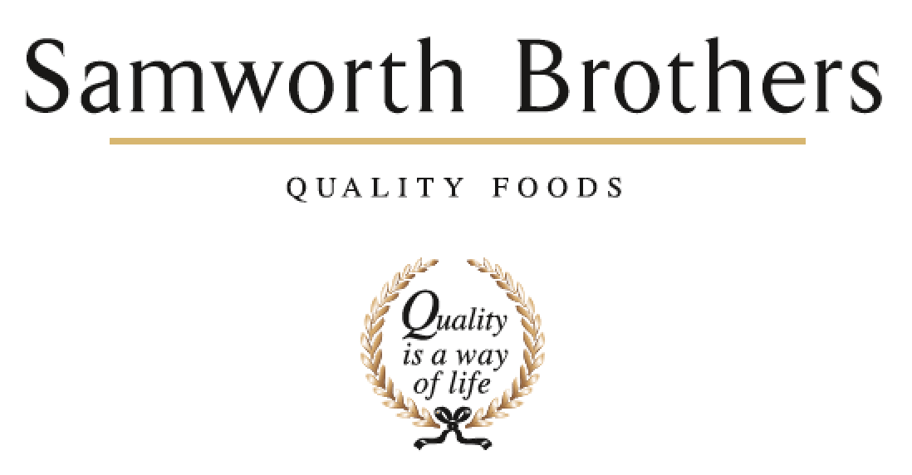

|  |  |  |  |
| --- | --- | --- | --- |
| ROLE PROFILE | | | |
| Job title | Senior Process Technologist | Date | 13/08/2025 |
| Business | Samworth Brothers | | |
| Department | Process/ Technical | | |
| Location | Manton Wood | | |
| ROLE SUMMARY | | | |
| To manage and co-ordinate the Technical Development function, from initial product concept through to product launch monitoring. Will ensure that all internal and external customer requirements are met and communicated to the business. | | | |
| REPORTING STRUCTURE | | | |
| Reports to | Process Manager | | |
| Key internal stakeholders | FTG NPD Department, Operations, Supply Chain, CI, Technical, Engineering, Finance, Packaging Technologists. | | |
| Key external stakeholders | Equipment suppliers, Raw material suppliers and retailers. | | |
| KEY ACCOUNTABILITIES AND RESPONSIBILITIES | | | |
| This is not an exhaustive list and the role will require you to accept additional responsibilities.   * To organise the planning of projects in line with the critical path as well as highlighting product/process improvement margins as directed by Process Manager. * To work closely with the NPD team to ensure feasibility of new products and push through potential process improvements. * To work closely with external suppliers and the technical team to identify and resolve any raw material issues. * To support production, CI and procurement teams on potential margin improvements. * To support production and engineering teams on new equipment to site. * To liaise with the packaging technologist on packaging related projects and support any new packaging trials in conjunction with engineering where required. * To prepare for pre-production and launch, ensuring all necessary validation carried out by the process technologist is complete and approved. * To deputise for the Process Manager. * Ensure food safety, legality and quality standards are met for new and existing product development. * Will be a member of the HACCP/TACCP/ VACCP team. * Carry out trials on new and existing products against plan, in line with the business critical paths, using a problem-solving approach ensuring issues are captured and communicated across multiple functions. Coordinating with the process technologist to ensure trials are completed and all relevant paperwork completed as required in line with retailer timings and requirements. * Facilitate post trial evaluation, co-ordination of samples required for evaluation, QAS generation, organoleptic review, photo standard generation, and moisture migration completion. * Using a problematic approach to ensure all procedures shelf-life/microbiological and nutritional results are met ahead of launch. * Validating line map to ensure we are in line with costed labour and throughput, communicating any issues or changes to the process manager. * Completion of all controlled documents that form the launch pack ahead of launch meetings. * Pull together relevant information for post launch reviews ahead of meetings. * Artwork checks in line with the artwork approval procedure completing the artwork checksheet to ensure any changes to artwork are captured and in line with requested change from customer. * Organise site visit including agenda, refreshments and room bookings, PPE etc. * Visibility of 2-3 months ahead for the raw material and packaging requirement in line with trial plan/ raw material tracker. * Ensure that raw materials delivered for trials meet the raw material specification and are fit for purpose, completing visual, taste and texture review communicating issues to the raw materials team to feedback to supplier.   Key Performance Indicators   * To organise the planning of projects in line with the critical path * Ensure key product/project deadlines are met. * Review trial data with the relevant teams and support the Process Technologist when issues arise, communicate issues to wider teams and escalate as necessary. * To work closely with the NPD team to ensure feasibility of new products and suggest potential process improvements. Review product samples and feedback to relevant development manager and chef to identify any potential issues and process improvements. * Arrange feasibility trials where necessary to approve ingredients/packaging/processes prior to a handover to ensure suitability in manufacturing. * Identify potential material issues throughout trial phase and communicate issues to suppliers and development to overcome issues raised. * Collate data and arrange for costings to be completed on amends made. * Organise process validation of new equipment through trials collating relevant data including yields. * Support the Process Manager to review and approve validation work carried out by the Process Technologist. * Support the technical team in the first production/delivery of new materials to site. * Support all departments in the lead up to launch with sharing knowledge gained throughout trials through arranged launch meetings. * To deputise for the Process Manager, cover meetings where required * Attend site visits where required. * Hands approach, positive approach to getting the job done will be necessary. | | | |
| QUALIFICATIONS, EXPERIENCE, TECHNICAL SKILLS / KNOWLEDGE | | | |
| * Excellent communicator and influencer. * Proactive approach to work * Highly organised and ability to manage time well and motivate within the team. * Adaptable to change at short notice, flexibility to cover production on all shifts outside of normal working hours. * Strong IT skills * Highly driven, working to high standards with great attention to detail * HACCP/Food Safety training level 3 or above * Degree level or equivalent in Food Science/Technology and/or relevant experience. * Proven delivery of projects on time, in full, within budget * Flexibility to travel to customers and suppliers where required | | | |
| CORE COMPETENCIES, ATTRIBUTES & BEHAVIOURS FOR SUCCESS | | | |
| **Competency** | **Descriptors** | | |
| Values People | *Demonstrates the belief that people are our most important asset and central to the success of the organisation. Everybody should be treated with dignity and respect at all times.* | | |
| Customer Focus | *Demonstrates the understanding that the satisfaction of our internal and external customers is the foundation of our success* | | |
| Collaborative Team Working | *The willingness to act as part of a team and work towards achieving shared objectives through adopting best practice in line with PQP and Federalism.* | | |
| Flexibility & Adaptability | *The ability to change and adapt own behaviour or work procedures when there is a change in the work environment, for example as a result of changing customer needs.* | | |
| Initiative & taking ownership | *Steps up to take on personal responsibility and accountability for tasks and actions in line with PQP and Federalism.* | | |
| People Management | *The ability to understand people and their motivations, build good relationships with them and help them unlock their potential.* | | |
| Empowering others | *Creates an environment where people feel required and enabled to take ownership and responsibility.* | | |
| Coaching for performance | *The ability to help others achieve more through two-way feedback, clear direction and enabling.* | | |
| Analysis & Planning | *The ability to take a range of information, think things through logically and prioritise work to meet commitments aligned with organisational goals.* | | |
| Drive for Excellence | *Knows the most effective and efficient processes for getting things done, with a focus on continuous improvement.* | | |